A level programming project

Name: Abdelrahmane Bekhli

Candidate Number: 9537

Centre Name: CENTRAL FOUNDATION BOYS SCHOOL

Centre Number: 10304

Table of content

**Section 1 - Analysis** **2**

**Analysis** **2**

Problem identification 2

Why use a computer? 3

Stakeholders 4

**Research - initial stakeholders** **5**

Survey 5

Survey results 6

**Research - Existing solutions** **10**

Super mario bros 10

Cat mario 13

Super Smash Bros Ultimate 15

**Limitations** **17**

**Features to consider** **18**

**Hardware and software** **19**

**Success Criteria** **20**

**Section 2 - Design** **23**

**Development method** **23**

**Class diagram** **23**

How subroutines will run together 24

Pseudocode and flowcharts 25

Data structures 34

**Input and process and output table** **35**

stored data, format and where it will be stored 36

**GUI designs** **36**

Validation 39

Testing 39

White Box testing 40

Black box testing 43

Game Design 46

**Section 3 - Development** **48**

White Box testing 109

**Validation** **114**

**Evaluation** **115**

Usability 116

Criteria met: 119

Black box testing 120

Maintenance and limitations 123

**Programming Project**

# Section 1 - Analysis

## **Analysis**

### Problem identification

Over the past years, Mario has become a viral game, where everyone would enjoy playing it, typically from the age 10+. However, the game concept has become tedious as it is the same process at every level, and it remained like this for years, dodging enemies, getting to the flag and getting upgrades. Mario games have only one character playing the game, which might be annoying for some gamers as they might want to choose to pick another character. For example, girls might want to use a female character rather than a male one.

Most new Mario games are made with higher and better graphics and more exclusively for a Nintendo switch. However, not everyone can afford these gaming consoles; therefore, I will make my game have low PC hardware requirements to allow a vast audience to play and enjoy the game without spending money on expensive hardware.

I will be making a similar version of this game and expanding the target audience from young kids to adults by adding more features such as traps, skins and more upgrades. My idea would make people more interested in finishing the game as there are many different and unexpected features and surprises and different characters.

I chose to make this game for a computer as this platform has all the input keys needed and with spare keys that I can use in different upgrades. For example, the WASD keys to move, spacebar to jump, K to shoot. In addition, almost every household has a computer, so my audience would not need to spend extra money on other hardware to run a game.

### Why use a computer?

I will base my game on a character that's moving right, left, up and down which therefore is easier to manipulate and simulate on a computer as it has all the inputs required. Furthermore, my game will include many upgrades and traps which are impossible to achieve in the physical world.

In addition, the computer will allow my game to have sound effects and in-game music, and other outputs such as a display and this will make the game more enjoyable and look more professional as the player will be able to see the moving character on the map and hear the sound effects.

Furthermore, making a game on a computer will give me an advantage of using Computational thinking such as:

* Decomposition, where I can split the entire code into small parts where every part will present something in the game, and then add them all the part together to make the game functioning; this also will help prevent errors as if an error occurs in one Part (functions) it wouldn’t affect the rest of the game code.
* Abstraction will help solve a problem by ignoring all the unnecessary data, this will help in my project as I wouldn't need to acknowledge parts of real-life for my game, such as grass movement, body movement, day/night timing and can be replaced with less graphical items.
* Automation, the game will consist of many events happening at the same time. for example, a score system, where the player could be gaining points from completing levels and lose some from dying. Automation will speed up the process of calculating and adding/subtracting the points each time, therefore, using a computer will automate this process without the need to manually change the score.

Moreover, the computer has many paradigms that would allow me to code the game more efficiently, such as OOP (Object Oriented Program) where making objects and classes (Blueprints) is possible.

A computer is also made up of secondary storage that stores data even if the computer has been turned off, this therefore will allow the user to save their progress and carry on from where they left the last time, they played the game. Furthermore, the computer is also made of a CPU that can perform millions of calculations in seconds, this feature will be useful in making the game as it would make the game run faster compared to if it was in real life. For example, the points gained by the player will be added to the score instantly without the need for the player to stop playing or pause the game, however if the game was not made on a computer and was made as a board game for instance, then the players will need to pause the game each time and do the maths to overwrite the total score.

Having the game made on a computer allows adding more quality to it, such as animations. This can be added for example when the character gains certain power ups or loses them, a small animation around the character can appear, or the movement of the character is also an animation as his legs could be moving when the player walks, or performs a certain pose when he is standing still. This will therefore make the game more enjoyable.

Lastly, the speed of the computer is very beneficial when it comes to playing the game. A computer has a really fast response time (real time), and this can be used when the user inputs character (e.g., arrow keys) he will get an instant response making the game run smoother.

### Stakeholders

My clients will be students between the age of 15-19 of both genders because most of them are gamers. When asking them about making a game most of them remembered the game Mario and understood the concept of the game. On that account this would give me an advantage when making a questionnaire about my project as they have experienced playing a similar game therefore it will help make and choose solid ideas for the game that can satisfy them.

My game will make my target audience enjoy their time playing as well as giving them a nostalgic atmosphere, and could help them have a break from studying and working hard by entertaining themselves with my game.

In addition, the game wouldn’t be at such a high difficulty to make sure that they don't get stressed when playing the game, the game will therefore act as a stress reliever from the hard work at schools or exams. The game will also save their progress each time they play so they wouldn't need to keep restarting all the levels each time they play as that will potentially make them get bored of the game.

Since the game gives the players a nostalgic feeling it could make them focus on the game and remember their childhood and therefore drift their brains away from the present stress or the hard work they’ve been recently doing.

Furthermore, the game that I’m making can be played using just a keyboard and mouse, and this will suit my target age 15-19 as they are all experienced using these types of hardware as they could have used it in school for homework, write essays, or to play games therefore they won’t find a difficulty using them to play the game.

## Research - initial stakeholders

### Survey

In order to meet and satisfy my target audience, I need to gather information about their preferences, and therefore I’ve created a survey and asked them to complete it.

|  |  |
| --- | --- |
| What makes a 2D game interesting to you? | This would allow me to know how to make people attracted to my game, also it would help me ensure that it is not boring. |
| How many hours do you spend gaming? | If people on average play for long hours, then I need to make the levels longer so they don't finish the game quickly. |
| How difficult should a game be? | I also need to make sure that people playing the game actually enjoy it and not just speed run through it, or get stuck on a particular level |
| Do you prefer having in-game lives? | This will help me decide how long the game should be, like if they prefer lives then this will make it longer as they will have more chances to finish the level, otherwise the game will end as soon as the character dies |
| What type of sound effects should be added to the game? | Sound is a very essential part in a game, as it can make the game more interesting and keep the user entertained by the sounds |
| What do you expect from a 2D game? | This will help me understand how my target audience would prefer the game to be, and also five more ideas to add to the game |
| What kind of maps do you prefer? | The map will impact a lot on how the game will look like, and this will therefore help understand the preferred visuals of the game |

### Survey results

**Question 1: What makes a 2D game interesting to you**?

Stakeholder 1: as many people find 2D graphics to be more beautiful than their 3D counterparts.

Stakeholder 2: the movement, as in how smooth and fluid it is.

Stakeholder 3: Solving puzzles.

Stakeholder 4: The art style.

Stakeholder 5: cool looking pixel graphics and movement animation.

Stakeholder 6: Characters development

Stakeholder 7: Living in another world

Stakeholder 8: Open world 2D games like Terraria

Stakeholder 9: it's nostalgic I guess

Stakeholder 10: game mechanics, character design, lore and quests.

**Analysis**

From this question, I can make a conclusion that my stakeholders are mostly interested in the appearance of the game, as that makes them feel nostalgic. Furthermore, some of them also like the animation of most 2D games which does make the game look and feel smoother.

In addition, they mentioned they find character design and character development, this can be achieved through adding power-ups that would develop the character.

I will make sure that my game will cover most of these requirements such as power-ups, and look nostalgic by making the maps and the texture look like the old games such as Mario game’s map.

**Question 2: How many hours do you spend gaming?**

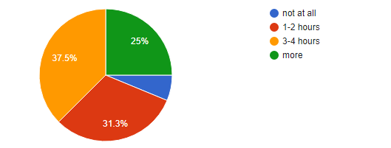

**Analysis**  
From this pie chart we can see that most of the stakeholders play from 3 - 4 hours. Therefore, the game can include more levels and I can make the game longer to finish by adding more traps and slightly increasing the difficulty. This also makes them more experienced in gaming and also shows that they enjoy it, therefore they wouldn’t have trouble using my game.

**Question 3: How difficult should a game be?**

Stakeholder 1: challenging but not frustrating

Stakeholder 2: Enough for you to have to put some effort in but at the same time not be too mind testing to the point where it's annoying

Stakeholder 3: Decently hard.

Stakeholder 4: It must have a lot of different levels, but not till you spend all of your time on it.

Stakeholder 5: Medium.

Stakeholder 6: Between hard and normal

Stakeholder 7: reasonably difficult, challenging enough to make me struggle to complete the level, but still possible to defeat the level.

Stakeholder 8: not so hard

Stakeholder 9: To the point you die 2 times fighting the boss

Stakeholder 10: It should vary according to the player. For example, easy for beginners, medium and hard for people who know about the game.

**Analysis**  
According to the answers provided by the stakeholder, most of them don't want a very hard game that could make them stress more about it. However, they didn't want the game to be too easy, therefore the game should be at a medium level of difficulty to achieve my client requirements. This can be achieved by adding traps.

**Question 4: Do you prefer having in-game lives?**

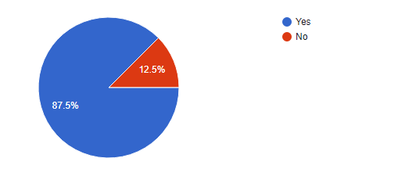

**Analysis**

This pie chart shows that the majority of the stakeholders prefer having in-game lives, however according to the previous questions such as the difficulty and how much they play, my game shouldn't have too many lives to make the game long and easier to complete, on the other hand it shouldn’t have very little amount of lives to make the game end more quicker and more harder. Therefore I will make the character have 4 lives before he dies and the game ends.

**Question 5: What type of sound effects should be added to the game?**

Stakeholder 1: Something that makes the game come off as more vibrant.

Stakeholder 2: Retro sounds

Stakeholder 3: Death soundtracks after you die, sound effects from enemies.

Stakeholder 4: not sure.

Stakeholder 5: Sound of shoots/ being hurt.

Stakeholder 6: Nature sounds like wind and waterfall sounds

Stakeholder 7: sfx, music and boss themes (still a part of music)

Stakeholder 8: All of them, shooting, falling, power, etc.

Stakeholder 9: Guns SFX

Stakeholder 10: when the player dies, they should have a sound effect.

**Analysis**

Overall the stakeholders would like to have interaction sound effects such as when gaining power-ups, dying and while using the powerups. However some also mentioned they want a background sound track such as “Nature sounds like wind and waterfall sounds” or music. This also can make the game feel more enjoyable as you won't just get bored by the animations and the movement of the game.

**Question 6: What do you expect from a 2D game?**

Stakeholder 1: Fun, Fluid and challenging.

Stakeholder 2: To complete several levels.

Stakeholder 3: i expect there be a multitude of enemies and a gorgeous map design

Stakeholder 4: Levels and lives. Different types of enemies.

Stakeholder 5: Good gameplay / good story.

Stakeholder 6: Cool champions.

Stakeholder 7: combat and action.

Stakeholder 8: A fun game, which has a good game point.

Stakeholder 9: smooth gameplay.

Stakeholder 10: To Be fun.

**Analysis**

This question helped me understand what my target audience really want my game to include, and according to the answers, some said they want a smooth gameplay, different types of enemies and they want it to be fun. I will make sure that my game contains all the features that the stakeholders want in-game, and as smooth as possible by adding animations and having the movement speed synced with the opposite direction.

**Question 7: What kind of maps do you prefer?**

## 

**Analysis**

This pie chart shows the preference of the map style, and as shown most of the stakeholders preferes having a dark theme. This can be achieved by making the sky black as it would be if it's night time.

## 

## 

## 

## 

## 

## 

## Research - Existing solutions

### Super mario bros

Super mario bros is the game where my game Idea/concept was inspired from. This game is a 2D platform game made in 1983 by Nintendo.

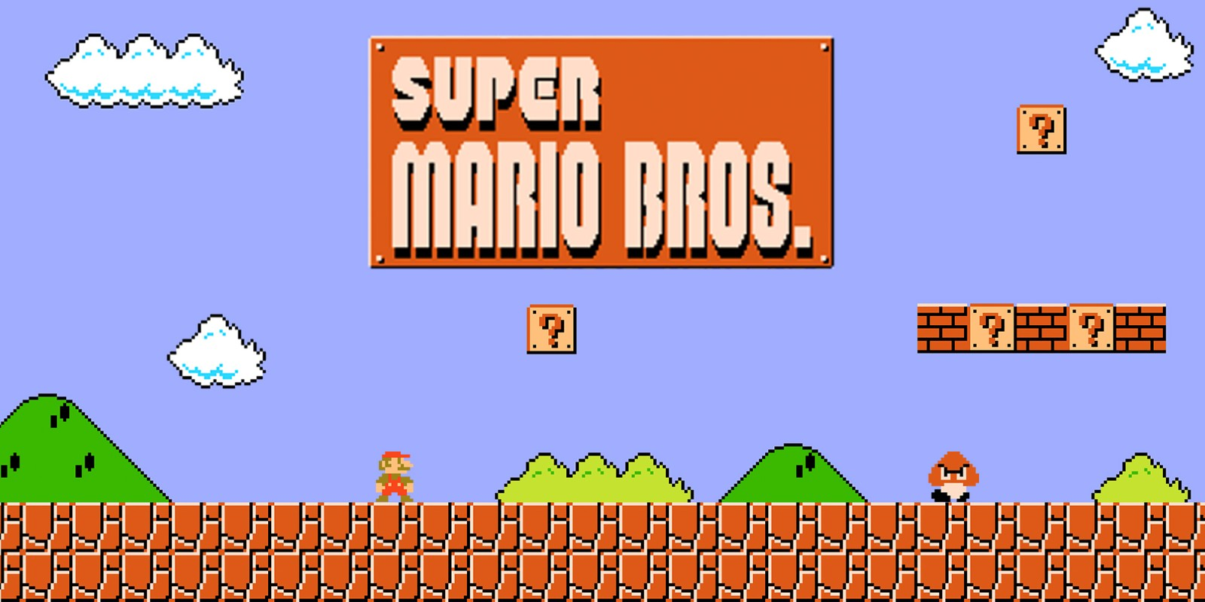

**Welcome screen**

In Super mario bros the player will need to complete the level by reaching the other end of the map, defeating enemies and collecting power ups in the way as well as avoiding holes.

The design of the game makes every bit of the game clear to see such as the enemies, blocks, characters as well as the background (sky, clouds, hills).

Once the game is launched this would be the welcome screen and it waits for the user input (arrow keys to move the character “mario”) to start the game.

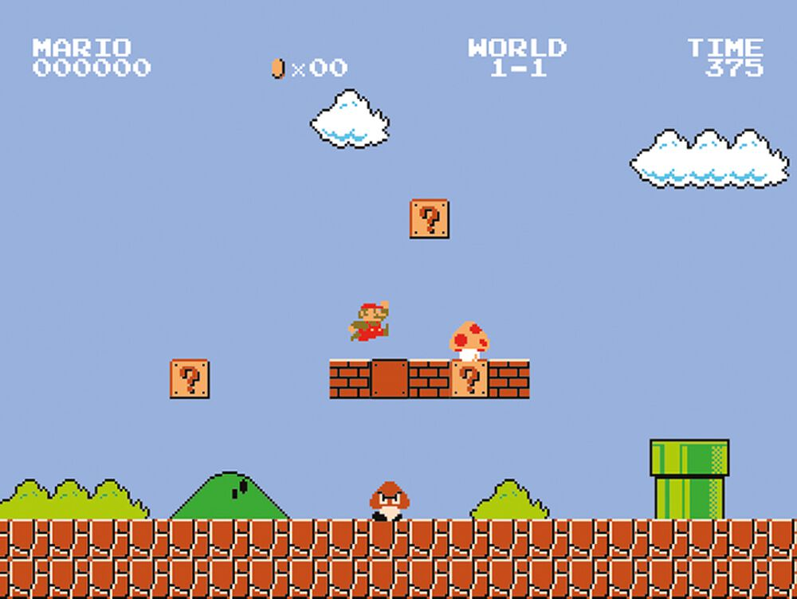

**Mechanics**

Once the game starts the world number and the level number will be displayed at the top so that the player would know at which stage of the game he is. In addition the time, score and coins are displayed in the top corners so that the player can keep track of his progress.

As the player hits the golden block from the bottom a mushroom appears and starts moving, the player will then need to reach it to gain a growth power up which will make him more powerful and acts like a one time shield to the enemies.

My game will have similar features to this as it will include powerups and the score will be displayed to the player. However I will not include a timer in the game to give the players more freedom on how fast they want to finish the level and not make them just rush it. I will also make the same method of gaining a powerup but add more power ups and more methods to get them.

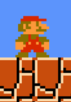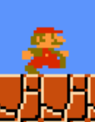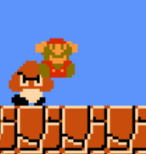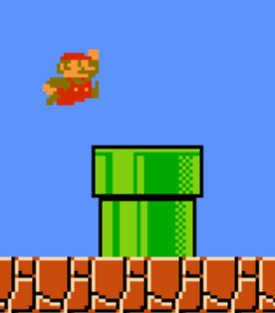

**Character animations**

Super mario bros also includes character animations such as when he is walking, standing still, jumping or dying. The use of the animation made the game feel more smoother and closer to reality as the character is responding to the user inputs and reacting to the surroundings.

I will be using this in my game to give a smooth gameplay, and not only that. This will also make the game look much better as it wouldn't just be plain pictures just moving around, but it would have animations according to each action.m

### 

**Points gathering**

Mario allows the user to gain points through multiple ways, such as killing enemies, breaking certain blocks or finishing the level. The amount of points earned differs from each method.

I will be using this concept in my game so that the player can repeat the game trying to get higher points and break his record, which therefore will make the game more enjoyable and creates a small challenge for the players.

### Cat mario

Cat mario is the game designed to make super mario bros harder by adding more traps and changing the speed of the player as well as the gravity. This game was released in 2007 and is available to play for free on browsers.

**Traps**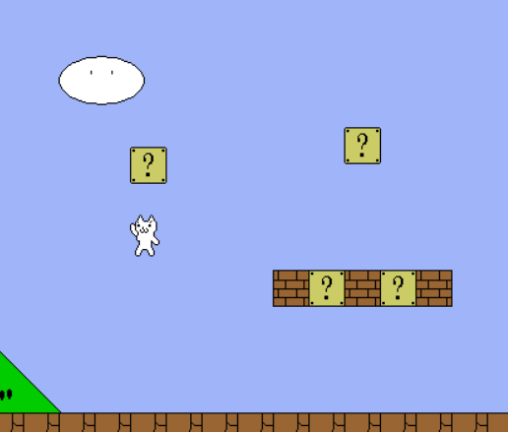

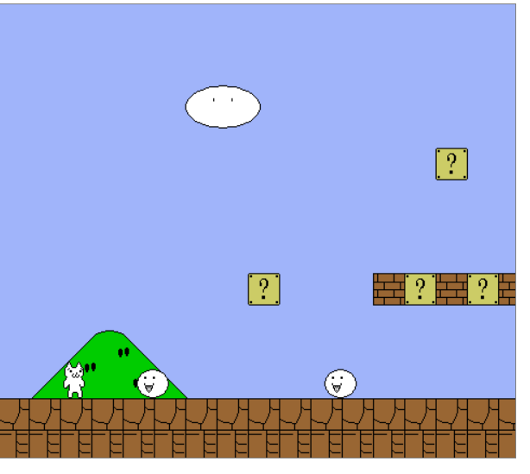

Cat mario has a lot of different unexpected traps, some that can kill while the other are meant for fun, for example when the player tries to reach the golden block (in super mario bros its used to gain a powerup) the block will move up away from the player making it unreachable.

Another example that can make the player die in the game, is there is a floor that will disappear once the player steps on it.

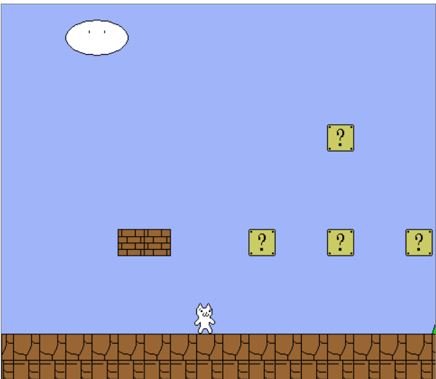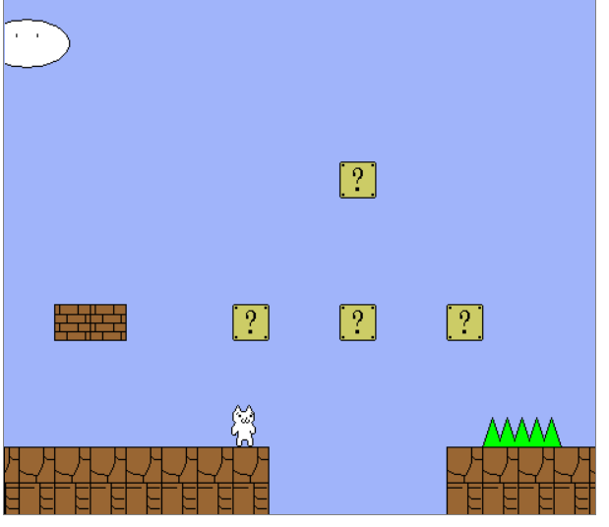

In my game I will include traps like those in cat mario, however in cat mario the traps are overused and make the player more stressed rather than it being a stress reliever, therefore I will include less traps in my game. Furthermore the way the cat moves is different to super mario bros as there is more gravity coming down than going up, and this also increases the difficulty of the game. I will make sure that the speed the player goes up is the same as the speed the player comes down.

**In-game lives**

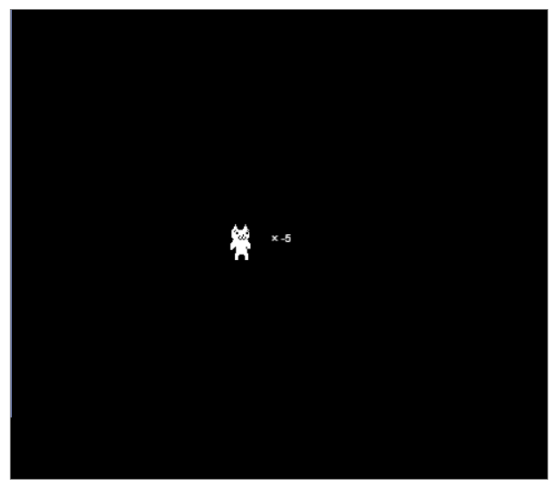

Cat mario also has a lives system, however the lives are unlimited as they start from 2 and go down to negative numbers. This makes the game more easier considering the amount of traps are in this game. However my stakeholders preferred to have in-game lives therefore I would not include this feature in my game, but I will include a lives system where when it reaches 0 the game will end.

**Game design**

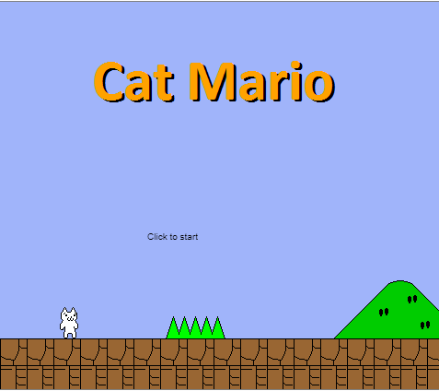

Cat mario has a simple design with simple graphics, this makes the game suitable for computers, will lower specs and run smoother. Since I am using Pygame which won't allow me to use high tech designs I will be using a similar way as cat mario using lower graphics which for instance can be made on paint and imported to the game. However the map will be dark themed as my client audience wanted so.

### Super Smash Bros Ultimate

Super smash bros Ultimate is a fighting game that allows the player to select a character from a huge number of different characters to use in a fight. It also has different combos with many items and power ups that keep spawning during the gameplay. It was first released on 7 December 2018 and ever since it's been only available for the Nintendo switch.

**Character selection**

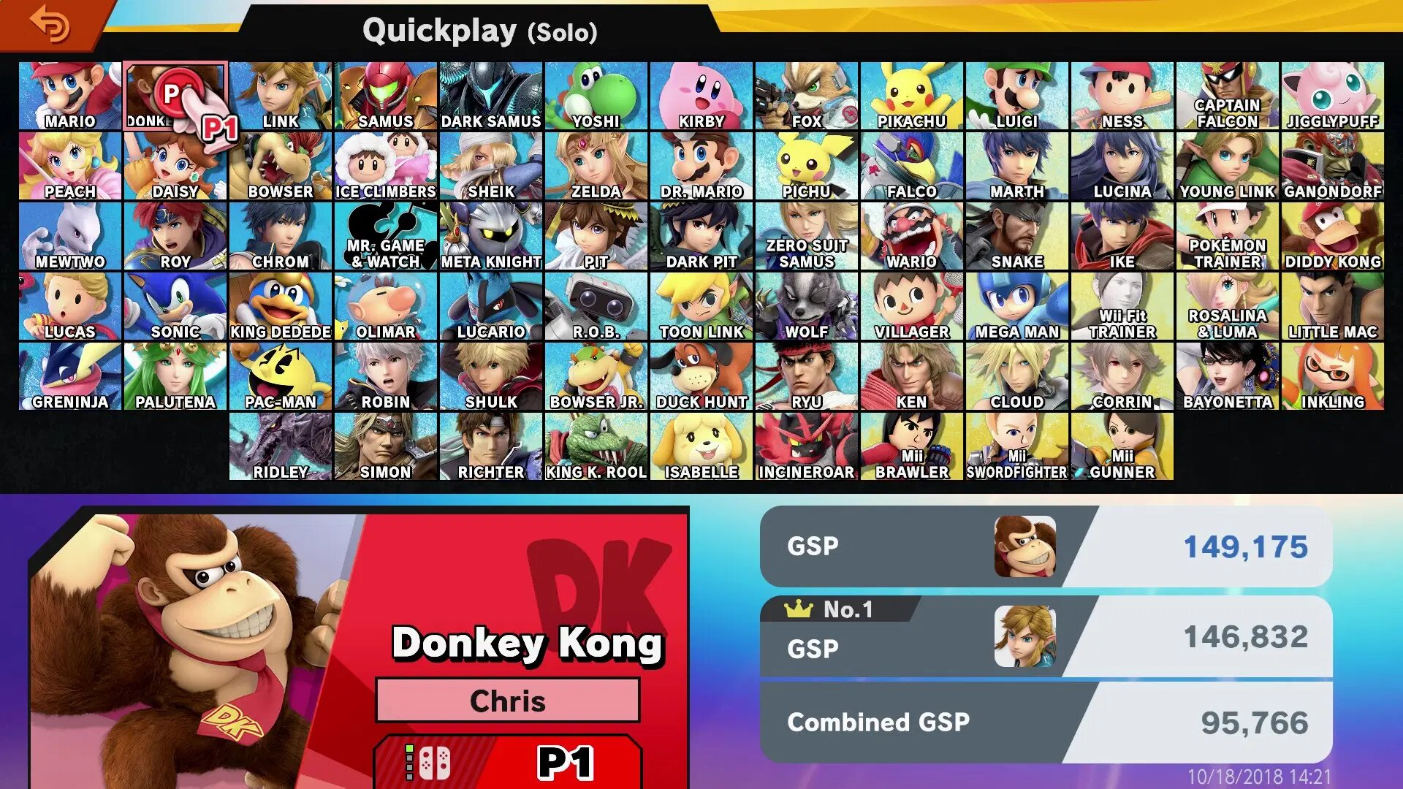

Super Smash Bros Ultimate has a character selection screen with over 80 different characters that the player can select to use in the battle. The game has a wide variety of choices making it targeted at a wider target audience, it has characters for young people and some for older, furthermore it has many characters with different genders, and different types like humans, animals, robots and many other types.

I will be adding this feature to my game since it's aimed for both males and females where some of them might want to use different characters, this will also make the game more appealing to both genders as they can get to play with the character that matches their gender.

**Game power-ups**

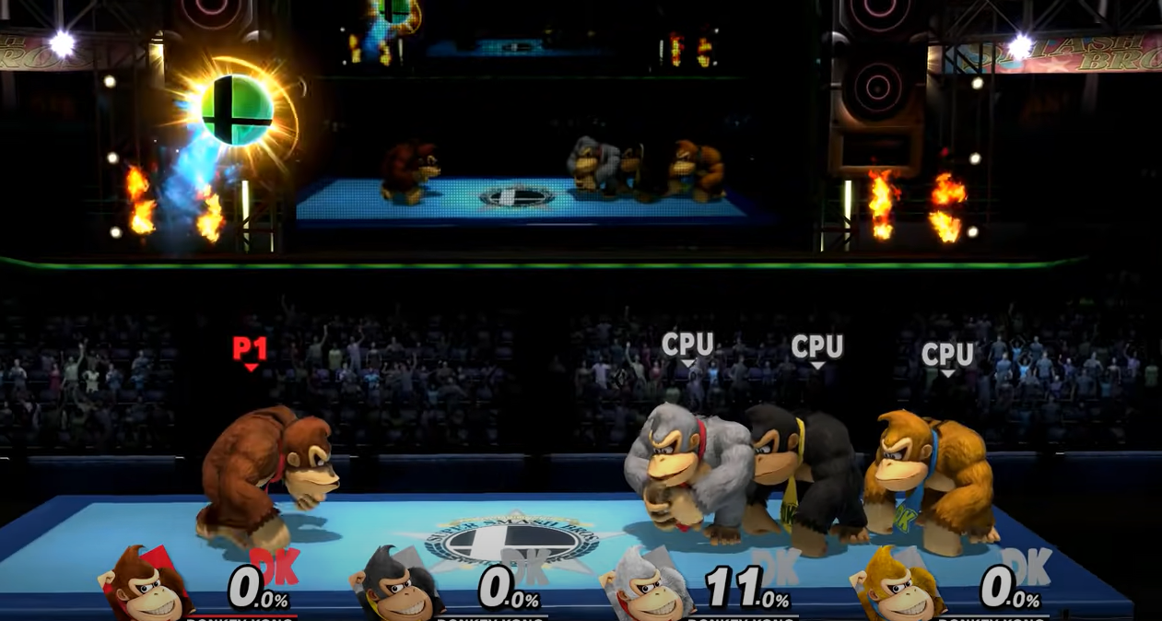

The super smash bros ultimate has power ups that spawn during the gameplay, these powerups are in a spherical shaped ball and floats on the map, once the player breaks it he will gain a special power that deals extra damage to the rest of the players. Every character in the game has their own special powerup and each differs from each other dealing different amounts of damage.

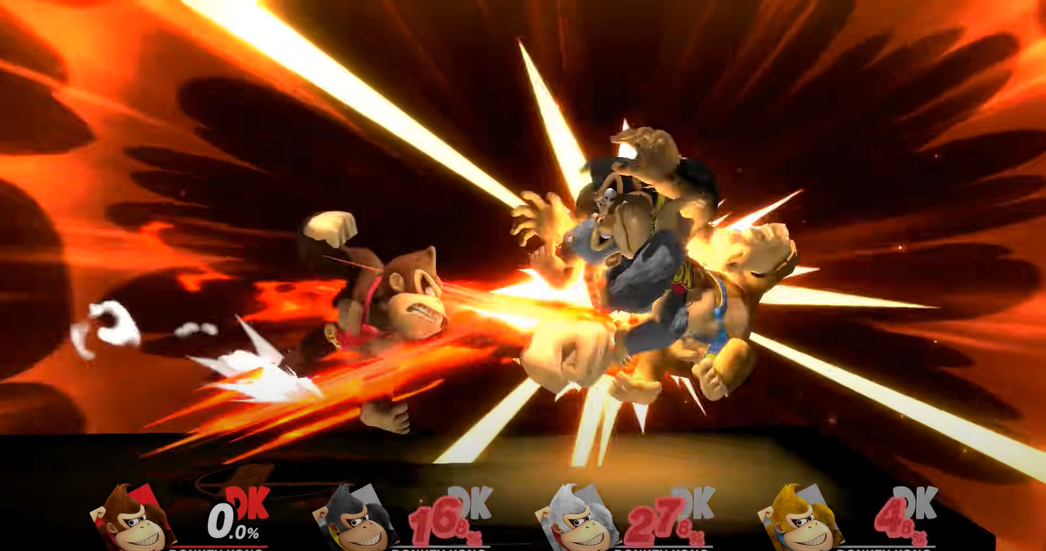

I will be adding this feature to my game however the powerups will differ from each other unlike this game where it's the same power up but differs depending on the character selected. In my game I wouldn’t make the user need to break it to gain it but just collide with it and it will be assigned to him.

## Limitations

When making my game I won't be able to make it as good as I want it to be due to some limitations.

Time is a key factor in this project, some of my stakeholders wanted my game to have levels, but considering that I am designing and coding the game byself in a short period of time, I wouldn't have all levels completed by then.

In order to make my game as smooth as I want it to be, and include some new features, I would need to make my code as efficient as possible. I also need to learn how to code certain features to create new ones. However, based on the little knowledge I have, I might not include every single feature in my program .

Once my game has been completed, it wouldn’t get noticed by a lot of people as I don't have a big audience or a link with a games company to help share the game with more people and make them play it more.

Furthermore I won't be able to afford to pay for existing engines to implement in my game such as a physics engine, therefore my game will be less close to the real world in animation and movement wise.

Moreover, I need to acknowledge people with certain disabilities or needs, such as people with visual impairment to minimise their struggle to play the game, i would be using clear text fonts that are easy to read, in addition I need to take Ambidextrous people into account as they might have a missing hand which might make controlling the game harder for them, therefore I will make sure that the keybinds will be close to each other and less inputs as possible making it possible to play comfortably with one hand.

My game wouldn’t be running on a special software that can help monitor it such as a launcher, I wouldn’t also be able to access high end softwares that can model and simulate the game as they are expensive to buy, and it would require me to have better hardware such as a GPU, CPU and more RAM to make the rendering process faster. Furthermore my client will also need a more powerful computer to run and render the game if I used such software to make the game.

Lastly I will be using Pygame and Python to code my game, therefore I wouldn't be able to use advanced methods such high graphical images or use smart AI, unlike other programming languages that are dedicated for making games, furthermore Python can be a time limitation as its process speed is low compared to game engines, during the gameplay there might be a lot of concurrent process happening at the same time which might be too much for python to handle therefore it will cause the game to run slower. Moreover this will make the game only available to play on one single platform which is a computer if python and pygame are installed.

## Features to consider

|  |  |  |
| --- | --- | --- |
| Game | Features | Reason |
| Super Mario bros | Points system | As each game has a track of how well a player did, super mario bros has a feature where the player gets points after accomplishing certain tasks such as completing the level or collecting coins. These points add up and are always displayed on the top of the screen. I will be using this feature so that my user can always keep track of his score and perhaps try to beat his score each time he plays the game. |
| Map layout | Super Mario Bros has a simple well known map, therefore I will use this format in my game as the majority will be familiar with it. |
| Character movement | I will make sure that my game has the smoothest gameplay possible, and I can achieve this by making the character opposite direction speed the same. This method is also seen in mario where each direction has the same movement speed as the opposite direction. |
| Cat mario | Traps | Cat mario is known for having many traps that make the game more enjoyable however cat mario included too many that it made its user rage and stress more, so I will add this feature but wont add it until it makes the game less enjoyable. |
| In-game lives | The cat mario game has an unlimited live system, however since my audience preferred to have a certain amount of lives, i won't be making it unlimited to match their needs. |
| Game design | I will be using pygame to code my game rather than an engine so having a simple design will make the processing speed faster, also it will make the user able to play the game on computers with low specs. |
| Super smash bros ultimate | Character selection screen | Since my game is aimed for both genders and I want to make the user pick a choice of using a female or a male character, this feature will allow the user to achieve so. |
| Powerups | This game has power ups that can be used where it would allow the user to deal extra damage to the opponent. I will be adding this feature to my game and adding different power ups that can be stacked up and used to kill the enemies and complete the map. This will also make the game more enjoyable as it won't be the same character that can only move to just finish the game but it would create different ways to complete the maps. |

## Hardware and software

|  |  |  |
| --- | --- | --- |
|  | | Justification |
| Hardware | Monitor  At least 60Hz | A display to allow the user to see what he is doing. I recommend that the user has at least 60Hz to be able to run the game at the maximum of 60fps which will be enough for the game and wouldn't require high end hardware. |
| Keyboard | To enter the characters, it can also be used to control the player in the game. |
| Mouse | To be able to launch the game and move the cursor to access different apps. My game also requires mouse input to switch between screens and to control the sound (mute/unmute) |
| Secondary storage  At least 500GB HDD | To store the game’s files and data so the user can save his progress and run the game. The reason that I chose at least 500GB is so that the user can store other essential programs, operating systems and have enough space for my game. |
| Operating system  At least windows 7 | To provide the user with an interface so he can run the game. Windows 7 is the oldest windows version that can run the latest version of pygame. |
| Speakers/headphones | So that the user can hear the music game and the sound effects |
| RAM  At least 4GB | The game will need primary storage to hold its data, while it's running. Having more RAM will ensure that it won't get overloaded causing the game to run slower or crash. |
| CPU  At least 1.5GHz | The CPU provides all the processing power therefore this is needed to run the code. Having less than 1.5 GHz can cause the game to stutter and make it unplayable. As the cpu will fetch, decode and execute the program. Having a slow CPU can make the execution time very slow and the FPS (frame per second) low. |
| GPU  At least GT 710 or integrated Intel 630 | A graphics processor unit will be need to render some parts of the game, however my game will be running on python therefore it does not include 3d or high high texture objects thus it wouldn't require much processing power so it would work on low specs GPU to run the game |
| Software | Pygame latest version | Pygame has a big library of computer graphics and sounds, this will allow the game to be written in python creating a GUI to display the game |
| Python latest version | So that the computer can translate the code and run it to launch the game. Having the latest version of python will ensure that the game will run as the liberties and functions will be up to date. |

## Success Criteria

|  |  |  |
| --- | --- | --- |
| Requirement | Success criteria | Justification |
| 1. The game must have audio | 1.The game must have a music track | In order to make the game more interesting, enjoyable and give out a great experience, music will be needed as it will make the user focus more. Furthermore, it can control the emotions as well as creating a tone for the game. |
| 2.The game must have sound effect | To make the game as enjoyable as possible. Also, according to the questionnaire all of my clients were suggesting sound effects and none of them said “none”. Sound effects are also important as they emphasise what's on the screen, making it an entertaining experience and helps deliver the information. |
| 3. The user should be able to turn on/off the music | Since not every person likes gaming with music or they might not like the music used I will be giving them the option to turn it on/off for convenience |
| 2. The Character must have in game lives | 1. The game should display a full health once as soon as it starts | According to my questionnaire I made my client prefered to have an in-game life so therefore I will be adding this to the game to meet their requirements. I’ve chosen that they will start with 4 lives so to make the game at a medium level |
| 2. The game should have mobs | Adding mobs allows the player to gain points and at the same makes him lose lives if the player fails to kill the mob then it will result in him losing heath/powerup if he had any |
| 3. The game should have traps | Traps will make the game more enjoyable creating new challenges, and causing the player to lose lives |
| 4. The player should lose lives if they collide with a trap or a mob | Since there will be mobs and traps their whole purpose is to make it challenging for the player to complete the level, therefore they should deal damage to the user otherwise their purpose is useless. |
| 5. The level should end when the player runs out of lives | The whole purpose of adding in-game lives to the game is so that when the player runs out of them he must restart the level from the beginning to make it a bit difficult. |
| 3. There must be a user interface | 1. User interface must be clear | My target market is people aged between 15-19 years old, therefore they will need an easy and simple interface to not struggle to start the game. |
| 2. Some screens require a mouse input | The game won't just require a keyboard input, it will need a mouse too as some screens will have interactive buttons that need to be clicked |
| 3. The game needs a keyboard to control the player | In order to play the game a keyboard is needed to move around the characters e.g. using the WASD keys, and it's also needed to pause the game and use other power ups |
| 4. The game must have the option to pick characters | My game is aimed for both males and females, therefore this will allow them to pick which gender they wish to play. |
| 4. The game must be responsive | 1. The game must have animations | In order to make the game not boring i’ll be adding some animations so it would look smoother such as the character will look in the direction he is moving to |
| 2. The map must update depending on the player location | To make the game playable the map must respond to the player and display where the player is, furthermore according to the questionnaire the majority of my target audience preferred that the map will be dark themed so I will make sure this will meet their requirements. |
| 5. The game should be at a medium level of difficulty | 1. The game must have power ups | To make the game more enjoyable, i’ll be adding power ups so that the map can be finished in different ways |
| 2. There must be a score system | In order for the game to be enjoyable and to make it a bit competitive so that it will make the player try to beat his score every time he plays the game. |

# Section 2 - Design

## Development method

My game will be made using OOP, this will allow me to make classes which act like a blueprint for certain objects, inherit them to other objects, which would save time re-coding every single line. Due to the limited time I have, I will be using the RAD model (Rapid Application Development) which is to keep referring back to my clients and make sure that my game achieves the requirements as much as possible even if it isn't fully finished on time.

## Class diagram

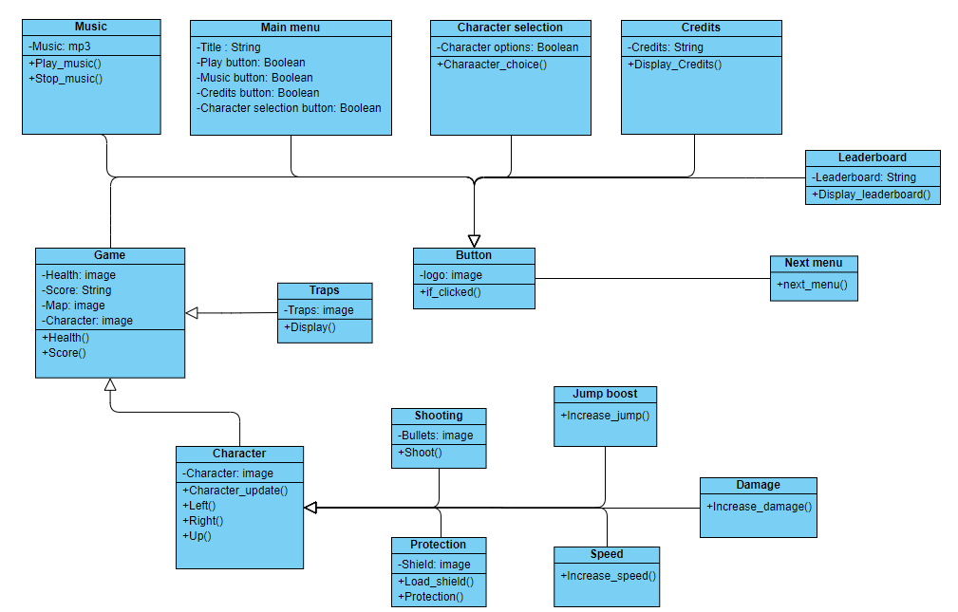

I’ve made a class diagram for my game showing all the methods that I will be aiming to use.

**Main menu:** the main menu class will include texts which will be stored as strings, and some buttons which will be in a boolean data type (either true or false), this class also inherits “Button” class as it checks whether a button is pressed and loads the next menu

**Character selection:** This menu will contain the characters that can be selected and waits for the user to click on when, it also inherits “button” class to be able to load the next menu after the user has made his choice.

**Credits:** This menu only has the credits text which is stored as a string, however it also inherits the “button” class for it to load the next menu

**Music:** Holds all the music methods (play and pause), it checks whether the button has been pressed through the use of the “button” class which was inherited

**Quit:** The quit menu will be simple, as it will wait only for the user input to click “yes” to close the game, and it will inherit the “button” so that it can tell when it has been clicked.

**Game**: this class will load the necessary elements for the game such as, health, score and map. It also loads the Character which it inherits from “character” class and the traps that are inherited from “traps” class. Furthermore it also inherits the “button” class so that the user is still able to press buttons, for example the mute button.

**Character:** This class stores everything related to the character, the image and the movement.

**Shooting/Speed/protection/Damage/Jump boost:** All of these classes have their own different methods and attributes that make the character have power ups, also all of these classes will inherit “Character” as they will all need the same mechanics to be able to be used.

**Leaderboard:** This class will be called when the “leaderboard” button is clicked, it inherits button class for it to do so, it will display the score of the players that previously played the game before.

### How subroutines will run together

**if_clicked():** this will check whether a button has been clicked, if so then it will pass on to **next_menu()** that will run the next menu/function.

**Display_Credits():** if the user accessed the Credits screen this subroutine will run loading all the text about involving the credits and display them on the screen until **if_clicked** is true to load the next menu.

**Character_Choice():** This subroutine will store the player choice so that it can be passed on to the game class to load the character.

**Display():** This will display any object, in my game for example it will display the traps when it has been triggered.

**Music:** the music subroutine will allow the music to be played and paused, it has the **play_music()** and **stop_music()** functions that can be triggered when the user clicks on the mute button which is detected by **if_clicked()**

**Health():** This subroutine keeps track of the player health and decreases/increases it depending on the player’s action (earned a powerup or took damage), it will also check if the health == 0 to see whether to end the game or not.

**Score:** here this subroutine will keep track of the players point which is gained by killing some mobs or completing a level and resets each time the game restarts

**Character_update():** This subroutine will be used to make the game smooth as it will keep updating the character to face the direction he is going, all of these depend on the user’s input **Left(), Right()** and **Up()**.

### Pseudocode and flowcharts

**Music**

Music()

Clicked = False

While Clicked == False:

song = MusicTrack("Music.mp3")

play(song)

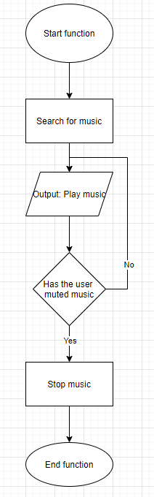

The music subroutine will allow the user to be able to mute or play the music whenever he wants through clicking the button. The music will be playing until the user decides to mute it.

**Main menu**

Main_menu()

DisplayBackground (image)  
 Clicked_1 = False  
 If Clicked_1 == True:

Next_menu()

music()

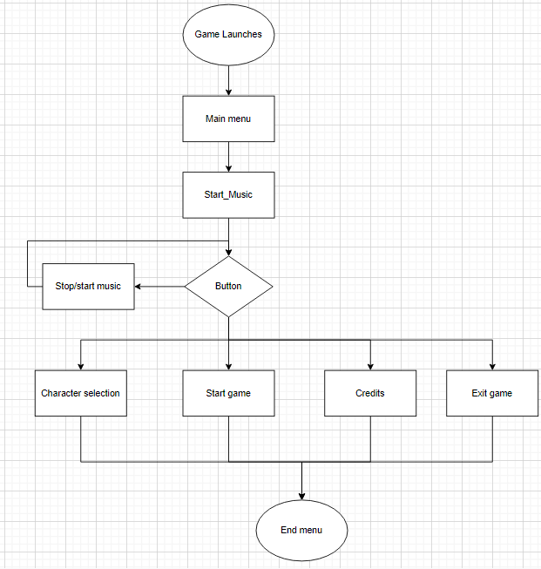

I’ve made a flowchart for the main menu when the game launches, firstly the music will load, then the user will be able to make decisions by clicking many buttons, when the audio button is clicked it mutes/plays the music and loops back to the decisions waiting for another decision to be made. Once the player clicks one of the options (start game, credits, character selection or Exit game) their own function will be loaded and the current function will end.

**Character selection screen**

Character_selection()

DisplayBackground(image)

Option1 = Character1.rect()

Option2 = Character2.rect()

If choice == Option 1:

Character = character1

Else:

Character = character2

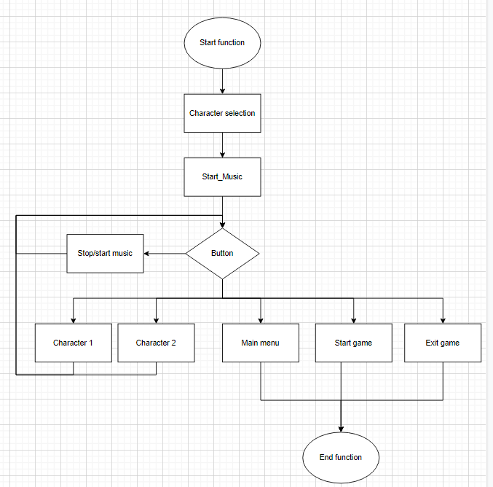

Once the player is in the character selection screen they will have the option to pick a character, if they click a character it will keep looping back to the decision until another button is clicked (main menu, start game or exit game) to start the next function.

#### 

**Quitting the game**

quit()

Clicked == false

yes = Choice_yes.rect()

No = Choice_no.rect()

If choice == yes:

End program()

Else:

previous_function()

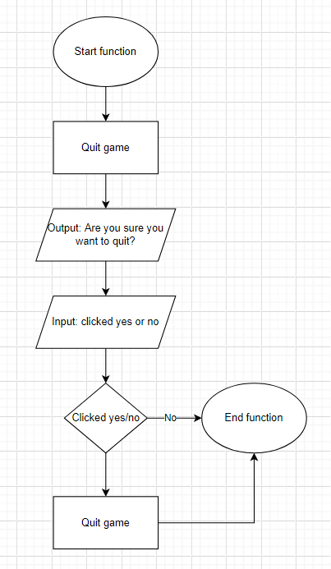

Once the player clicks the “quit” a message will pop up asking for a confirmation that the user really wants to quit in case it was pressed by mistake, if the user clicks yes then the game will be closed. If the user clicked on the quit function it will get closed returning to the previous funcion it was in.

**Credits screen**

Credits()

credits.rect(text)

Clicked = False

If clicked == True:

main_menu()

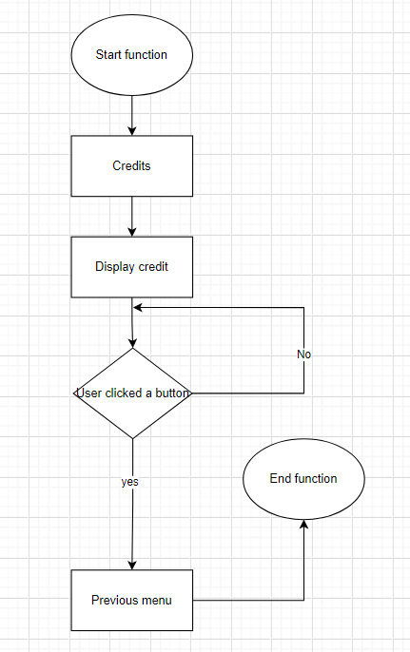

Once the user clicks on the credits button, the credits will appear then the program will wait until the user presses the button to exit back to the main menu.

#### 

**Traps**

Traps()

Collision = False

If collision == True:

Display_Traps()

Health = health - damage

Update_health()

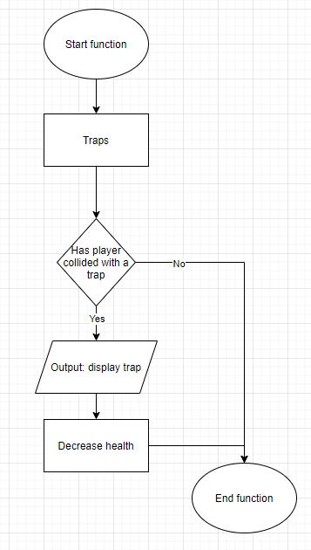

During the gameplay the player will collide with invisible traps. Once this occurs the trap will be displayed and visible to the user and the health will be updated decreasing it by a certain amount.

**Character**

Character:

Valid = False

While Valid == False  
 Input = enter key

If input == “W” or “S” or “A” or “D”:

UpdateCharacter

Move character

Valid = True

Elseif input == SpaceBar

Gained_powerup = False

If Gained_powerup == True:

Shooting.powerup()

UpdateCharacter

Valid = True

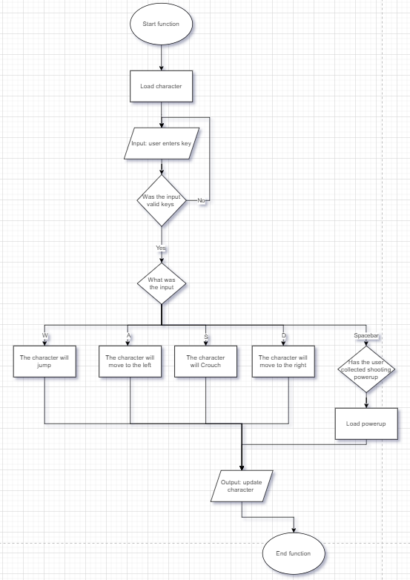

When the game starts the Character function will be called in, it will check for input validation and make sure that the user inputs keys that make a change in the game otherwise it will keep waiting for a valid key. Depending on the input the program will have different outputs, i.e “w” to jump and “s” to crouch. It will then update the character by changing the image and make him/her face the direction of movement. Furthermore if the input was “spacebar” a further validation will be needed to check whether the user has gained the required powerup to use this key.

**Gameplay**

game()

DisplayMap(image)

DisplayCharacter(image)

DisplayScore()

Display player_health()

Character()

Enemy_killed = False

Coins_gained = Flase

If Enemy_killed == True or Coins_gained == True:

Score = score + score_gained

powerUp.item = False

If powerUp.item = True:

powerUp()

Traps()

If health == 0:

text.rect(game over)

end function

Level_complete = False

If level_complete = True:

text.rect(level completed)

end function

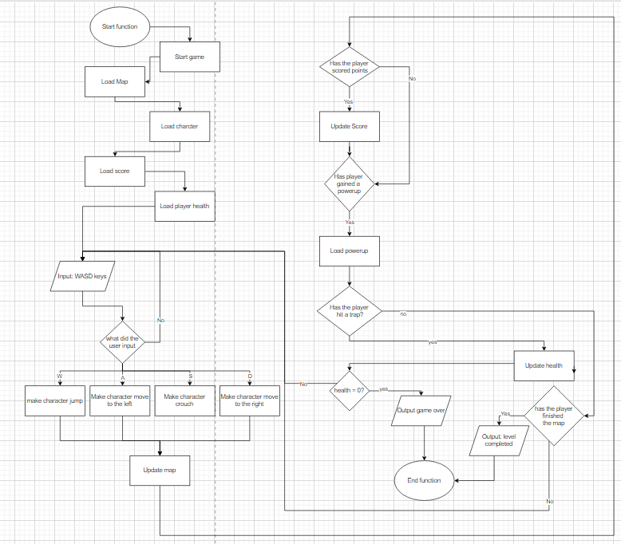

Once the game starts the map, character, score and player health will load in first and be displayed to the player, then the game will wait for the user input using the (WASD keys), depending on the key pressed the character move in that direction, the game will also check of the character gain a point, interfered with a trap and it will update each, it will then check if the player gained any power ups and apply it to the character. Furthermore it will check if the character lost all their lives so it can end the game outputting “game over” messages and ending the gameplay function, otherwise it will keep waiting for the user input until he completes the level and outputs “level completed” and loads the next level that would go through the same process.

### Data structures

|  |  |  |  |
| --- | --- | --- | --- |
| Variable | Type of data structure | What it stores | Why it's needed |
| Final_score | 2D Array | Stores the user name and hes score in a file | So that the user can see his previous scores and tries to beat it each time he plays the game |
| Powerups | Stack | The powerups gained by the player | The player can have multiple power ups at once |
| Power Ups list | Array | All the powerups in the game | Once the game is loaded it will load the power ups from this list to be included in the game |
| Mobs list | Array | All the different types of mobs in the game | So that the game would know which types of mods can be included in game |
| Characters | image | Stores the picture of the character jumping/moving up | One of my requirements is to make the look smooth as possible, having the character change when he jumps will help achieve this |
| Mobs | image | Images of the mobs that can be in the game | So that the program can load them into the game and passed to the mob list. |
| Health | image | Image of the health bar | To show the player how many lives he has before he loses and the game ends. |
| Score | string | Player current score | So that the player can keep track of this score, and the score will keep adding up whenever they gain points |
| Character chosen | String | The chosen character by the player | So that the game will load in the character the player wants to play with |
| Lives | Integer | Keeps count of the health | When the lives reach 0 the game should end |
| Music button | Bloean | Whether the user clicked it | If the music button is clicked its should stop/start playing it |

## Input and process and output table

|  |  |  |  |
| --- | --- | --- | --- |
| Requirement/ criteria number | Input | Process | Output |
| 1.1 | None | The game should search for the soundtrack. | Plays the music when the game is launched |
| 1.2 | None | The game should identify when the user interacts/collides with an object | Plays sound effect |
| 1.3 | User clicks on the mute button | Loads the Music function | plays/stops music |
| 2.1 | None | The player must have his health displayed | Display the health |
| 2.2 | None | Spawn mobs | Display mobs |
| 2.3 | None | Detect when a player collides with a trap | Display trap |
| 2.4 | None | Detects when a player collides with a mob or a trap and update (decrease the health) | Display the new health |
| 2.5 | None | Checks if the player has any more health/live | Print “game over” and end the game |
| 3.2 | User clicks | Checks what the user clicks and loads the menu that's needed | Next menu |
| 3.3 | “W” key | Make the character jump and load the jump image for the character | Character jumping and load sound effect |
| 3.3 | “A” key | Make the character move to the left and load the image of the character going to the left | Character moving to the left |
| 3.3 | “D” key | Make the character move to the right and load the image of the character moving to the right | Character moving to the right |
| 3.3 | “Space bar” | Checks if the players has a powerup if so it would load its function | Powerup features |
| 3.3 | “P” | Loads the pause function | Pause menu |
| 3.4 | User input (mouse) | Detects which character the player selected | Displays the character |
| 4.2 | None | Tracks the player on the map and updates the map camera | Map |
| 5.1 | None | Detects when a player gained a powerup and loads its function | Display the powerup |
| 5.2 | None | Adds up the points gained by the player | score |

## stored data, format and where it will be stored

In order to make a game some files will be stored so that it can be read from, I will be storing files such as: Characters images, Mobs images, maps for different levels and Power Ups in secondary storage, this is because secondary storage is non-volatile therefore the data is not lost when the computer turns off.

## GUI designs

**Main menu screen design**

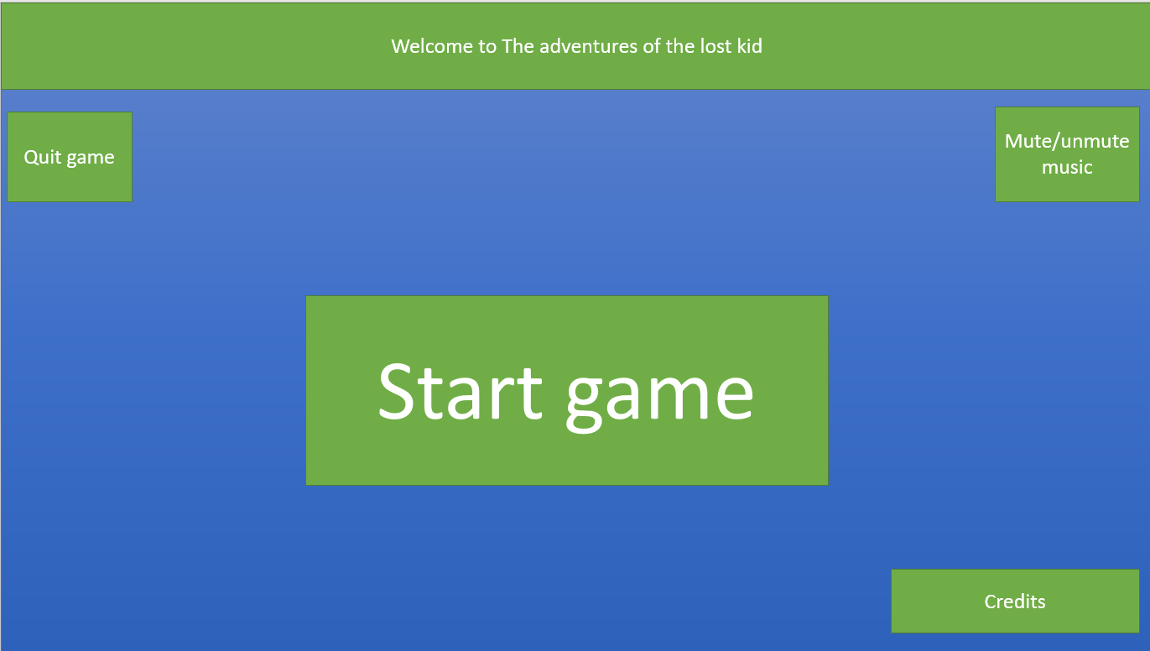

I’ve made a screen design for my game so that it would be easier to code it as I already have an idea how it might look. The start game button will be clear in the middle so that the user can clearly see it. On the bottom right the user will be able to access the credits page. At the top of the screen there will be a nice welcome to the game. In addition the main menu screen will have two extra buttons on each top corner, one to mute the music and the other to quit the game. I chose to use this design as the menu would include all the menus/screen with a simple and a clear layout which is inspired from some research i did where most games have their buttons on the corners of the screen, and the button to start at the centre I decided to keep this layout so that the user is familiar with the menu and knows how to use it.

**Character selection screen design**

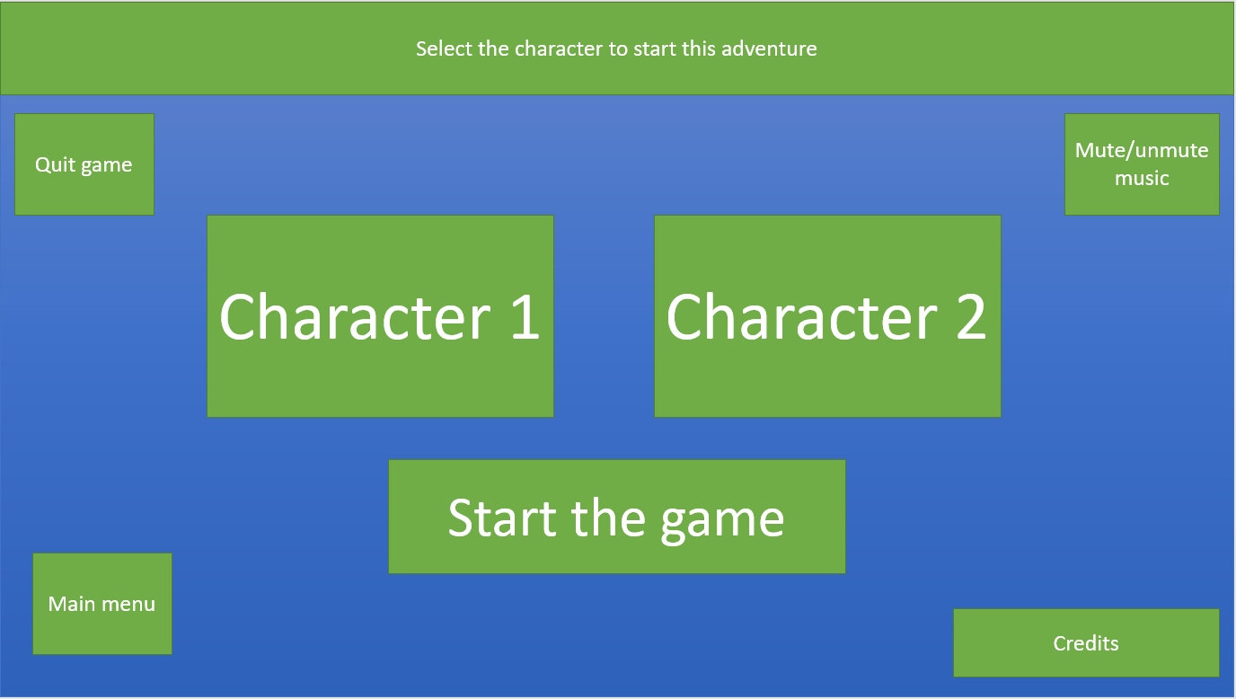

In the character selection screen, to make everything as simple as possible for my target audience I will be keeping the same buttons from the main menu. This screen will differ from the main menu screen as it will have 3 extra buttons, the two different characters will be displayed so one of them can get selected, the player will be able to go back to the main menu by clicking the main menu button which is found on the bottom left. To avoid confusion for my target audience, I gave them instruction for what the screen is for (found on top of the screen)

**Gameplay screen design**

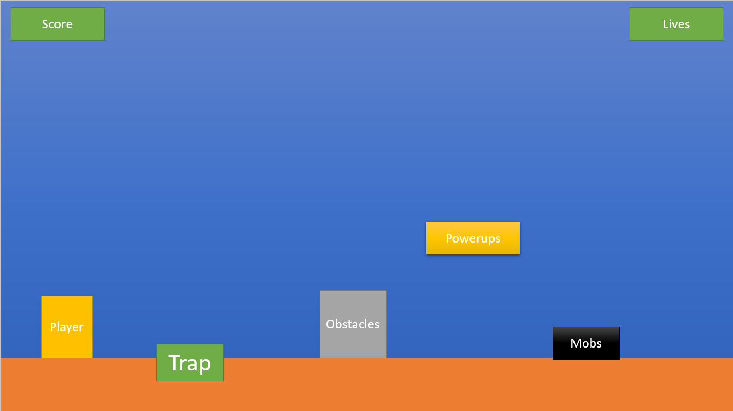

The gameplay will have many different functions in it, the character will be displayed on the map and will be able to move across the map. The trap will be invisible until the player hits the trap. Furthermore there will be moving mobs that can decrease the players' health which is seen on the top right while the points are displayed on the top left. In addition there will be obstacles to make the player movement a bit harder, and the powerups will be accessed from different places such as breaking blocks. The choice of this design is inspired by the game Mario, and since its a well-known game I decided to use its layout so that most of my client audience aren't struggling to understand what's going on while playing the game, furthermore each component in the game is spaced out to give the user more movement space and not make the game very hard and match my client requirement (medium difficulty)

**Credits screen design**

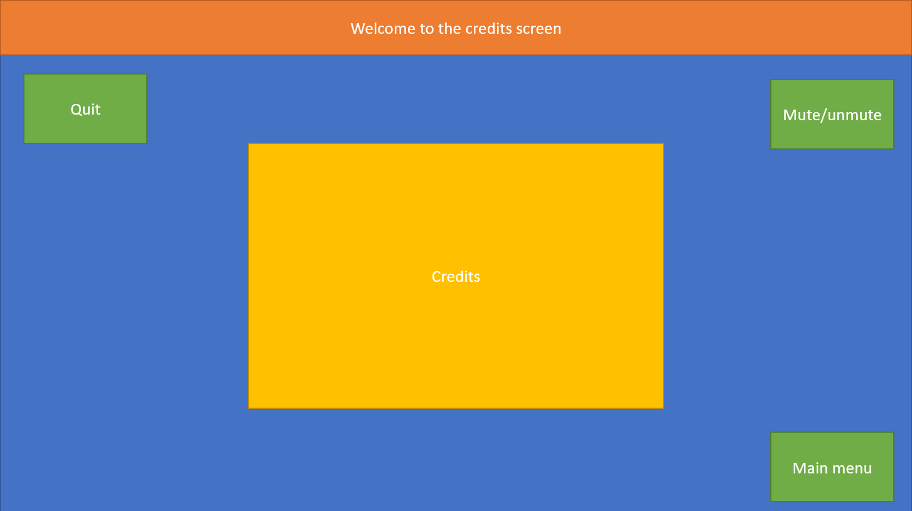

Once the player clicks on the Credits screen, the credits will be shown centered in the middle. The user will be able to return to the main menu to start the game through using the bottom right button “Main menu” and as in the previous screen this screen will be similar having the mute music buttons on each top side of the screen keeping the same layout to achieve simplicity for the user. Lastly the screen will have a title telling the user what the screen is for. “Welcome to the credits screen” which will be found on the top of the page.

**Quit screen design**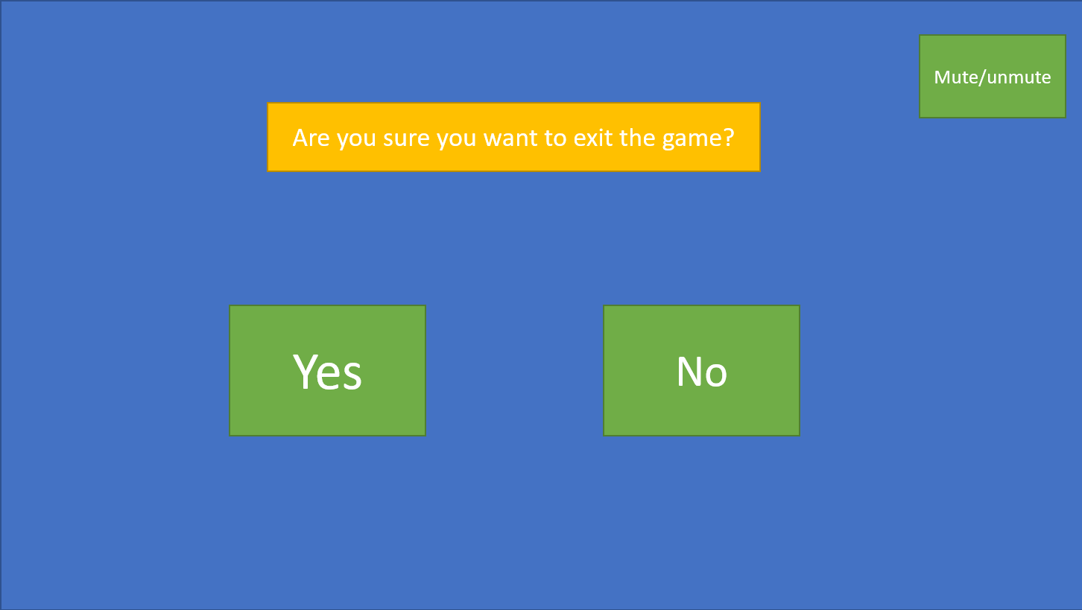

The quit screen will be very simple, a text will appear at the top middle of the screen asking for the user’s confirmation to leave the game. The user will then respond by either clicking the “yes” or “no'' buttons. In addition, following the same layout as the other screens, the mute button will be on the top right so that the user can mute it at any time. This is so that the user does not leave the game by accident and lose their progress of the game, which might cause them to stress even more which would defeat the purpose of the game (act as a stress reliever and make students enjoy their time)

## Validation

Since my game will require user inputs some validations will be needed to make sure that every input is valid, I will be validating the followings:

**Username input:** When the game ends or the player runs out of lives a screen will pop up asking the user to enter their username so that it can be added to the leaderboard storing the points they have gained.

**Buttons clicked:** I will be making sure that the mouse must be hovering over the button within its area for it to be clicked, this is so that it won't get triggered when the user clicks on a random place in the game that's far from the actual button.

**Length check username:**  I need to make sure that there is at least a certain number of characters entered so that the score wont be stored under a very short name that can possibly just be a letter.

**Presence check username:** When the game ends the user will be able to enter a name, therefore I need to make sure that the user did not just enter an empty username.

## Testing

Before my game can be released and people can start using it, I need to make sure that my game is fully tested with no errors so that it can be playable.

SInce my game will be made of subroutines, I will be testing each subroutine on its own to make sure that there will be no errors when the actual whole game is run, and if there is this method will help point them out easily to fix them and prevent them from affecting the main game.

This testing will include inputting different types of data and seeing how the program will respond and ensure that there are no errors occurring, some inputs will be valid and required in the game whereas some won't and all the inputs shouldnt cause any problems to the program.

Destructive testing is inputting the invalid data. I will be using this method in my program and record any errors that occurred during this testing so that I can fix them and release it for the target audience so that they can play it. For example I entering a character that isn't used and test whether it would break the game

## 

## White Box testing

|  |  |  |  |  |  |
| --- | --- | --- | --- | --- | --- |
| Test number | Test description | Test data | Expected result | Justification of test | Actual result |
| 1 | Buttons should work | Left click | The button should load the menu it is intended for | To make sure the game is running correctly and not misleading the users to different screens |  |
| 2 | Usernames are stored | “James” | Username = “James” | Since my game will have a leaderboard, usernames will be needed to show what each player scored therefore I need to ensure this is working |  |
| 3 | User can control the player | “WASD” keys | The character will move | The main objective of the game is to move the character across the map and reach the end of the map to complete the level |  |
| 4 | Powerup will be applied to the player | None | The player will be able to use the powerup | To make sure that the powerup actually loads when the player collects it. |  |
| 5 | Buttons area | Left click | The user should click within the button area for it to work | The user shouldnt just click on a random spot and the game will load on the menu, however he should click on the button so it can work |  |
| 6 | Music control | Left click | The music should stop/play when the user clicks it | Some users might prefer to play with no music so I must ensure that this feature is working |  |
| 7 | Score system | None | The score must start at 0 and keeps updating  Score = Score + new_score | In order for the player to keep track of his score this function must be working |  |
| 8 | Game lives | None | Should start at 4 when the game is launched. Should decrease when a player gets damaged, ends when it's equal to 0 While health > 0:  Run game | The game lives is an essential part of the game, it keeps a track of the player health before it ends the game |  |
| 9 | Displays | None | Every relevant object/element is displayed to the user | So that the user can see and recognise what he is doing in the game |  |
| 10 | Quit function | Left click | The game should close  quit() | If the user decides to close the game, this function would be necessary in order to achieve this requirement. |  |
| 11 | Player can kill mobs | None | The user must be able to kill the mobs and in return he will get a certain amount of points | To match the score system the user must have ways to gain the points, and the ways must fully function so it can keep getting added |  |
| 12 | Traps display | None | The traps should be invisible until a player collides with them | I will need to make sure that the player wont see the traps so he can just easily avoid them and complete the level easily |  |
| 13 | Mobs display | Images | The mobs should be displayed to the user  Mobs.blit() | This will ensure that the mobs and traps won't be the same thing and it will allow the user to see them, kill them and gain the points |  |
| 14 | Map display | Image | The map should be displayed and moves with the player  Map.blit  Map. update | For the player to see where he is heading and see the upcoming obstacles this needs to be tested and make sure it fully works to achieve this |  |
| 15 | Username minimum characters | String | username.length() >= 4 | Since my game will have a leaderboard I will make sure that the usernames are not just a letter and can be recognised by other players |  |

## Black box testing

|  |  |  |  |  |
| --- | --- | --- | --- | --- |
| Requirement | Success criteria | Test/test data | Actual output (via screenshots) | Justification for the test |
| 1. The game must have audio | 1.The game must have a music track | The music should start playing as soon as the game launches |  | So that the game can provide entertainment for the player and create a tone for it, as well as meeting the success criteria |
| 2.The game must have sound effect | Audio should be outputted according to the user interaction in the game |  | In order to make the game more enjoyable and make it look more reactive this feature needs to be included in the game |
| 3. The user should be able to turn on/off the music | The mute button should function correctly |  | Some user would rather have the music off while gaming so this is needed for them |
| 2. The Character must have in game lives | 1. The game should display a full health once as soon as it starts | When the game starts 4 hearts should be shown on the top of the screen |  | So that the user gets informed of how many lives he has before he dies and the game ends |
| 2. The game should have mobs | When the player gets in the reasonable range for a mob, it should be displayed |  | To add ways the player can lose lives and not just complete the level with no in-game difficulty |
| 3. The game should have traps | The traps shouldnt be visible until a player collides with them |  | To increase the difficulty of the game and make players have more fun trying to remember where the traps are and avoid them |
| 4. The player should lose lives if they collide with a trap or a mob | The number of hearts displayed on top of the screen should decrease |  | The user must know how many lives he has left before the game ends and he loses |
| 5. The level should end when the player runs out of lives | Make sure the “game over” screen and the game will request for username input |  | So the game can end when the player dies, and have his score saved in leaderboard under his name |
| 3. There must be a user interface | 1. User interface must be clear | Make sure that all the buttons are in the right place and easy to access |  | Since my target audience are aged between 15-19 years old, the user interface must be clear for them so they don't struggle using the program |
| 2. Some screens require a mouse input | In order to press the buttons a mouse input will be used, so i will test if the mouse input will be working when the buttons are clicked |  | Some menus and the mute button require this type of input so it is essential to have this working |
| 3. The game needs a keyboard to control the player | The sensible character will be assigned a task for the game and each should do its task where as the others shouldn't affect the game |  | I will need to make sure that the user can control the player easily and use the powerups and other functions, also i need to make sure that the other keys don't affect the game make it crash |
| 4. The game must have the option to pick characters | The mouse input should make the selection and it should be saved under a variable and loaded to the game |  | My game will have multiple characters for the user to choose from and use to play with in the game |
| 4. The game must be responsive | 1. The game must have animations | Each movement key for the character will load a different image of the character creating an animation of the player moving |  | To make the game look less boring and give a more advanced tone animations will be used and to make it look smoother |
| 2. The map must update depending on the player location | There will be a camera tracking the player |  | The player needs to know where he is on the map, whats facing him and what he needs to do to get to the next part of the map, therefore I will need to use a camera tracker to follow the player |
| 5. The game should be at a medium level of difficulty | 1. The game must have power ups | When the player collects them, they should be applied to him, and the powerup should be displayed on the map so the user can see them and collect them |  | One of making the game more fun is through using power ups, having these working will make the users want to complete the level in different ways and test multiple power ups |
| 2. There must be a score system | The score system needs to start at 0 and keeps updating whenever the player gains points |  | So that the user’s score can be stored in a leaderboard creating a self competition to try and beat it each time they play the game. |

## Game Design

Before I started coding my game, I made a few designs for how some screens might look, this would help me code straight away and save time as I already have an idea of how I want to design it.

**Main menu**

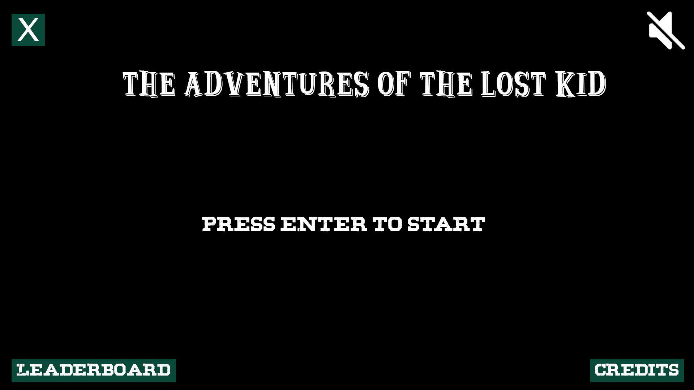

The first page that will be displayed once the game is launched is the main menu screen. I made it look very simple as it only requires the user to press enter to start the game, or use the buttons to go to the other screens. It will have a black background with contrasting reasonably sized white text and buttons to help the user read and see them easily.

**Character selection**

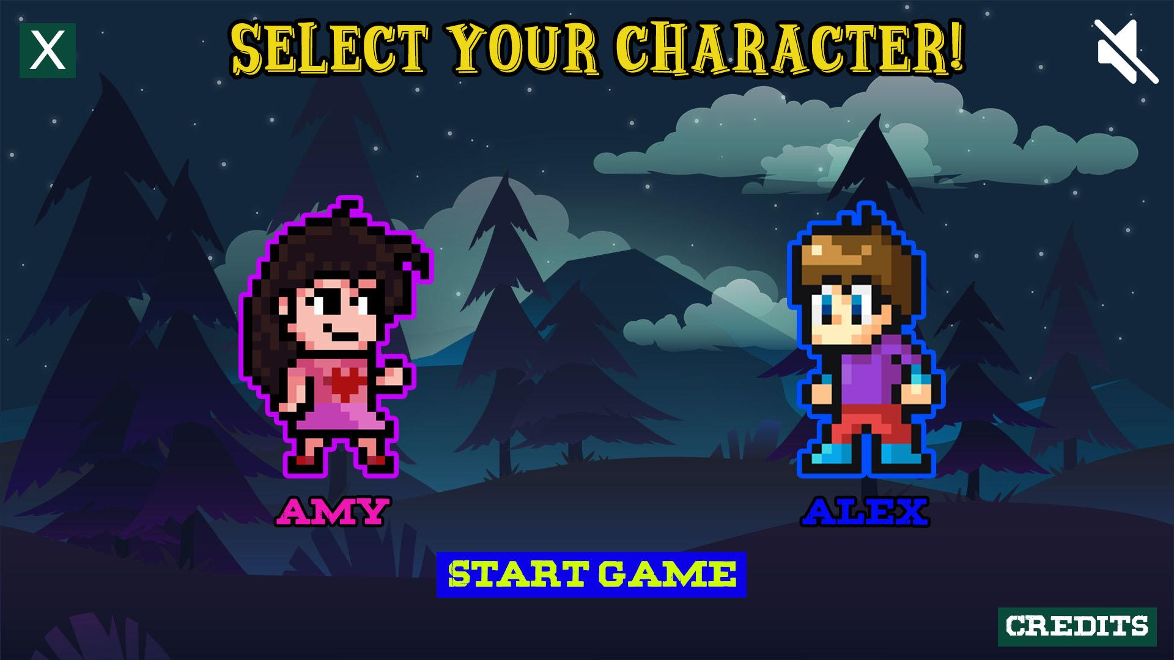

The next screen that is loaded is the Character selection screen where the user will be able to choose the character he/she wants to play with, Once the user hovers over a character they will get an outline matching the gender color as shown in the picture and when they select a player the outline will remain to show their selection, this will make the game look more clear to the user. The game will then wait for the user to press on the “start game” button to load the gameplay screen.

**Gameplay**

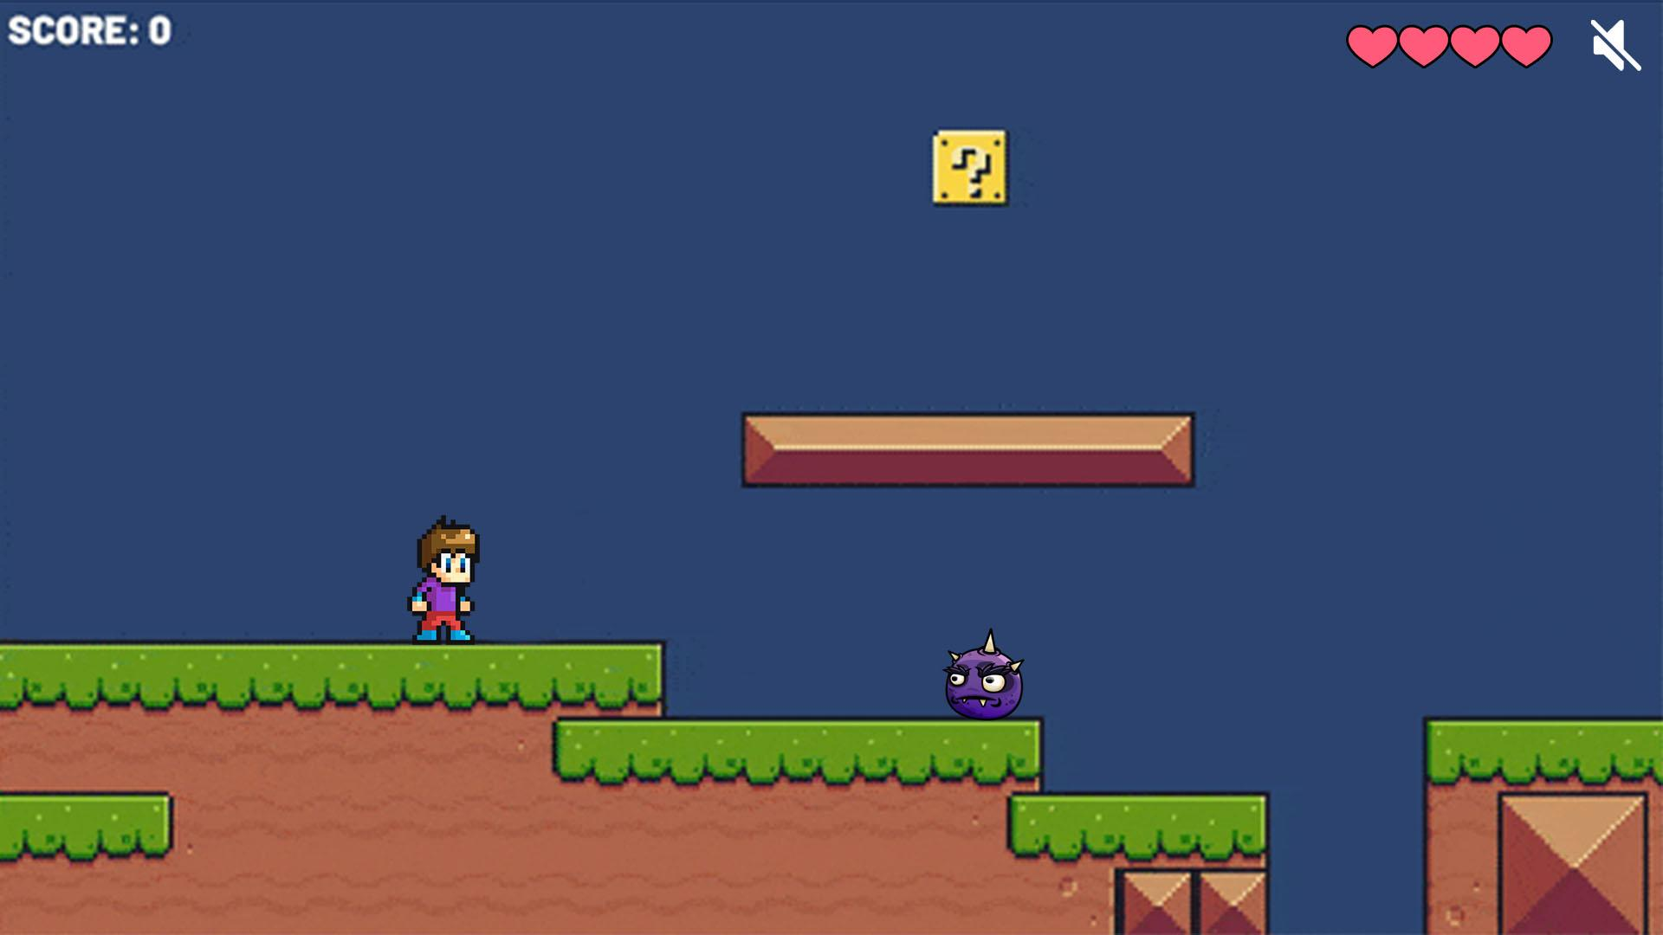

Once the game starts. The map will be displayed and the character chosen by the player will be displayed too so that he can control him. Since my client preferred to have a dark themed map I didn't choose to use any bright colors to match their requirement. The game will have mobs that they need to kill to gain the points which will be added to their score on the top left, otherwise the mob can kill them resulting in them losing a heart which is found on the top right. There will be blocks so that the user can break and allow them to be able to gain power ups and use throughout the game.

**Leaderboard**

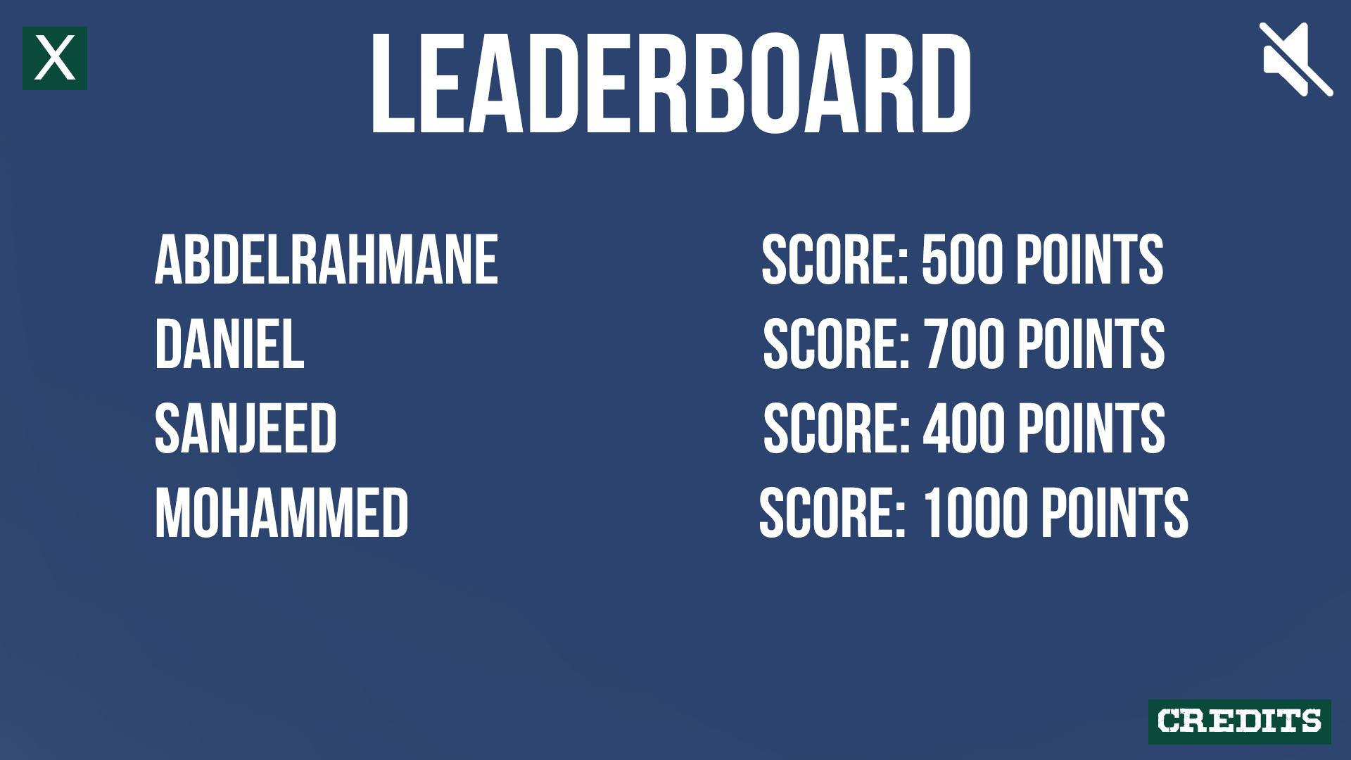

Since there is a scoring system in the game, the user will be able to input their names once they run out of lives or complete the game, this will save their points in a file and it will load the scores on the screen once the Leaderboard is accessed. I chose to use navy blue with white text to make it easy for the user to read the leaderboard.

# Section 3 - Development

To make the game I will be using pygame to code it. Here I will be documenting each step I took, any errors I ran into and how I fixed them.

**Setup**

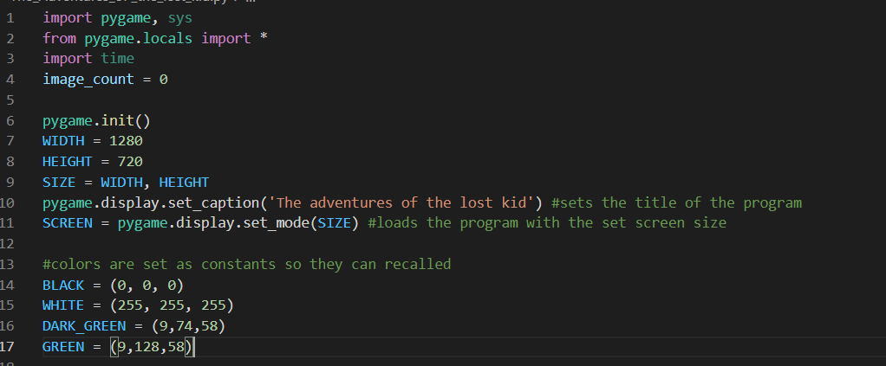

First I imported all the basic libraries needed to run a pygame screen, set the screen size and added some colors as constants to use later.

**Text class**

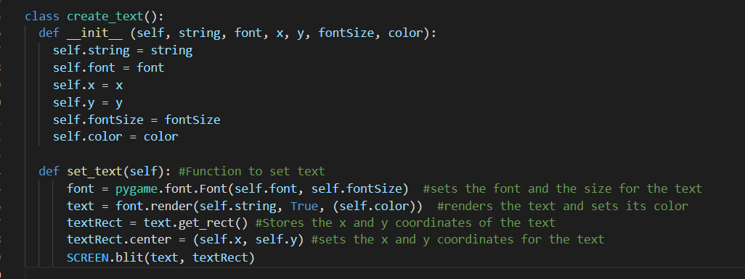

I made a class text so that I can just pass in the parameters and it will output the text instead of writing the whole lines of code again and again.

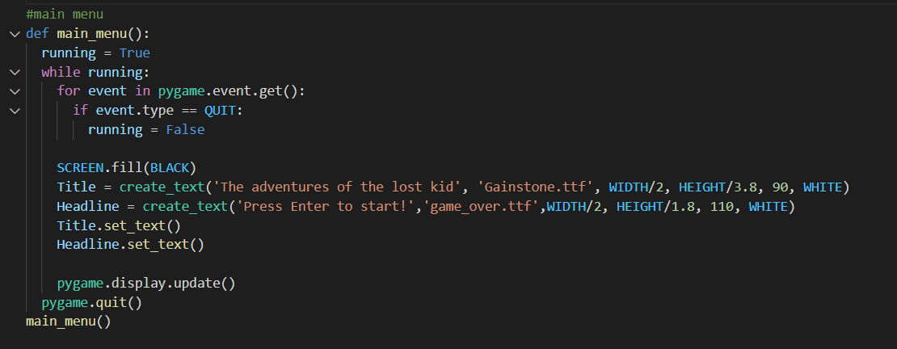

Here I made a function for the main menu screen, it keeps running as long as the variable “running” is set to True. The screen will have a back background with some text which have been passed to the create text class (Title and Headline), then the function is called to display the text on the screen Title.set_text()

**Text on screen**

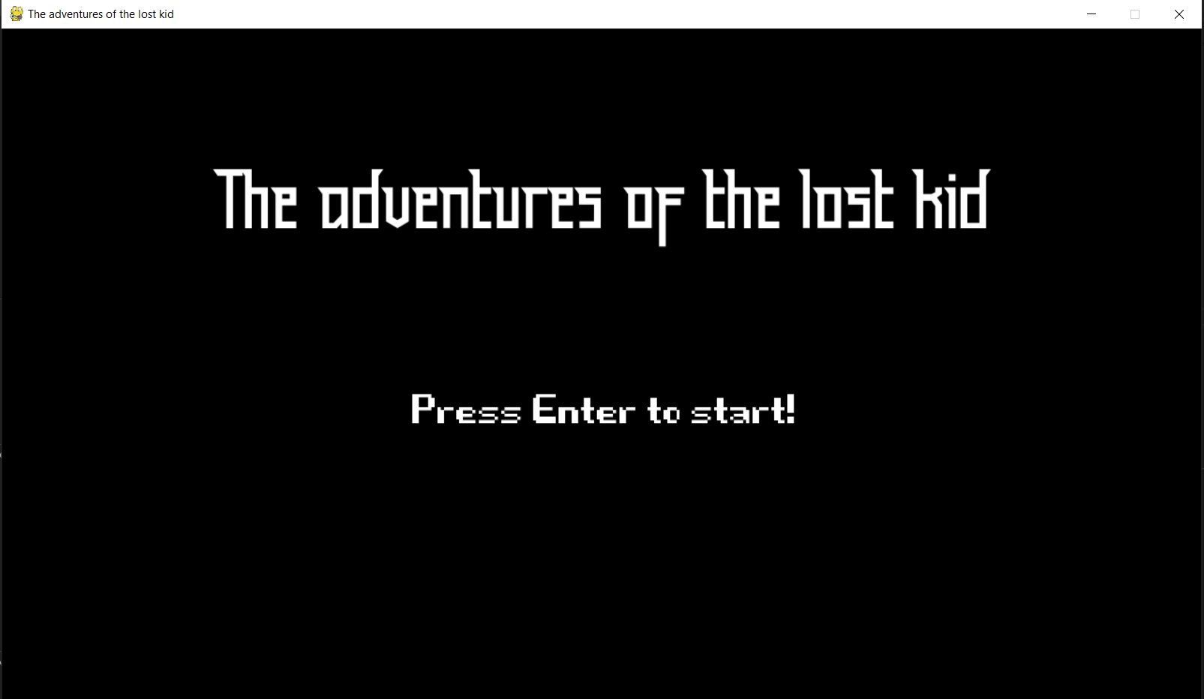

After running the code, the text was correctly displayed on the screen as well as its position, size and font.

**Button class**

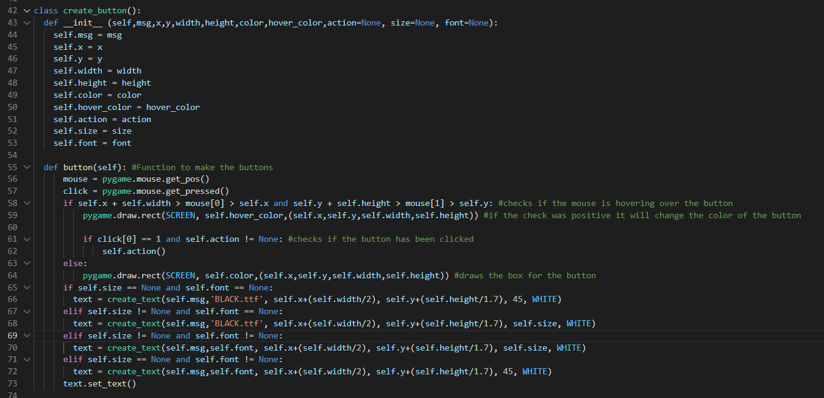

After making the text class and calling it for the main menu, I needed to make some buttons for the screen so that the user can navigate to other screens of the program. Once the button is made the function will use the same parameters and pass them to the “set_text” function to make a text on top of the rectangular button. The button will change whenever the user hovers over it, this is so that the user knows that it's a clickable element and not just an image.

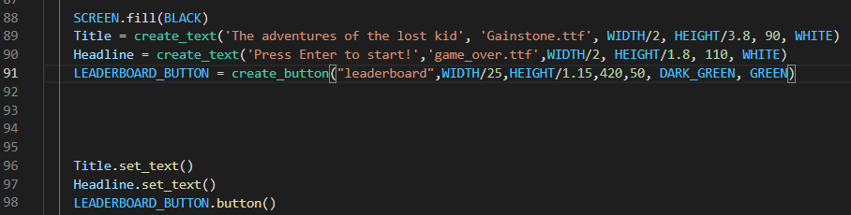

The function in the class is called using the same method as the text where the parameters are passed into the class then the function is called using implementation “LEADERBOARD_BUTTON.button() which will display both the rectangular object and the text of the button

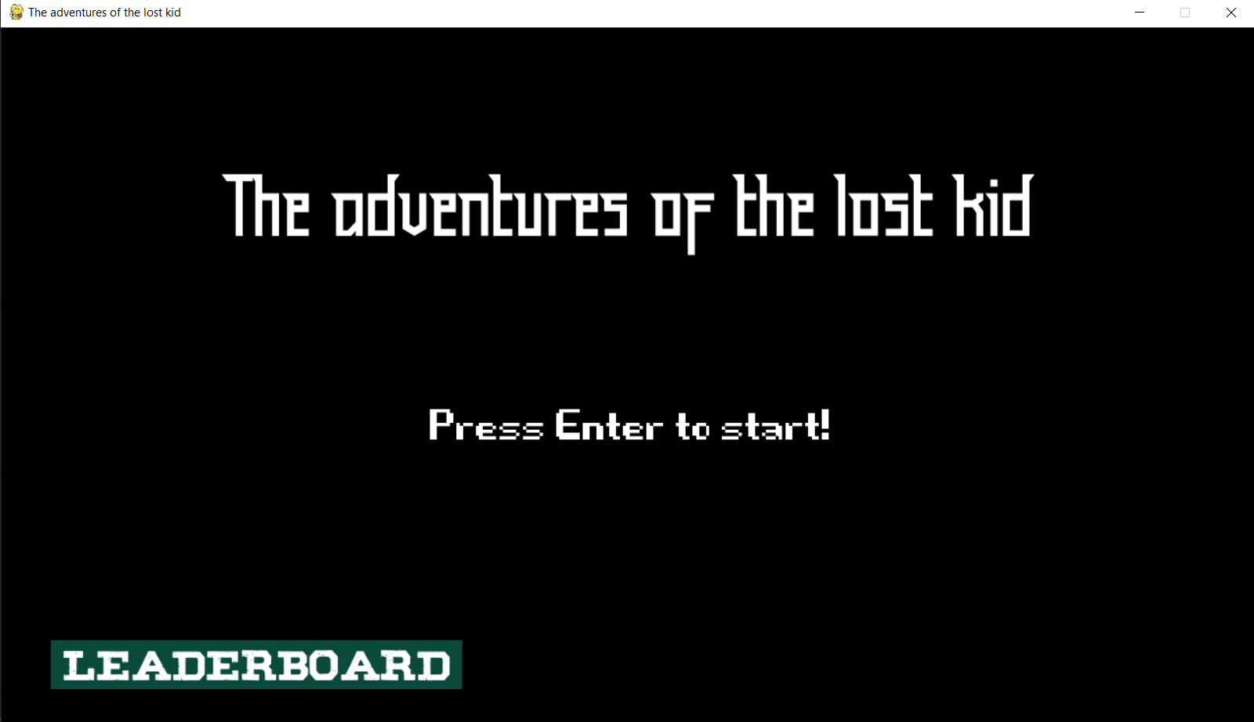

The button is now displayed with the text after running the code and works as it is intended to.

**Button navigation error**

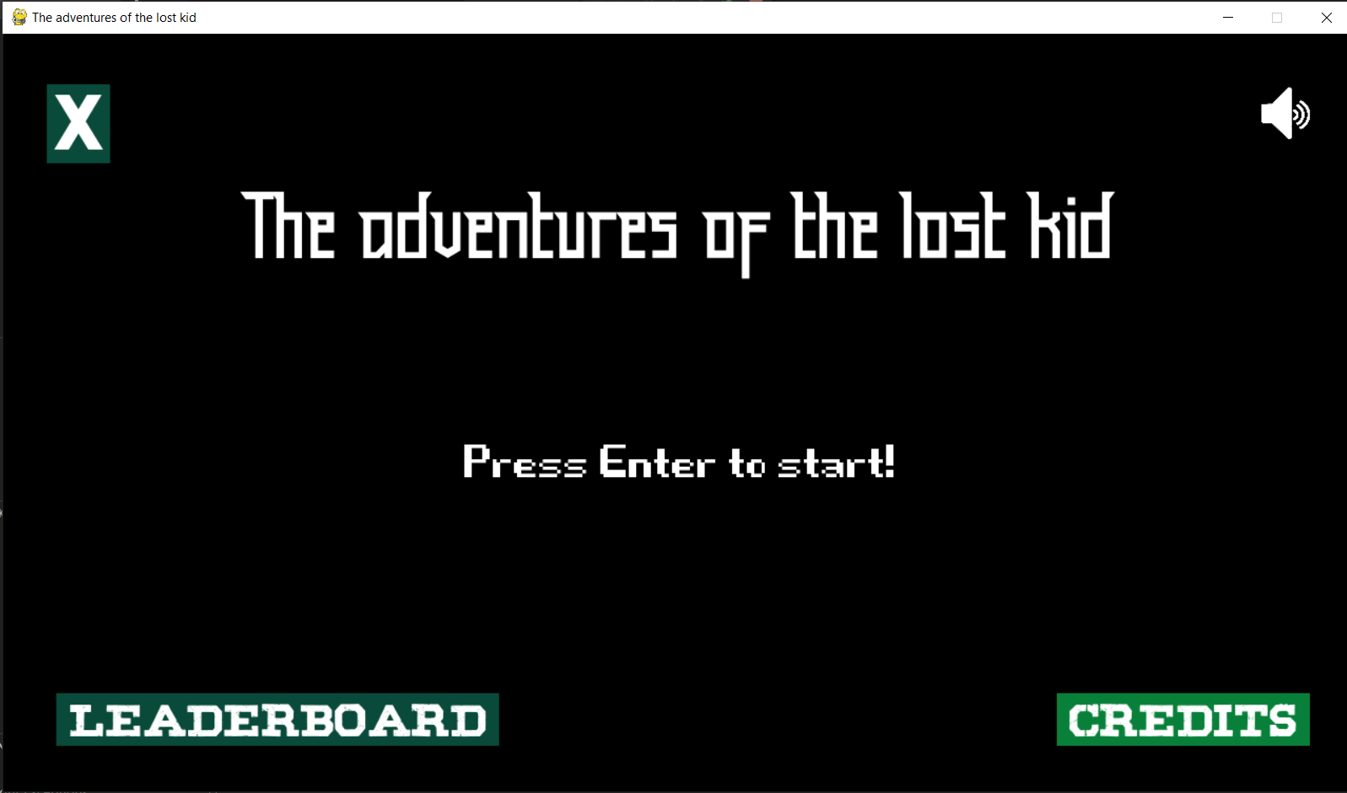

After setting up more menus the same method as the main menu was written, I added more buttons that would load the next screen, the credits button worked perfectly and took the user to the credits menu.



Once the background is in the credits screen, I added a main menu to test whether the user will be able to return to the main menu if they click the button.

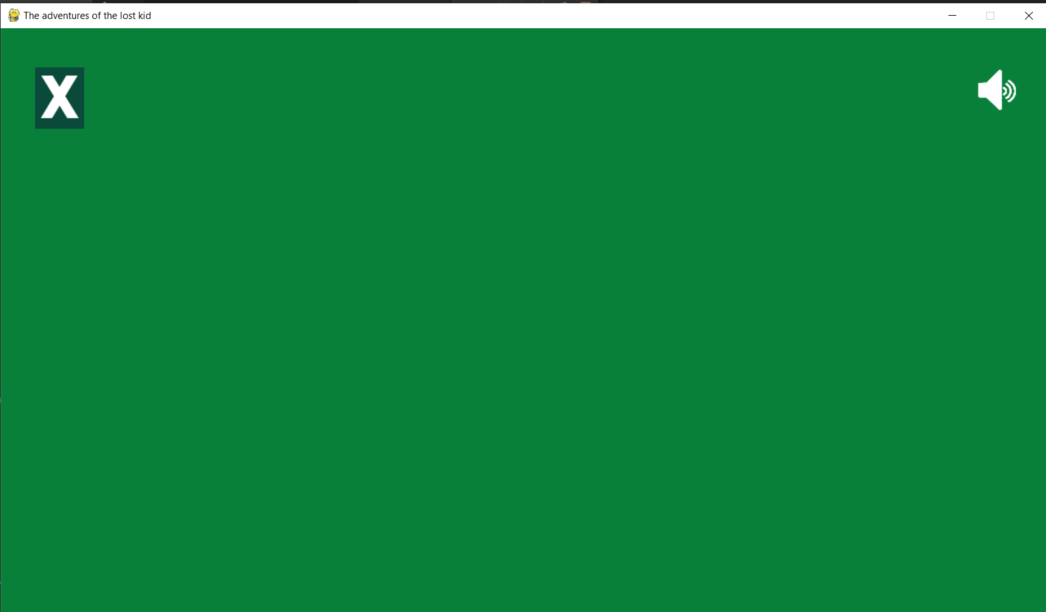

However, clicking that button makes the user go to the leaderboard screen instead of the main menu screen, this error was caused as there were two buttons at the same coordinates but on different menus.

**Solution for Button navigation**

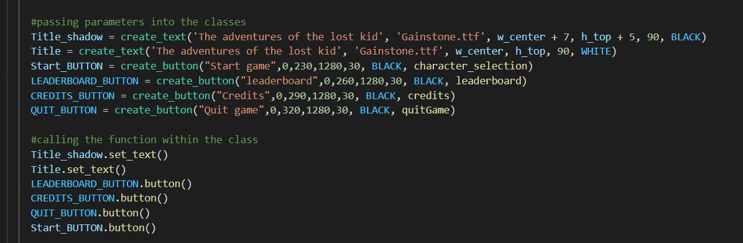

Since the buttons were overlapping causing problems and sometimes the game would crash, I tried to find solutions but my only fix was to change the design of the menu screen.

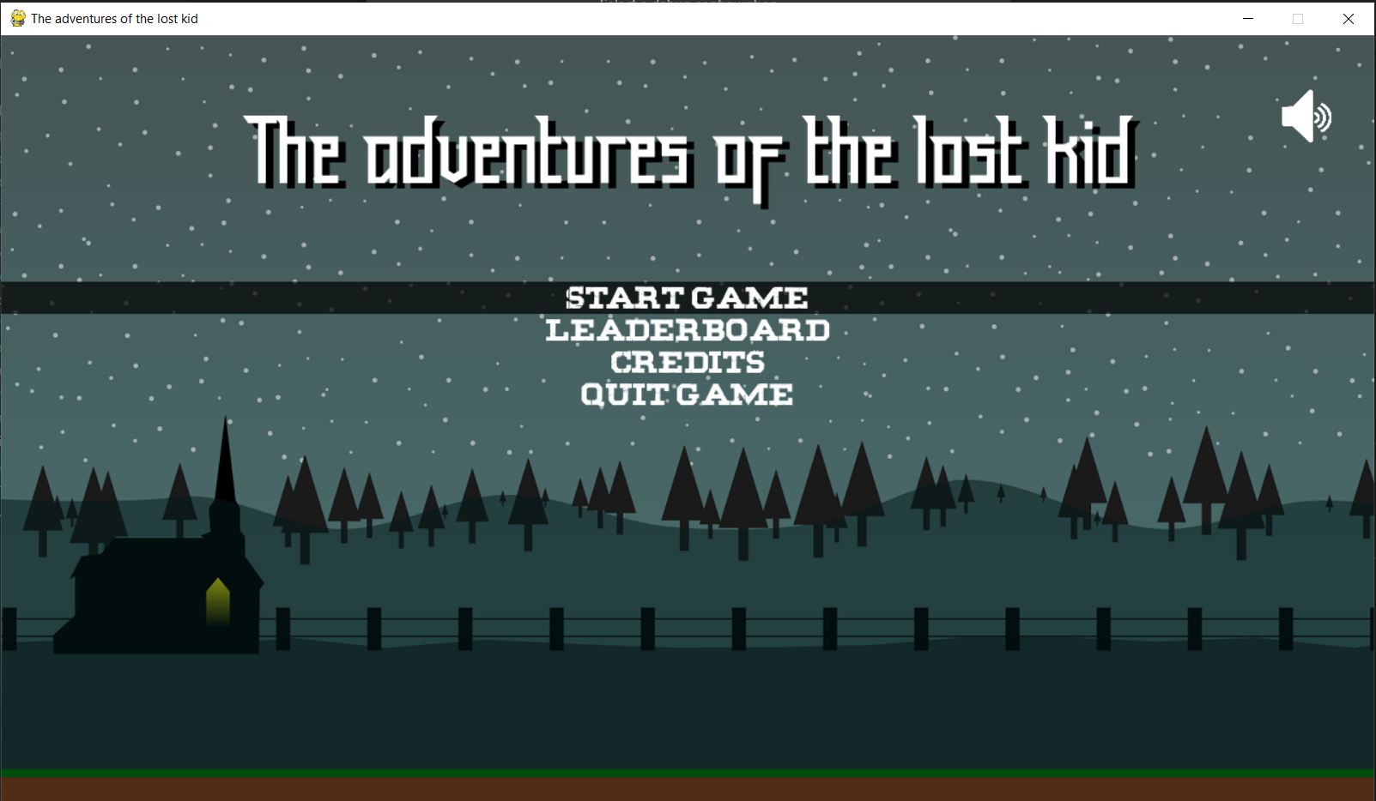

The main menu now looks like this, it has the text at the top centre of the screen and when the user hovers over the button a black background with a lower opacity will be loaded to make it easier to see what the user is about to click. Now all buttons are working and redirecting the user to the desired page. Not only did it fix the buttons but it also made it aesthetically better.

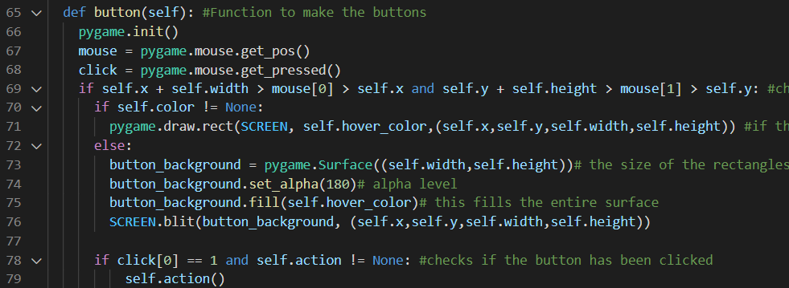

Lines 73-76 show how the opacity is achieved for the main menu buttons

**Character selection menu**

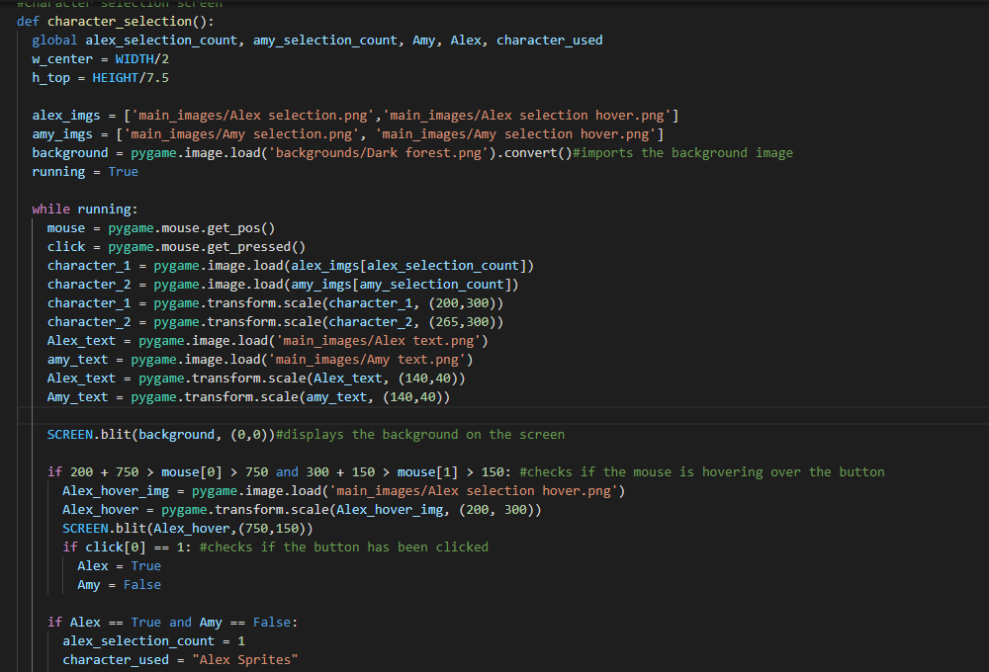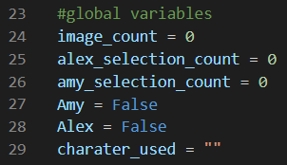

To make the character selection menu, I first set some global variables so that the choice is saved even if the function ends, the image and the hover image of the character are saved in a list so that whenever the game detects that clicked a character it will change the index to blit the required image to show that it was selected. The images are also resized to a smaller size so that they fit the screen.

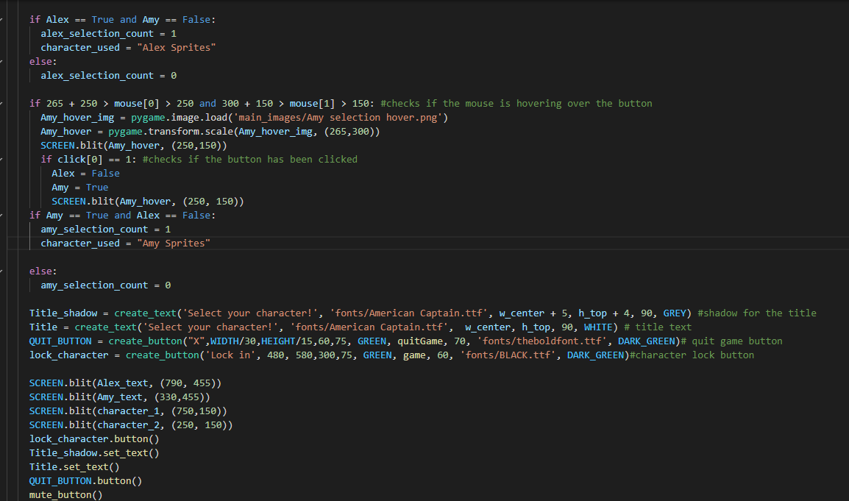

Once the character clicks on a character that they want to play with, the global variable of that image will be set to True and the other will be set to False, furthermore the index of the list will change to 1 to blit the image that shows the character that was chosen. The reason why the variables are set to True or False is that if the user wants to change their mind they can simply just click on the other character that will set itself to true and the other to false and this is also where all the elements are blit to the screen.

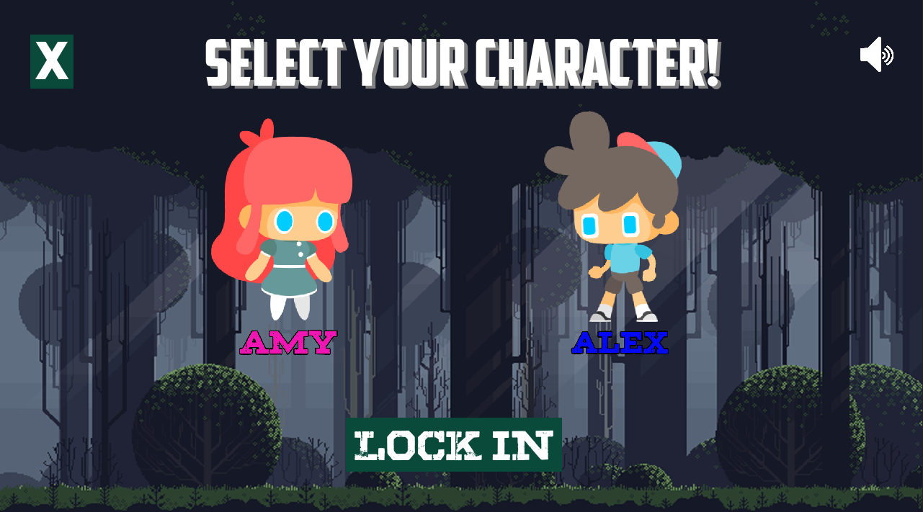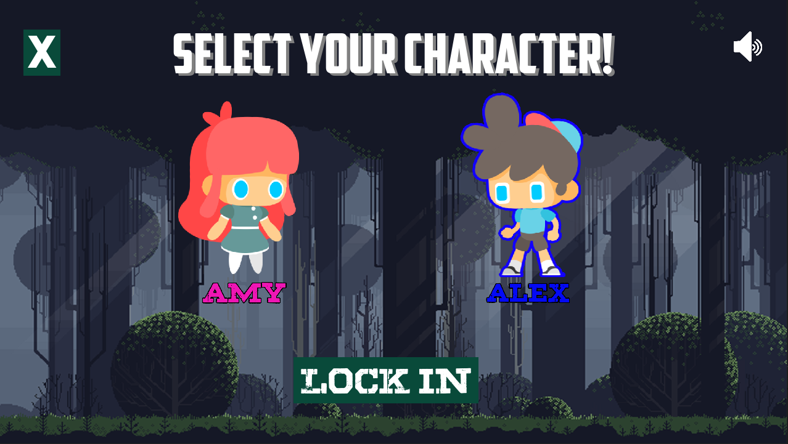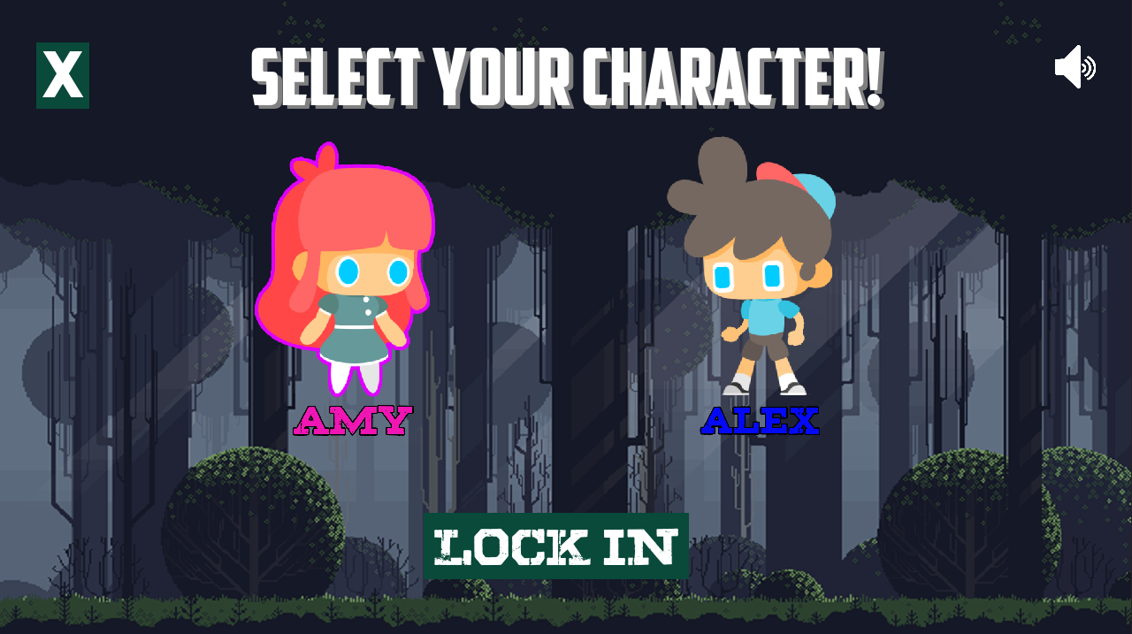This is how the character selection menu would look like when the player selects the player and how each character gets a stroke around the image.

**Character selection menu error**

This menu works perfectly fine, however it can make the whole program crash if the user presses the “lock in” without selecting a character, this is because the program wouldn’t know which character to load into the game.

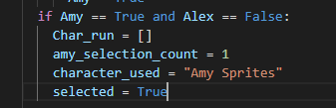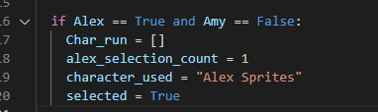

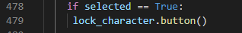

In order to fix this issue I made the “lock in” button only appear once a character has been clicked on, and this is checked by setting a global variable “selected” to True

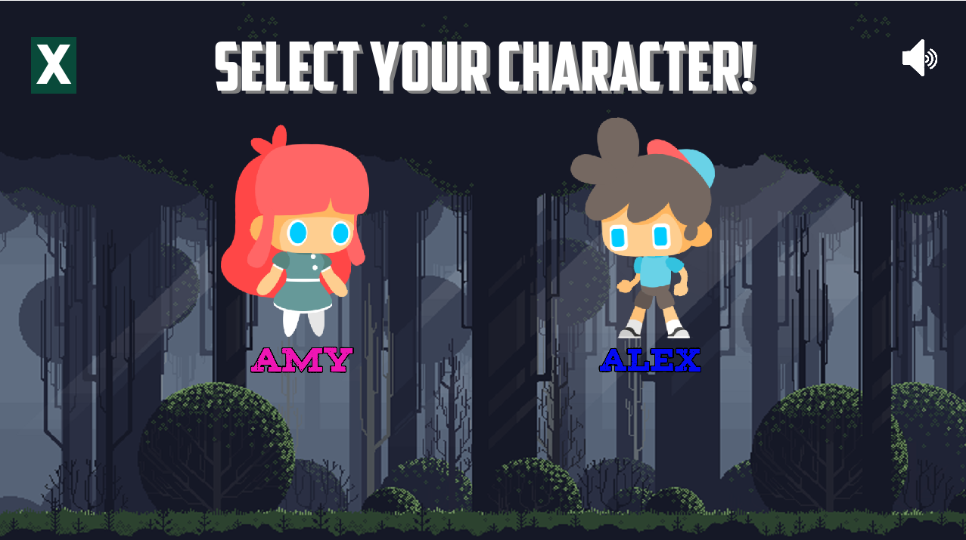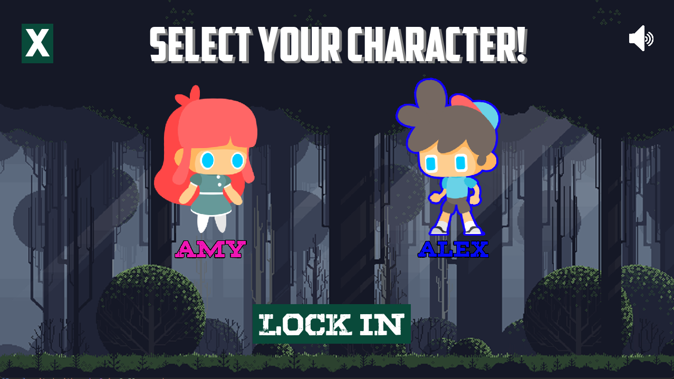

**Credits Screen**

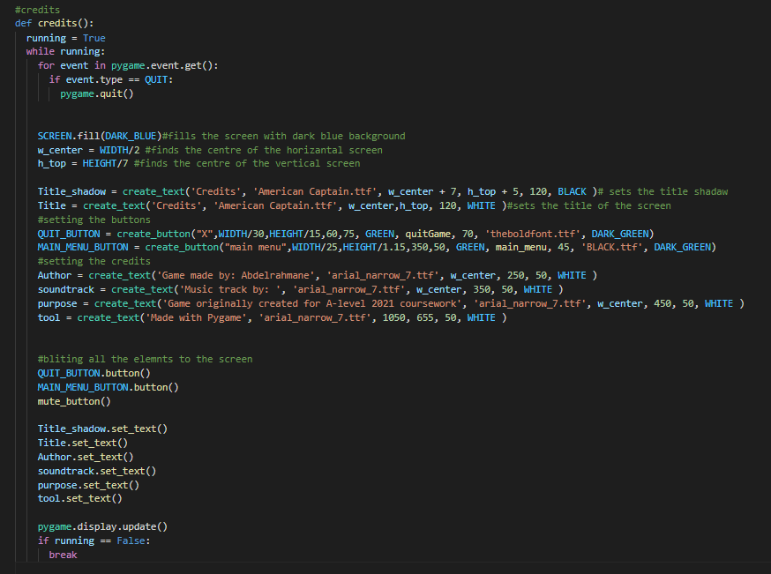

I then made a menu for all the game credits, who made the game, the music maker and why it was made. This screen is so simple that it only displays text on the screen.

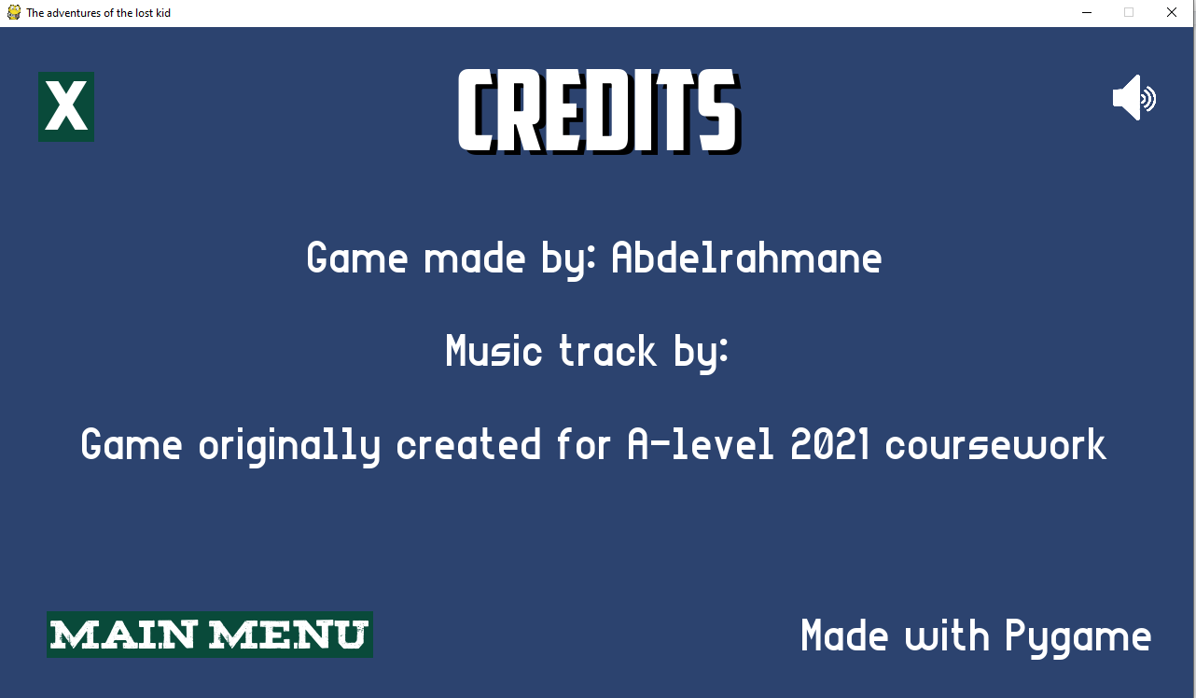

This is how the credits screen looks: a simple solid background with white text making it very easy to read. I left the music track name empty for now as I haven't chosen a sound track yet.

**Mute button function**

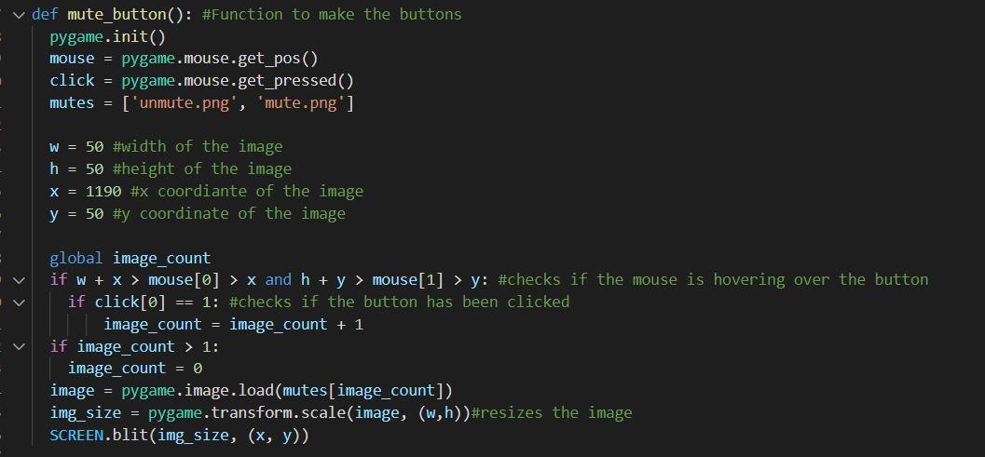

In order for the user to be able to control the music, I made a function that will be called in every menu. I first declared a global variable “image count” which was the index of the image list, (0 = unmute logo, 1 = mute logo) so that the program would keep alternating between the two images whenever the button is clicked.



**Mute button error**

Once launching the program, the mute button was changing images perfectly, however if the user held down the mouse it would keep toggling. Therefore it made it hard to use the button, to fix this problem i made a cooldown for the button so it won't keep repeatedly being toggled as well as making it usable.

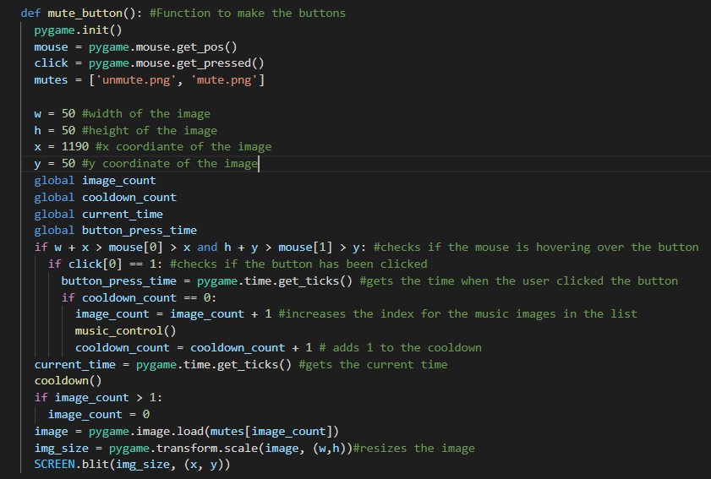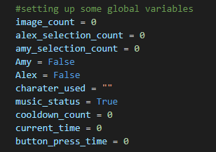

The cooldown works by getting the time the button was pressed then the time of when the image was changed (image counter increased) then the two values are passed to the cooldown() function.

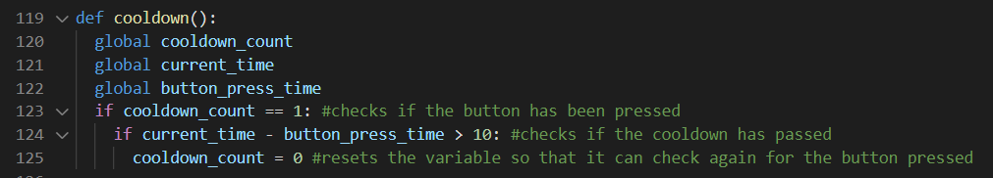

The current time and button pressed time are passed in and subtracted from each other, if they are it sets the cooldown count to 0 so that the mute button can use the music_control() function.

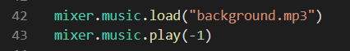

The song is loaded and played as soon as the game launches.

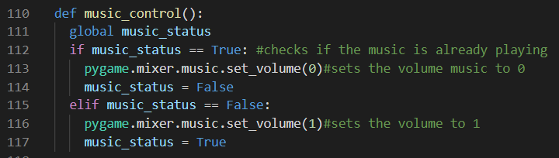

In this function it first checks if the music is playing or not through the use of the global variable “music_status” and depending on the status it would mute/unmute the music and set the status to the current music status.

**Leaderboard menu:**

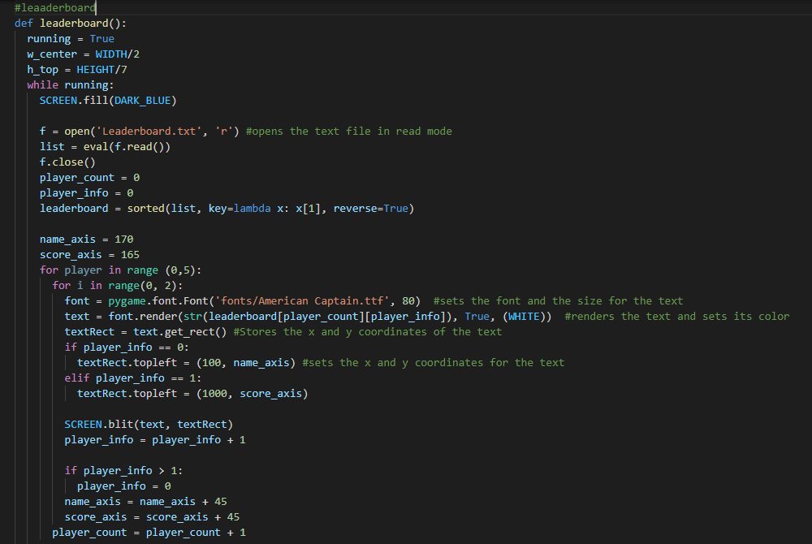

According to my client requirements, having a leaderboard is essential, therefore I’ve made this menu for it. The scores are saved in a text file and are read from it. Then the program sorts the list and loops through each line and displays the top 5 scores with their names on the screen with equal spacing between them.



The leaderboard text file storing some temporary scores which will then be displayed on screen

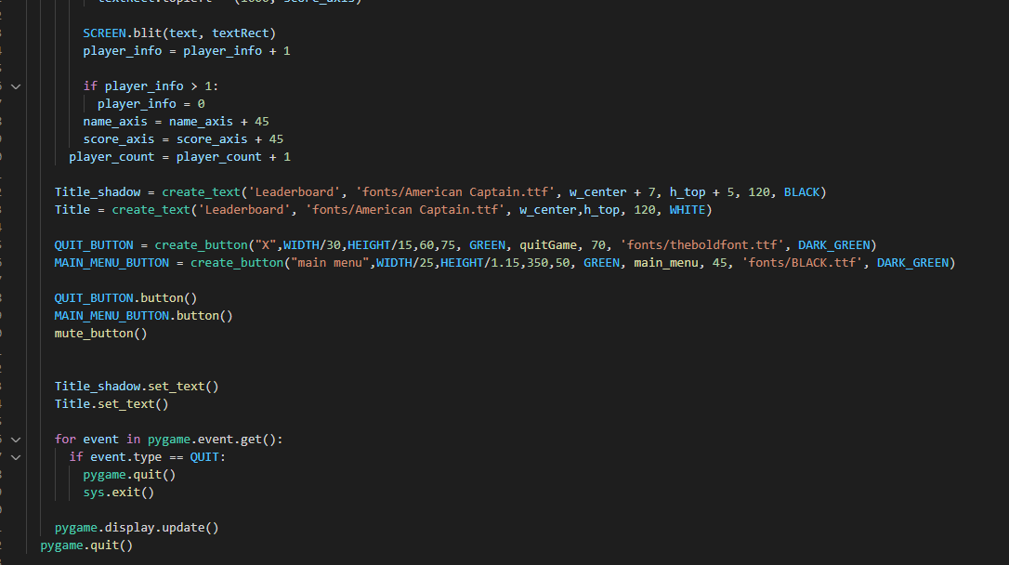

Here some buttons and text are created and displayed on the screen.

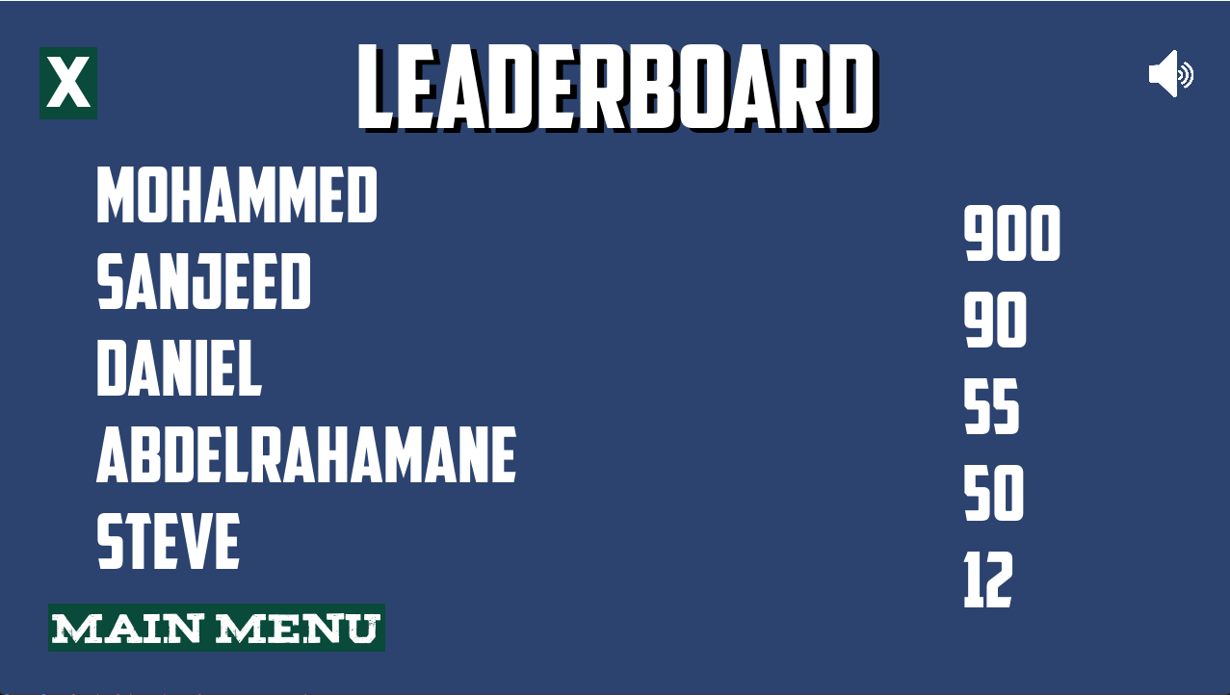

This is what the leaderboard menu looks like.

**Character class:**

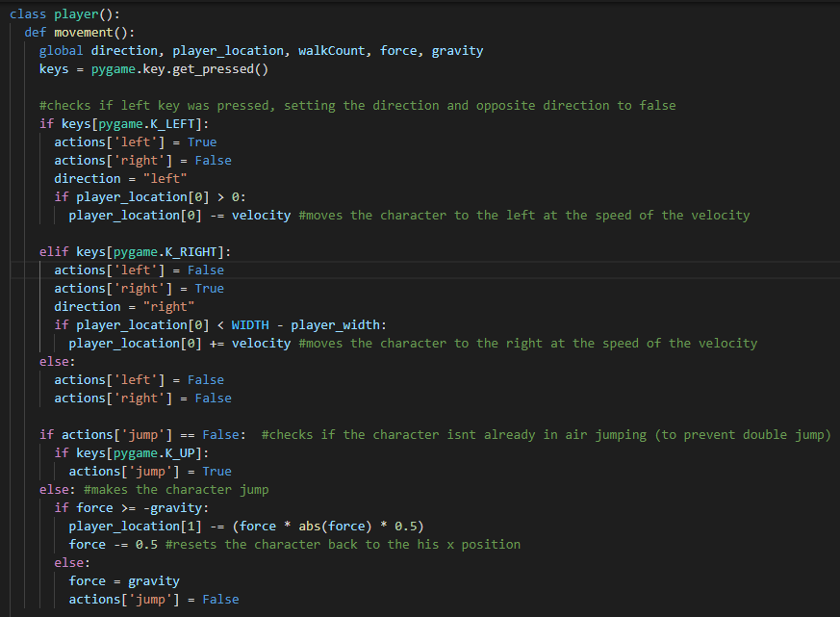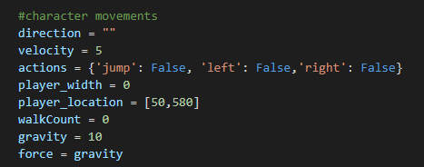

To make the code efficient I made a class for the player so that it can be called whenever it's needed and to make the code look better rather than having all the code in one function. This class has two functions, movement and sprites. The movement function includes the code for the character movement, (up, right and left) it also tracks the direction the character is moving in by changing the value of certain global variables.

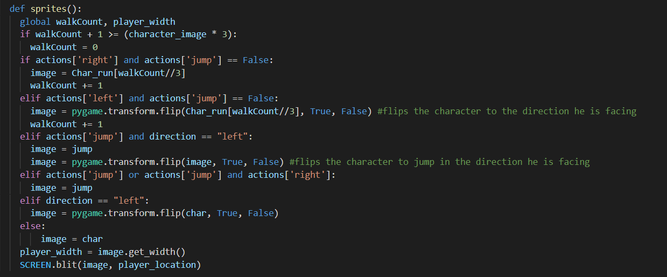

The player class also has a function called sprites, this function makes the character animated as it goes through the images in the char_run list increasing the index value whenever the right/left key is pressed (walkcount).

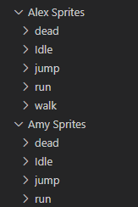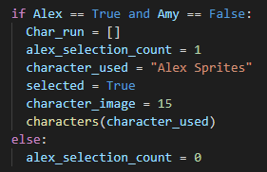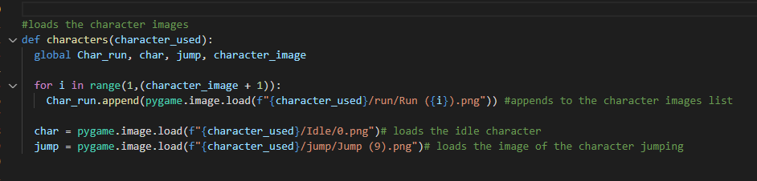

Furthermore a function called characters which requires a parameter or the selected character which is set by the character selection function. The images of the 2 characters are saved in separate folders containing images of the same name, therefore the function would use the variable to locate the images and append them to the list so that they can be read and blit on the screen. Whereas the idle image (char) and the jumping images are just saved in a variable and called later when needed.

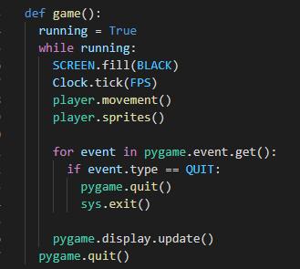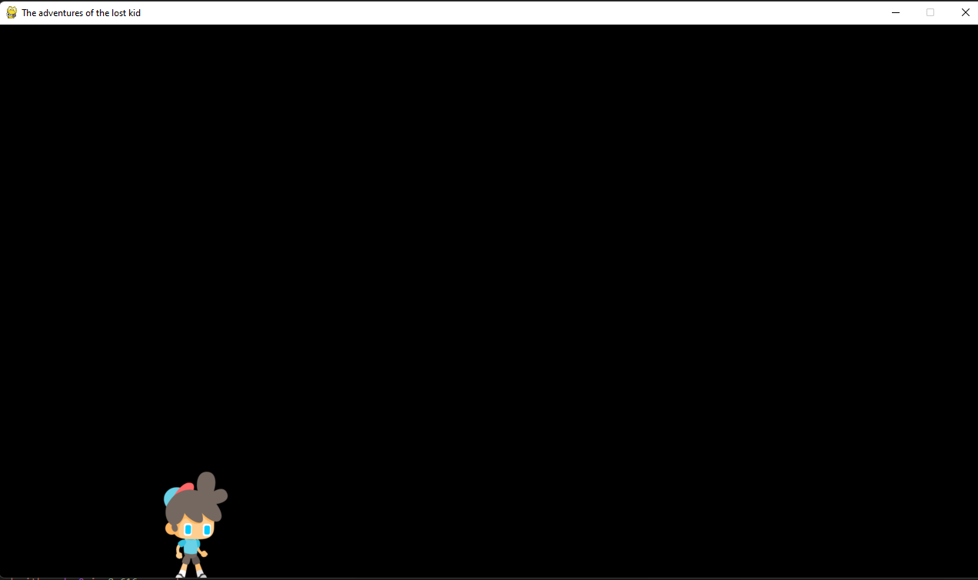

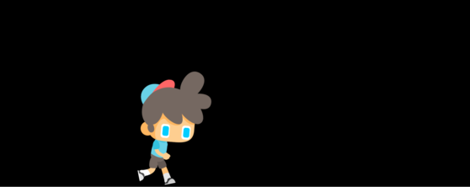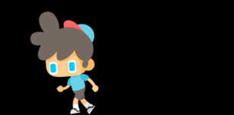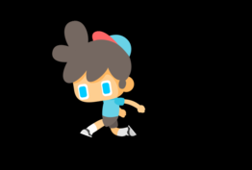

In the game loop, the character movement and sprite are called in so that the character is displayed on the screen.

**Tiles map:**

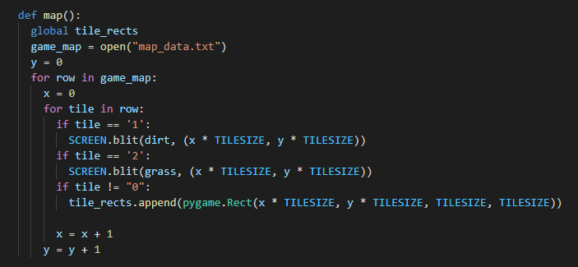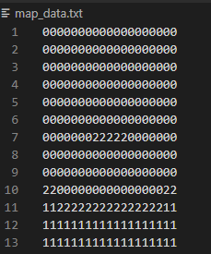

In order to make the map for the game, I made a function that would read a text file which contains 0,1 and 2. Where each number represents an image. The 0 is just empty space, the 1 is the dirt and the 2 is the grass. The function loops through each row and column and creates the map based on the txt file.

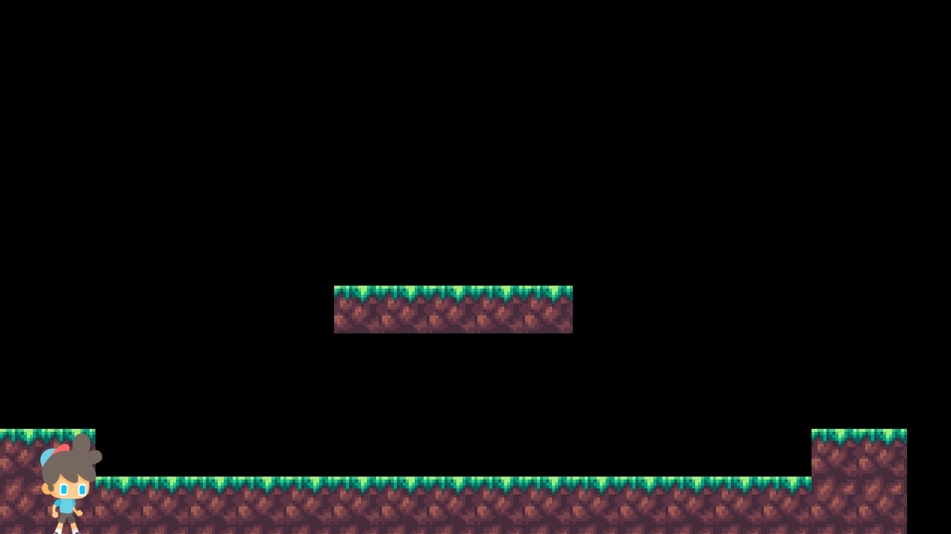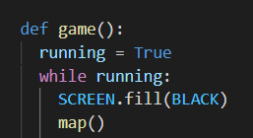

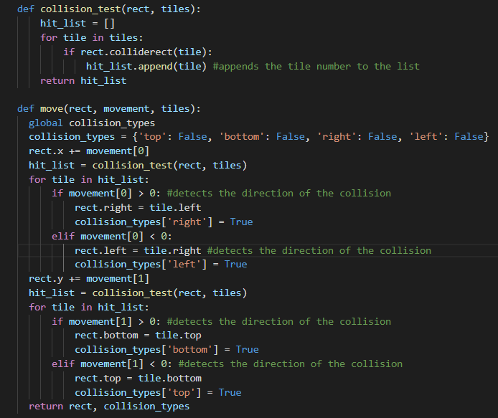

To make the character collide with tiles and make him able to move around two functions are used move and collisions_test. The move function loops through the ties in the “hit_list” list which is found in the collision_test function. It then detects the direction of where the collision occurs and sets the character to be on the opposite side.



After setting up a global value that would store the players coordinates, height and width, it gets passed to the function “move” and it would process the lines of code.

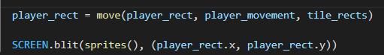

When trying to blit the player.sprites() “argument 1 must be pygame.Surface, not None” so therefore i took the sprites function out of the class, so that it can be passed into the blit function.

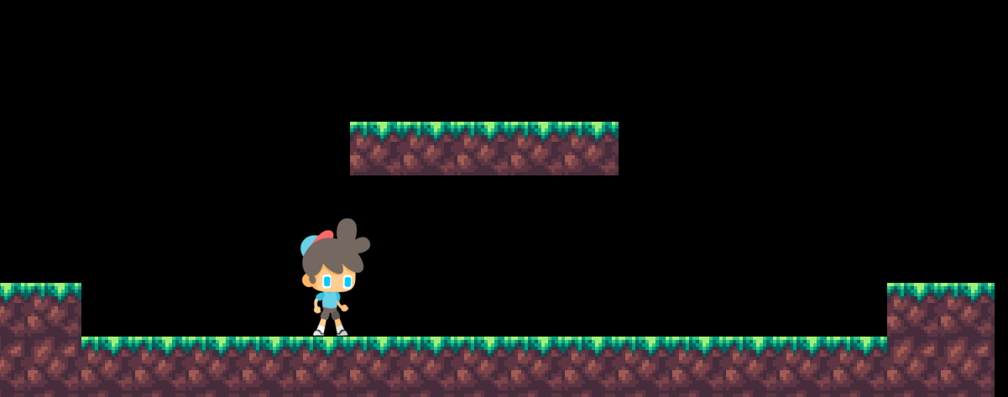

After running the game everything seemed to work perfectly fine including the animations and all the collisions. However I noticed that the game starts to lag after a while running around at 1 fps making the game unplayable. After trying to find out what was causing this problem, I found out that the program was consuming very high power from the computer. I tried to debug my code to see which part caused this and I found out that the move function was not efficient and made the program lag.



To fix this, first I separated the code into 3 python files so that it's easier to code and navigate around the lines, one file contains all the screens (main.py) while the other contains the gameplay (game.py) and the (settings.py) has all the constants that can be accessible by both files.

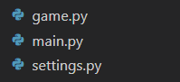

Settings.py:

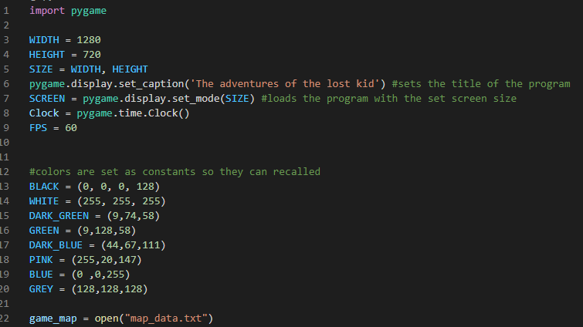

Calling Game.py:

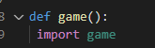

Whenever the game function is called, it will import the game.py making it run

**Game.py:**

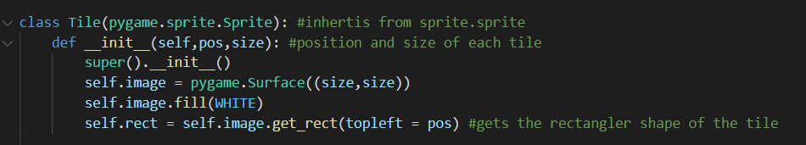

First of all I made a class for the tile where it would take in the position of the tile and its size, then it would fill in the tile with the colour white for each tile.

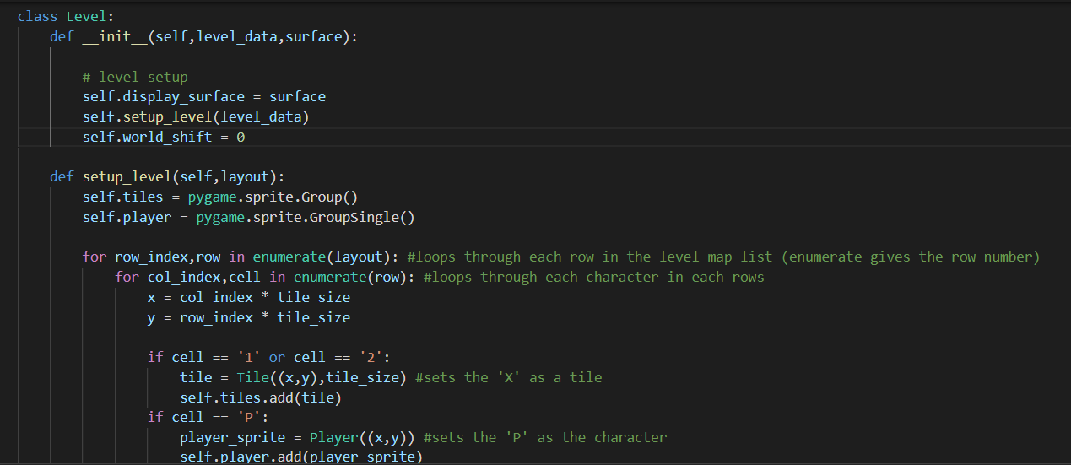

Then I made a class to set up the level map. The setup_level function would read off “map_data.txt” and replace the specific values with what it should be. For now since I’m testing if the code works, I kept the “1” and “2” as the same tile, passing them both into the same class “Tile” to create white tiles.

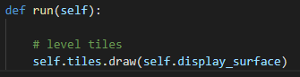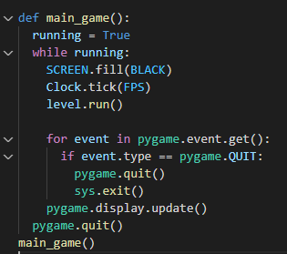

The level class also has a function called run which would be called to run the class, here the “level.run()” is used in the main loop so that it draws the tiles on the screen. Where self.tiles is a sprite group.

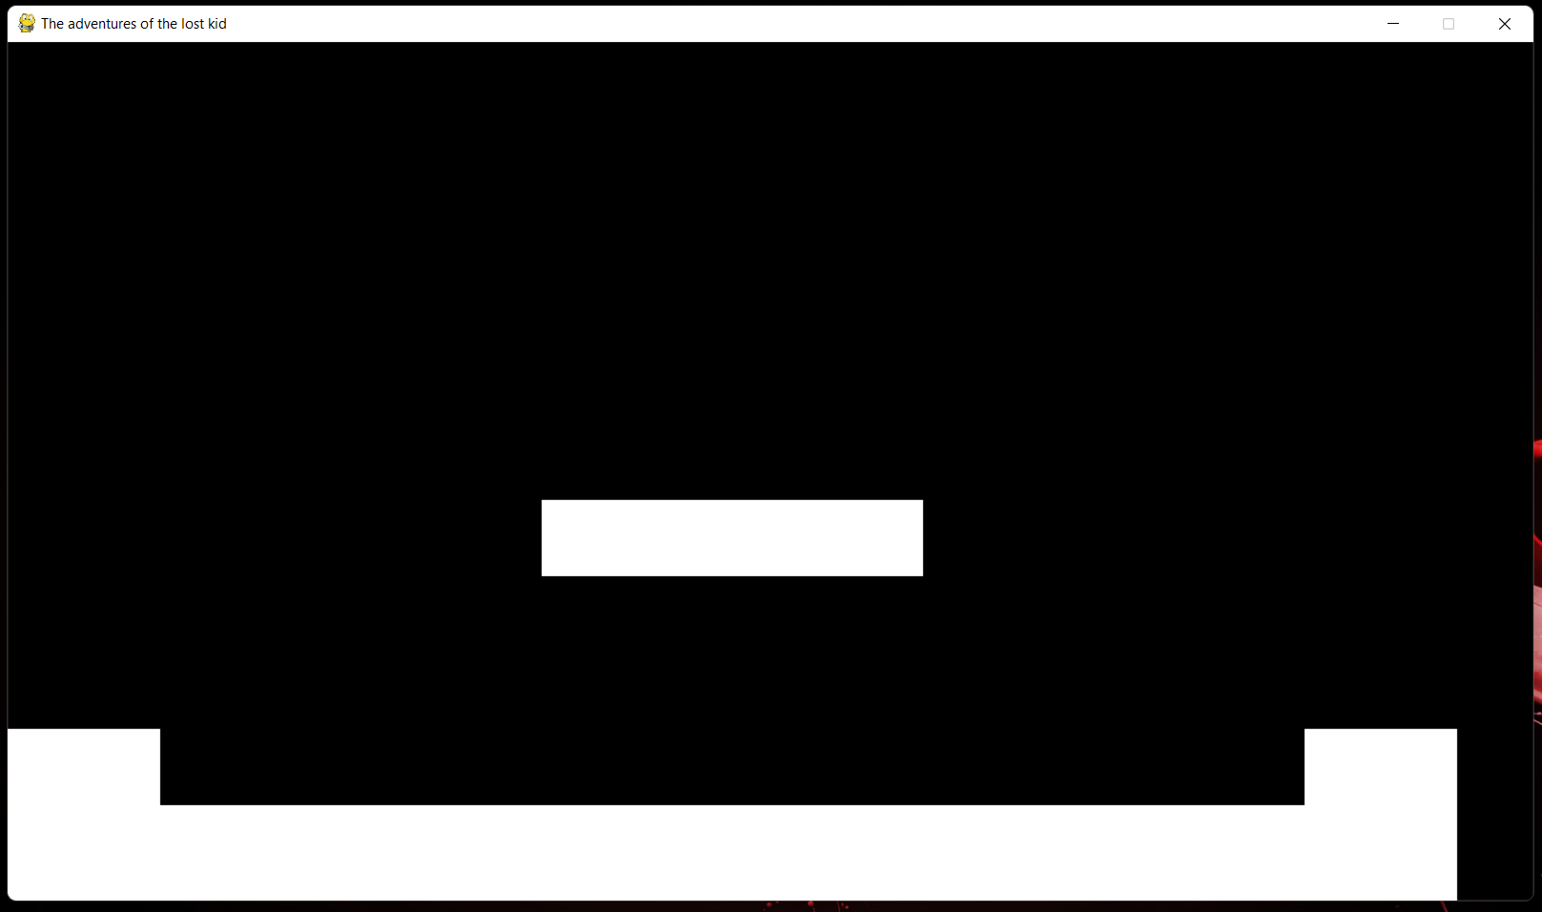

**Player class:**

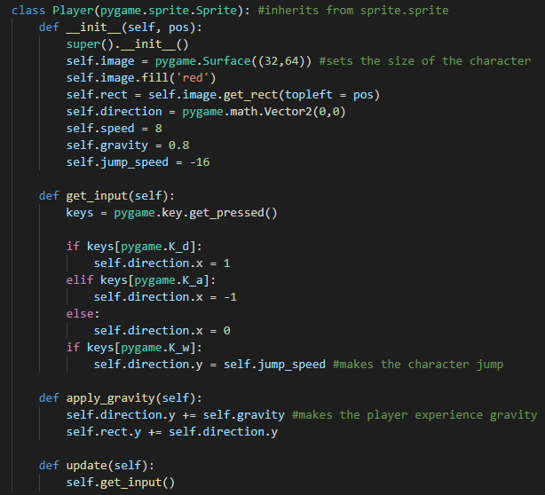

The player class is made to make the character able to move, pygame.math.Vector is used here which is 2 dimensional (hold x and y), vectors allows the ability to track the object as well as move it and provide with many other functions which can be useful. The get_input() function detects which key is pressed and performs an action based on the key. The apply_gravity function() makes the player fall back down once they jump.

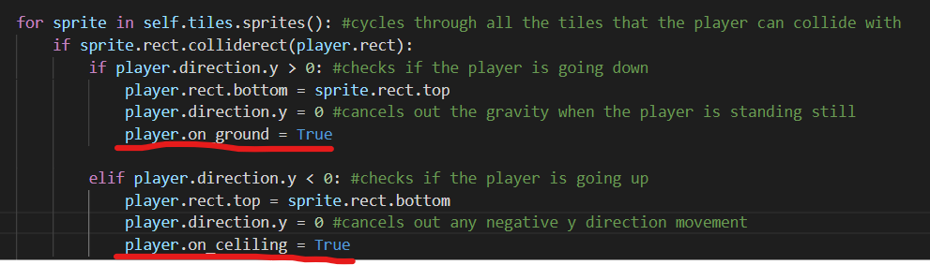

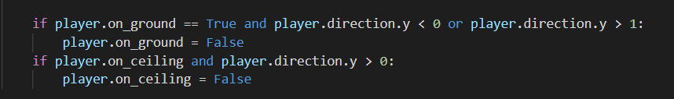

To make my character able to jump only when on the floor, i needed to add more code, so back in the level class, whenever the player collides with the floor, it sets on ground to True and if it hits the ceiling sets on ceiling to True, however a code is needed to set it back to false once the player hits the ground, therefore I made the code below it that will check the position of the player and sets whats needed back to False.

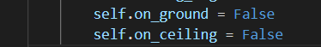

The default values for these two variables are False and are initialised in the player class.



Lastly I added an extra collision to ensure that the player only jumps when th player is on the ground.

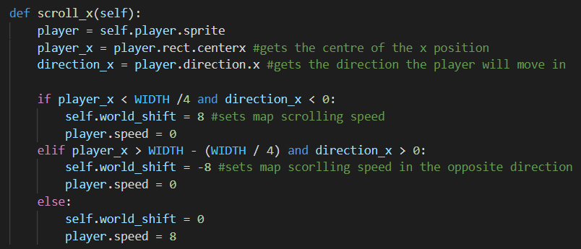

I then added a scroll in the x direction function so that the player can move through the whole level (camera movement), once the player gets to a certain x value (width /4) from both sides, and the character is moving in that direction, it will set the player speed (movement) to 0 and camera movement to 8, and since I am using vectors -8 would be the opposite direction.

The function for the camera movement from the tiles class:

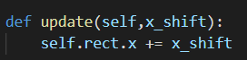

Calling the update function:

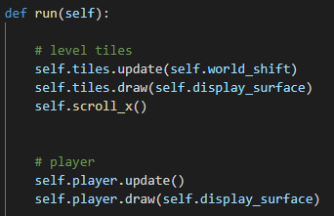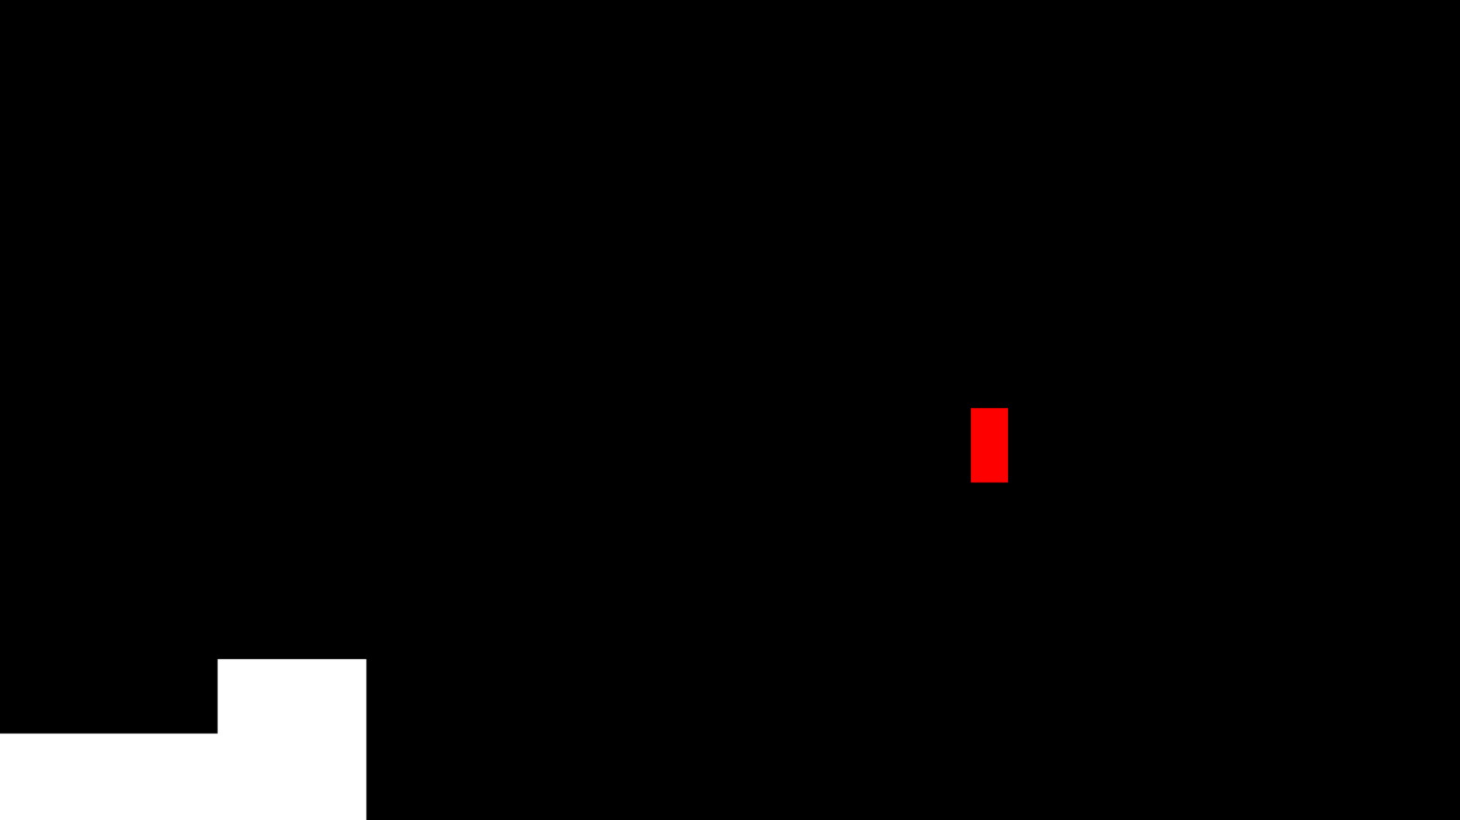

After calling the functions, this is what it looks like when the player moves to the right

**Collisions:**

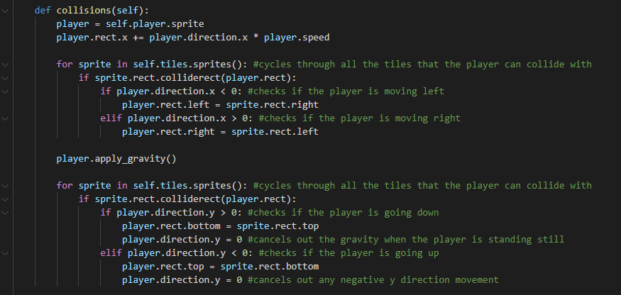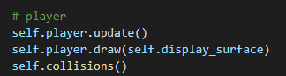

To make the character able to move on the tiles, collisions must me added, by using this method it checks tiles from the sprite rather than the list (in the previous code that consumed too much power) then it identifies the direction of collision and sets the character to be in the opposite side (same method as previous code). The apply.gravity() ensures that the player experiences gravity and falls back down after jumping.

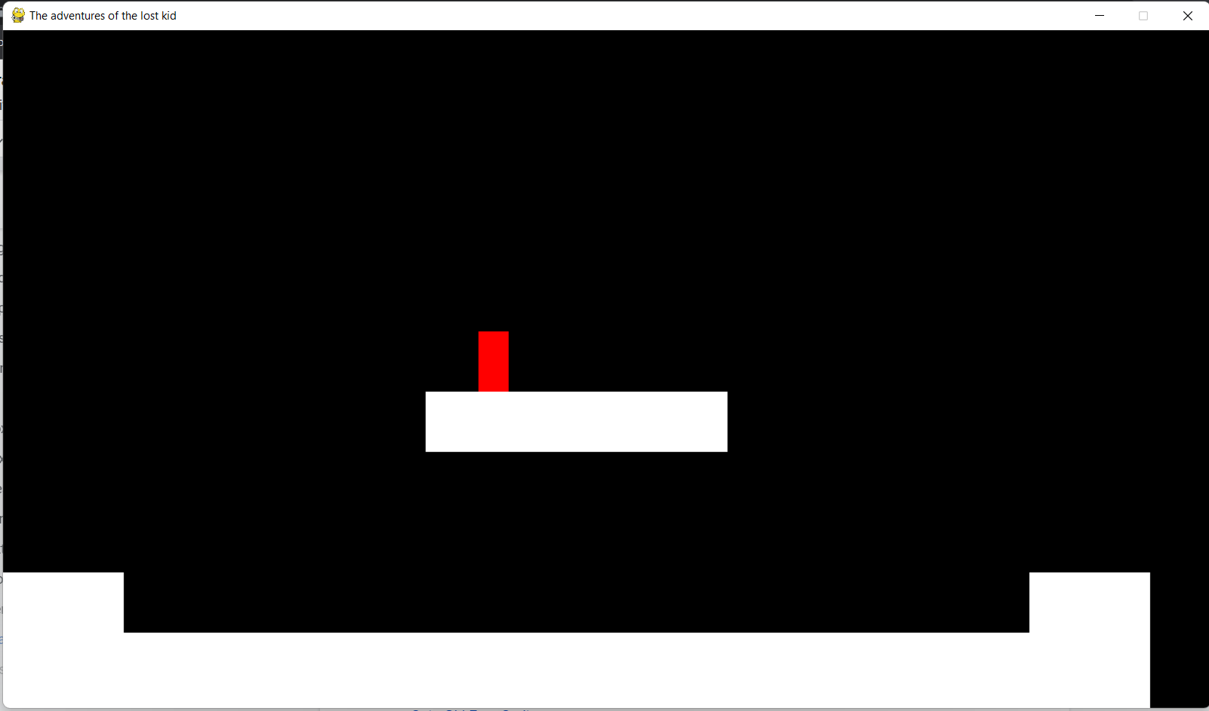

**Importing the sprites:**

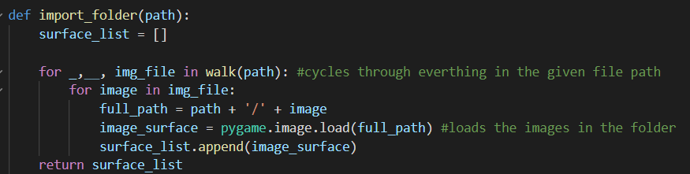

I’ve made a function to import all the images in a specific folder, this function will loop through the folder and add its path to the directory, so that the program can load the image.

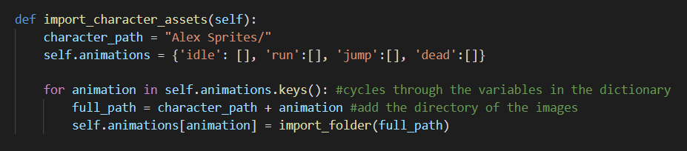

Then I made another method in the player class for the images for each animation, the code will cycle through through the keys in the dictionary, the key will be added to the character path then passed to the import_folder function which will fetch the images and add them to the list which is returned.

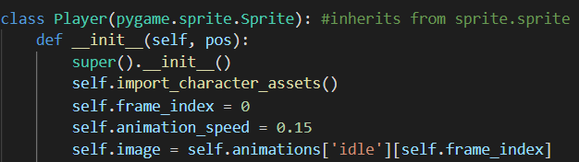

Calling the import_character_assets() function so it could be run, the self.frame.index will be the index used to go through each image in the dictionary, the index will be incremented by 1 at the speed of self.animation_speed. The first character image that would load (self.image) is the character being idle, which is found in the dictionary under the key: ‘idle’ with the index of 0.

**Animation:**

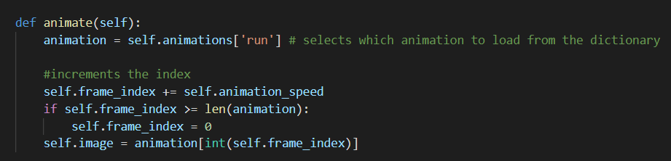

To make the character animation appear on the screen, I made another method for the class player that would set a variable to be a chosen list from the dictionary, e.g. run images list. Then the index would increase by the animation speed looping through the list, and to make sure the code doesn't make the index out of range, a small check is used to set the index back to 0 once the index is bigger than the length of the list.

**Import_folder(path) problems:**

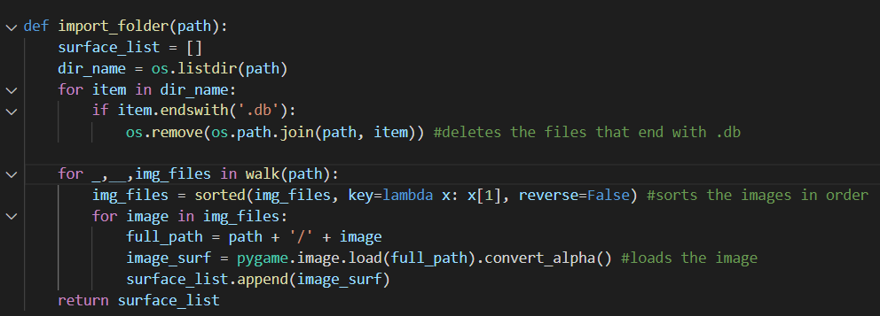

While testing the code, i ran into 2 problems, the first was that the order of which the images were appended to the surface_list was wrong and not in order making the character have stuttering animation, to fix this, i made img_files, which sorts all the data in the folders then appends each value in the img_files to the surface_list as an image. My second error was that, if the folders contains any file that's not a png, it will make the program crash. I removed any unwanted files from the folders and kept only the png, however the error kept occurring. After trying to find out what was causing the problem, I discovered that windows make files for the images and come by the name “thumb.db” which contains the databases for the images. To prevent this from happening I created an algorithm that searches for these files and deletes them from the folder.

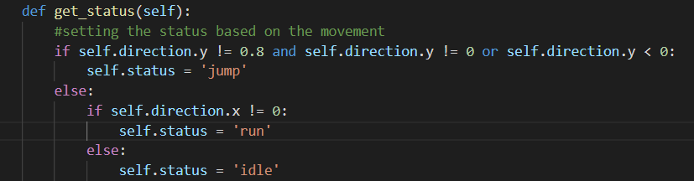

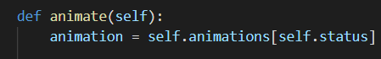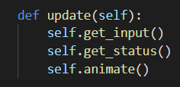

Since the animations worked, I now made a method to choose which animation to use when appropriate. The method will check if the character is not moving in the vertical direction, if so jump will be passed in to the animations key, the reason why it checks if the y coordinate is not equal to 0.8 or 0 is because when i did the collisions, it sets the player on the opposite side therefore the y coordinate keeps changing from 0 to 0.8. Using this method it will ignore the collision on the floor and not load the jump image when the character is walking or standing still.

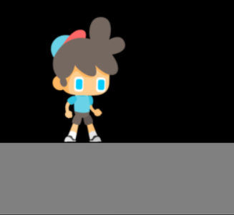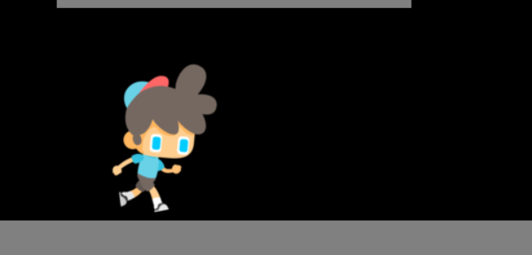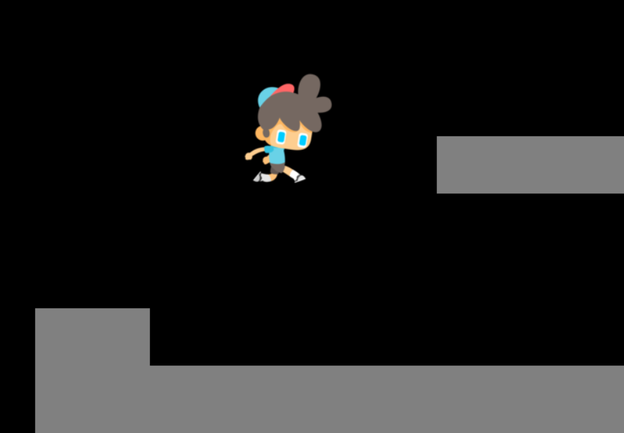

The code however only shows the animation based on the image i.e. facing right, therefore I added a code to flip the image if the character is facing the opposite direction.

In the animate method: 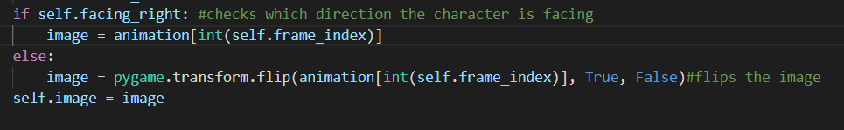

In get_input method:

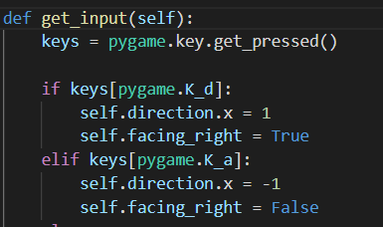by default facing right is set to True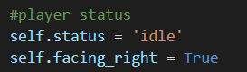

**Adding music to the gameplay:**

To add the music, I moved the music_control(), cooldown() and mute_button() functions to the settings.py so that both game.py and main.py can edit and access the needed functions.

To make the game more entertaining I added a separate music track for the game.py and loads in when the file is called.

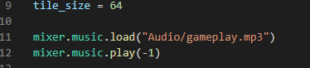

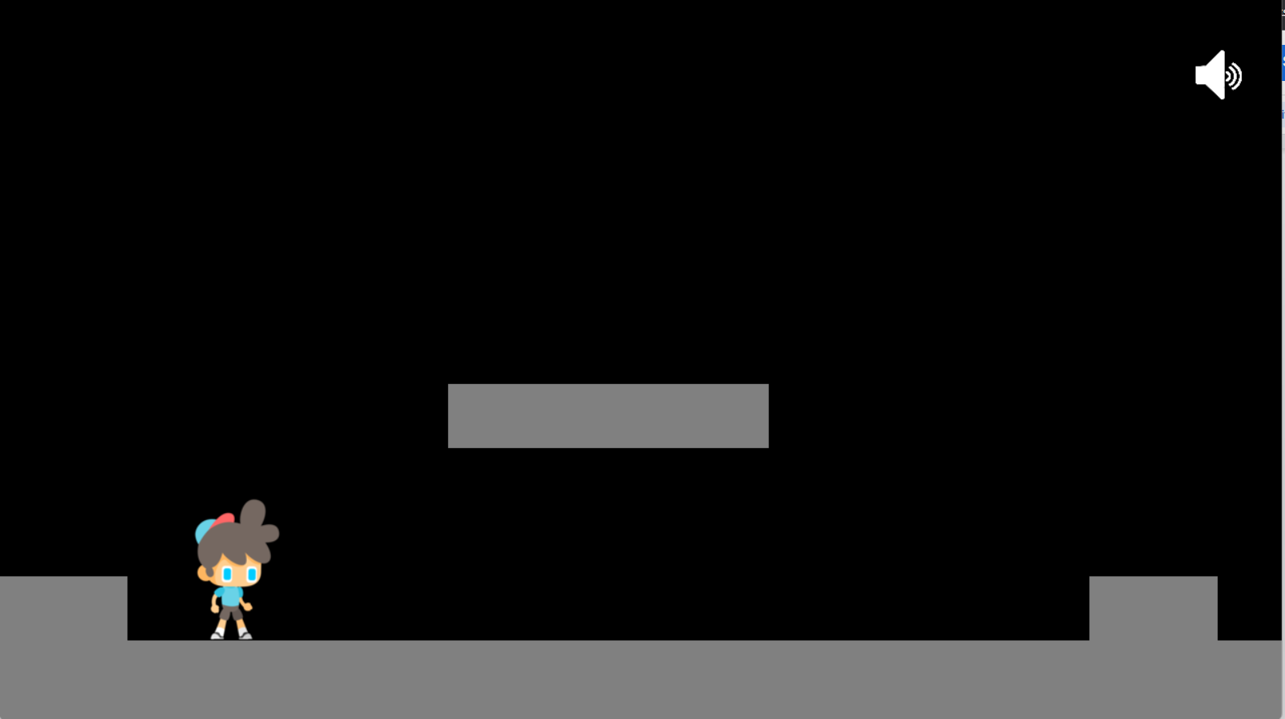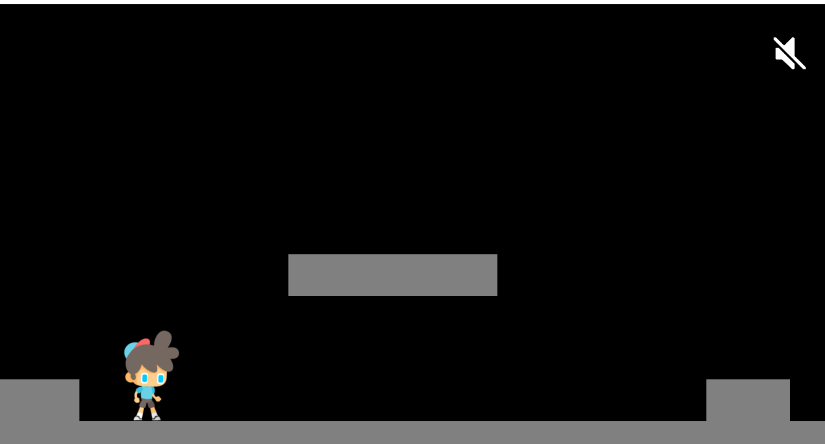

In addition I linked the two python files together, where the main.py would change the values in the settings.py for which game.py would read.



In the settings.py i moved the charcter_used variable there, so it can be accessed later on

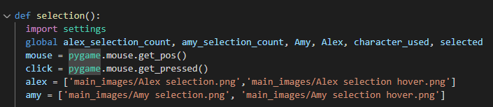

In the selection() function from the main.py the settings.py is imported.

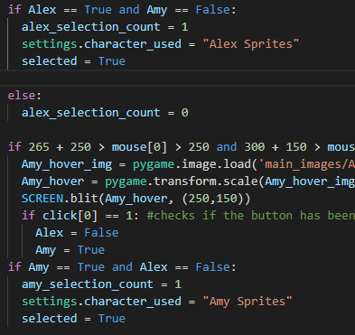

Then once the character is selected it sets the character_used in the settings.py to a certain value which is the folder name of each character’s image.

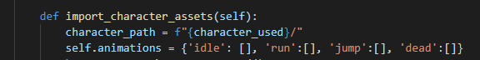

Back in the game.py using f string, the character_used variable is passed in so that the appropriate character’s images are loaded to the game.

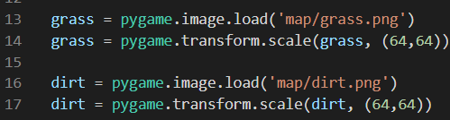

My game map must have some graphics, therefore I started importing some images and resizing them to be the same as the tile_size to fully fill in the surface.

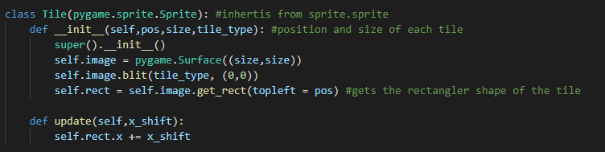

First I made changes to the tile class adding an extra parameter, “tile_type” which will pass i which image to use, so that it can blit it on the surface

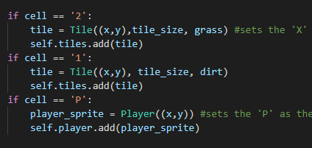

In the levels class when the code checks for the values in the text file and instead of replacing the 1 and 2 with a solid colour, it now replaces the 1 with dirt and 2 with grass, then calls the tile class and passes the parameters so it could be blit on the screen.

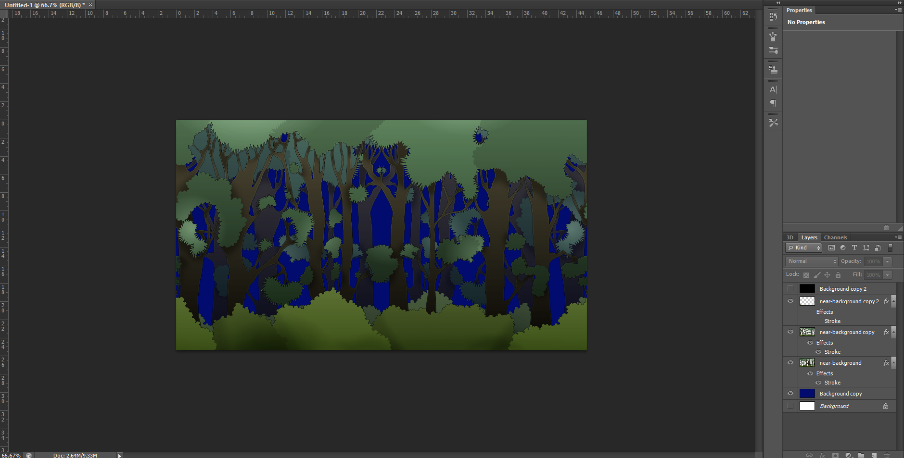

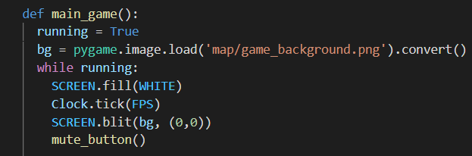

I made a background for the game using Photoshop, I stuck to the client requirement which was to have the game dark themed, then I imported the image into the program and blitted it on the screen.

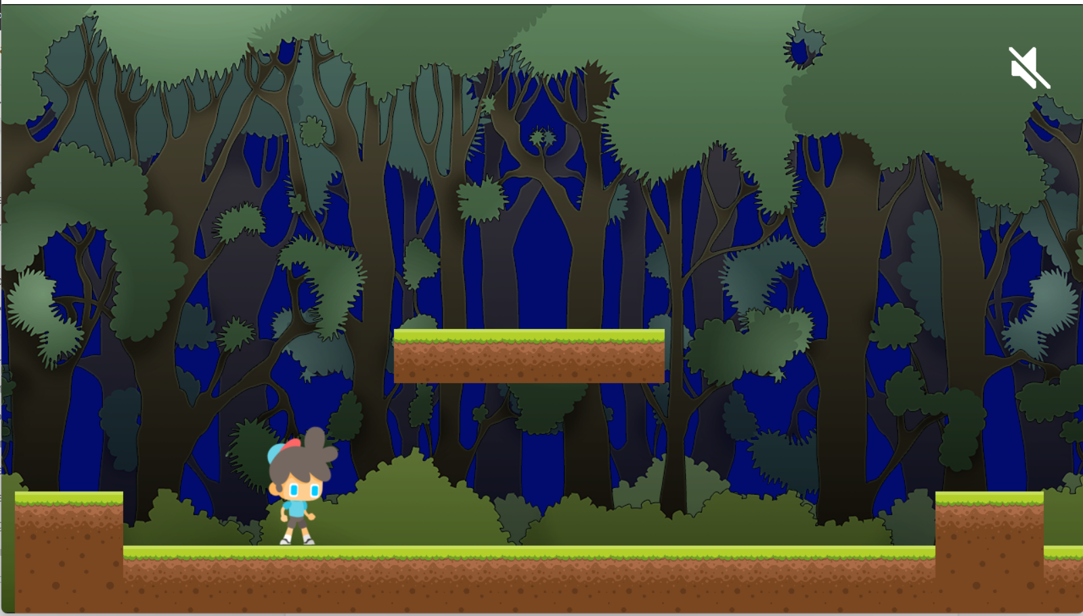

**Scrolling background:**

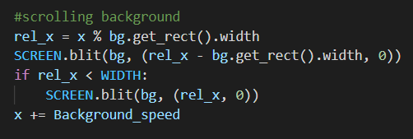

Furthermore to make the game look more realistic I made the background move along with the player, however I set the speed to be different from the self.world_shit as if something is far it would move slower than if it was closer. The x value is a global value which keeps incrementing by the background speed.

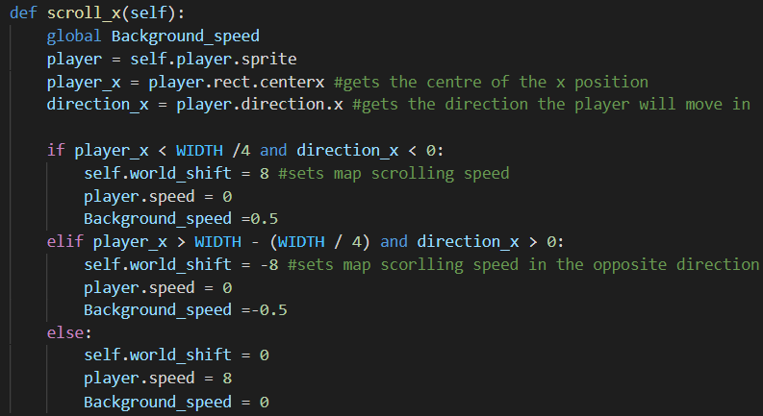

Back in the scroll_x function in the level class, I added the global “background_speed” which is set to 0 by default. And when the player makes the tiles move it will make the background also move by setting their speed to 0.5 or -0.5 depending on the situation since they are vectors.

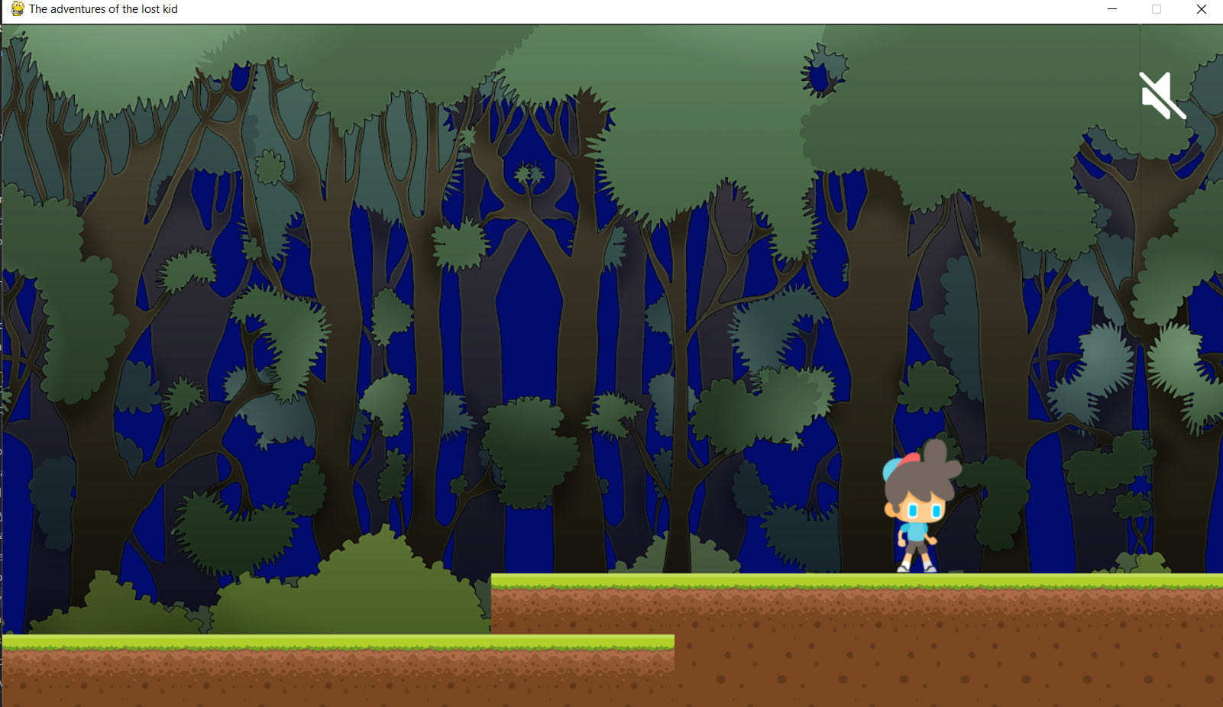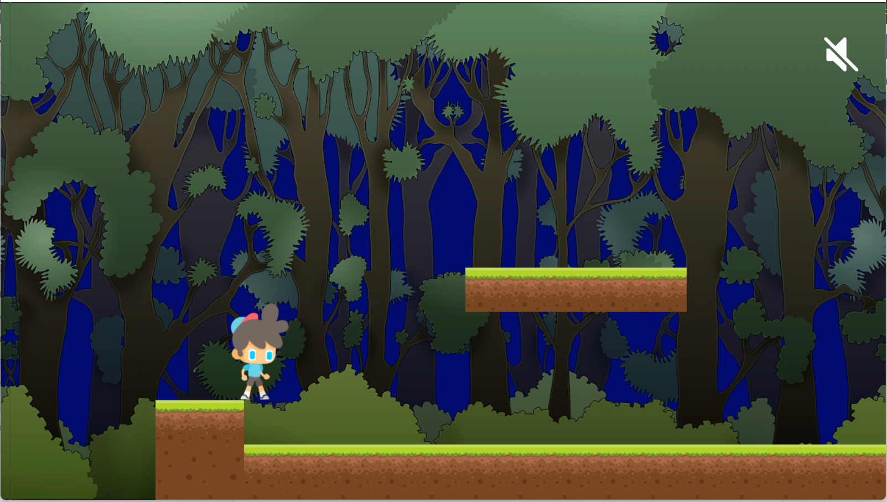

**Mob class:**

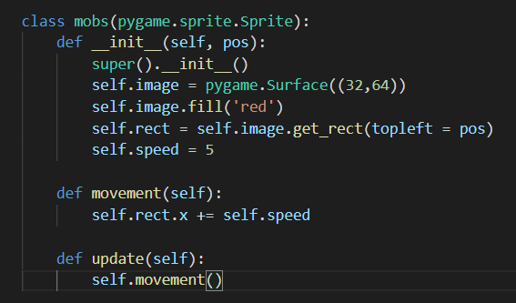

In order for the character to lose lives and have interactions in the game, I made a class for the mobs that will make the character move automatically.

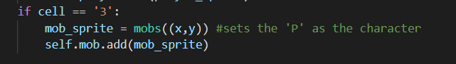

Then calling in the class when “3” is found in the map data and adding it to the sprites.

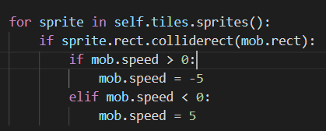

Lastly In the collision function from the level class, it sets the direction of the mob to be in the opposite direction of the collision.

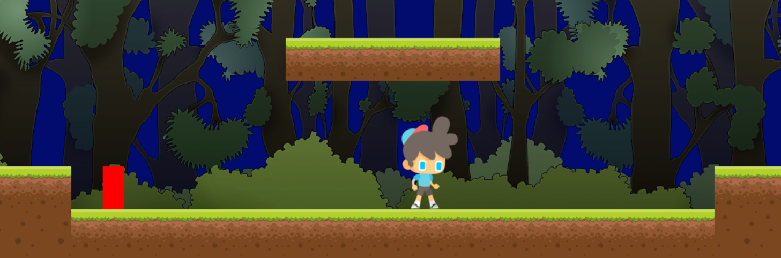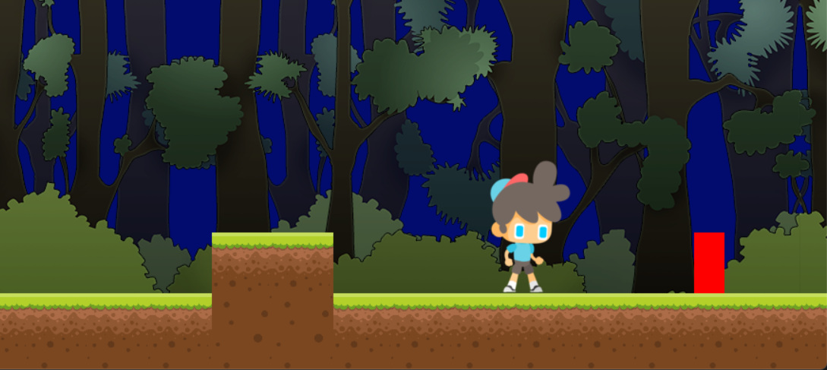

The code was working fine, however since my game has a scrolling map, the mob moves along with the player which makes the mob out of his set position therefore I’ll be using a different approach to make mobs on the map.

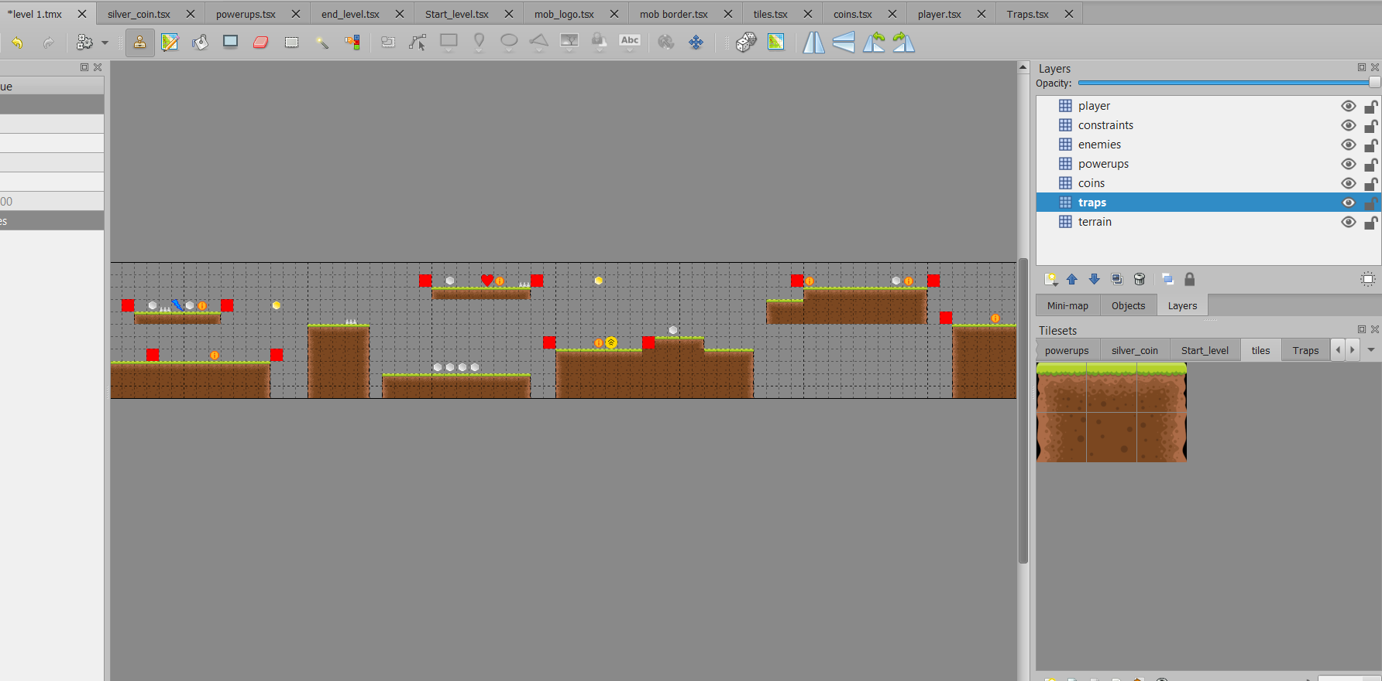

Instead of having the map as a list in python, I used a software called “Tiled” which helps you design the map tiles as well as any other objects in the map such as mobs, traps, coins etc.

The software will then export the project as separate csv files for each layer so that the code can loop through them and read the data.

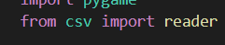

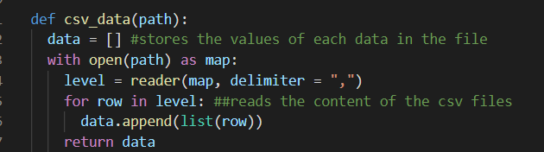

Then I made a function in the settings.py called csv_data that would loop through the data in the csv files and store them in a list (data) and return it. The “delimiter” is a function from the csv library and tells the function that each data is separated by a “,”

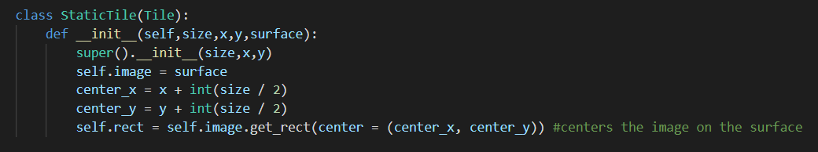

Then added some classes since each tile differs from the other and therefore need to have their own class. The StaticTile which inherits Tile is used for the tiles that are not animated and only have one image to display such as tiles and power ups. The class also makes sure that the images are at the centre of the surface (centre of the tile) by setting its x and y values.

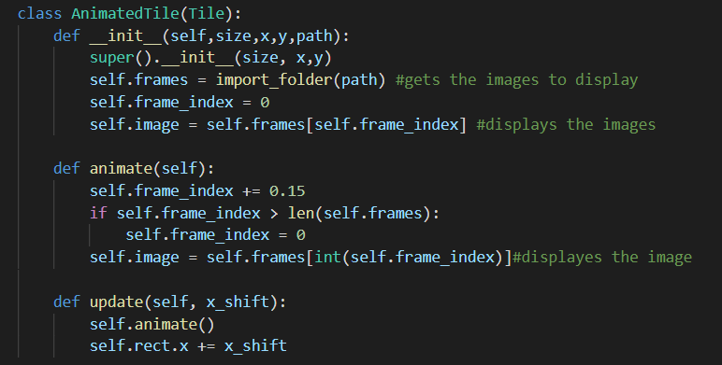

My game will also have animations, such as the player, coins and mob, therefore another class is needed. AnimatedTile is made and inherits Tile class. It uses the import_folder function to get all the images that need to be blit, then the index keeps increasing by the speed of 0.15 looping through the list and bliting the images on the surface.

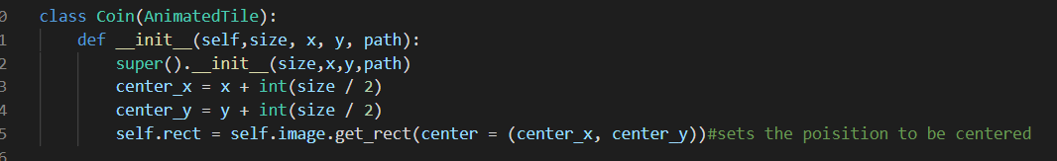

Since the coins are also animated and keep rotating, they can use AnimateTile, however they don't take the full surface so when bliting them they blit on the top left of the tile, therefore a Coin class, inherits AnimatedTile and centres them on the surface.

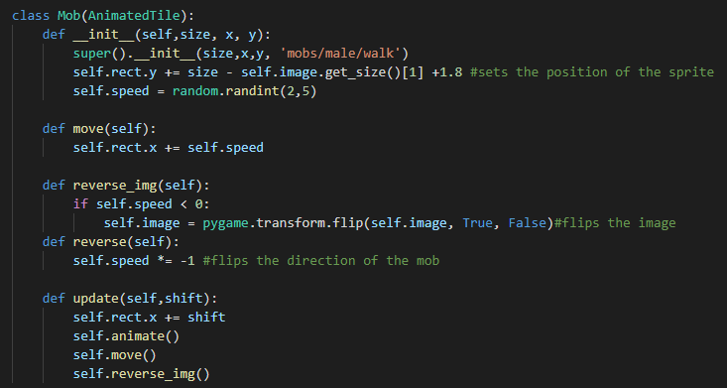

Lastly the mob also needs a class, it inherits the AnimatedTile class as they will be animated, however an extra method is needed which is to make them move and flip the image according to which direction they are walking in. the def reverse_img flips the image, while the def reverse flips the direction. while the def move makes the mob move by changing the x values by a random number between 2 and 5.

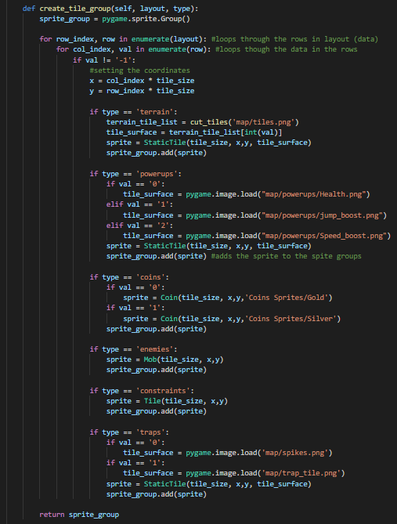

Now that I have all my classes ready, I can loop through the csv data and match the data with the required class so that it can be loaded to the game. The function used the keys in the csv file to tell which is which, e.g. powerups. Once each appropriate data value is given an image to load, the size and its coordinates are added to the sprite group.

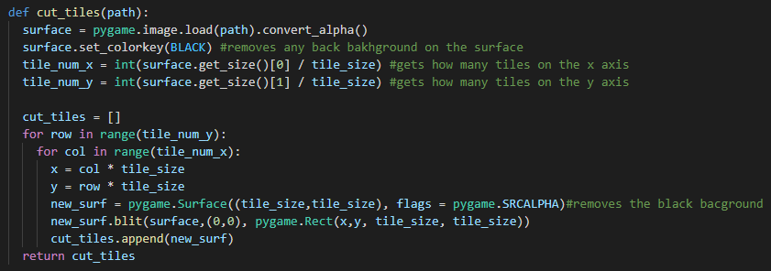

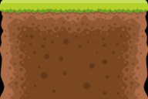

Before I start importing all the data, one further function is needed. In settings.py I made a function called cut_tiles, this function is used for the terrain tiles as when I was making the map, the terrain was in one layer and the images I used were also in one image that was split into multiple sections. Each section of that image was given a value so when it's put on the map it holds a value of a section of the image. This function splits the image into smaller sections which is 64x64 in my case (tiles_size x tile_siz), blits them on a surface, each with x and y coordinates, then stores them in a list and returns that list.

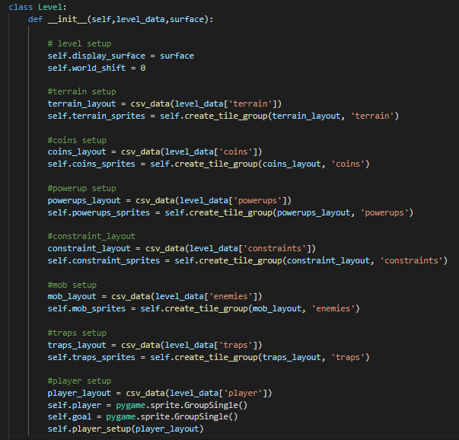

Now back to the level class, and setting up each element of the game, by passing them into the functions and creating a sprite for each. The player has a group single sprite rather than a group sprite because the images will change depending on the input, so the sprites will keep changing. The group single will hold only one sprite removing the old one i.e keeps updating

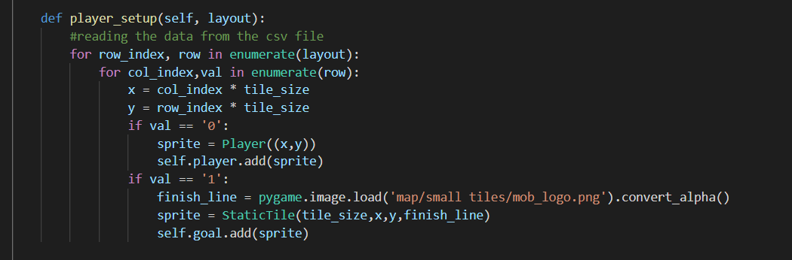

Before running the code one last function is needed, which is the player setup, this function is identical to the create_tile_group, however type attribute (key) is not needed. The function loops through the csv data and checks where the values are 0 or 1, if its a 0 then the player will be blit on the position, and if it was a 1 it will blit the end object that the character needs to collide with to win. For now I used a solid colour for the end object (mob_logo.png) to test how the program would look like.

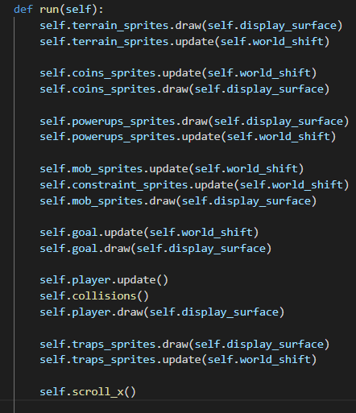

Now in the run function from the level class, i called all the functions and sprites that will be blit on the screen by drawing them, and updating them by the world_shift (moving them along if the player moved)

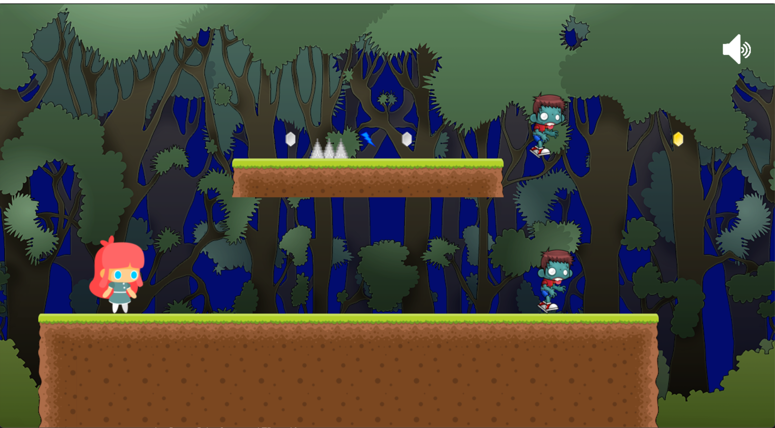

After running the code, everything works perfectly except for the mobs, once they reach the end or where they should change direction, they keep walking in that direction and do not change direction.



To fix this, in the Level class I made a function mob_collisions which checks if the mob collided with a constraint (not drawn on the screen), if so then it will call the reverse function to change its direction.

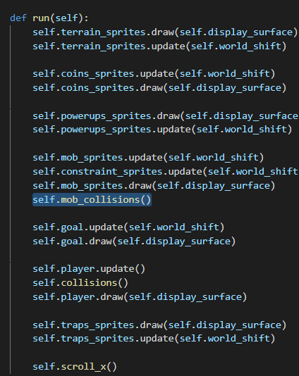

Calling that function, in the run method

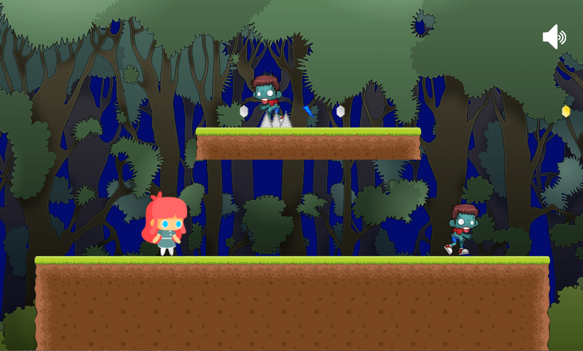

Running the code and testing whether the code works, and it seems to have to. The mobs did change direction and are now moving in the opposite direction as the image is flipped.

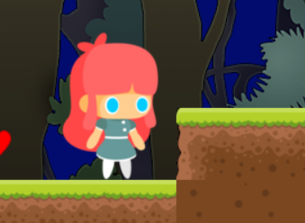

Once running the code, I noticed that the collisions for the x values weren’t as good as they should. The character was getting stopped before even touching the tile.

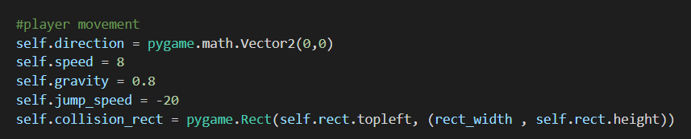

In the player class, in the __init__ function, I added a variable called collision_rect, which is a rectangle with the rect_width and self.rect.height coordinates.

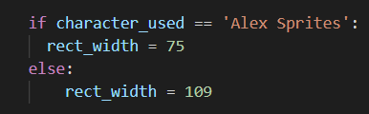

The rect_width can vary between the two characters, therefore i created an algorithm to decide which one to use

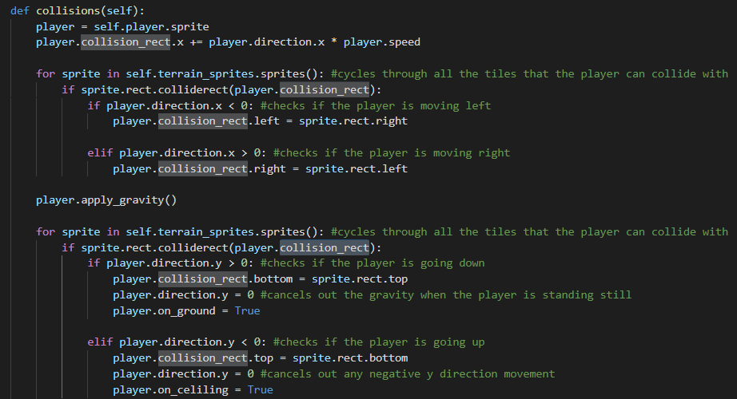

Then back in the collisions method from the levels class, I replaced the “rect” with the “collision_rect” to make the collisions checks using the new width.

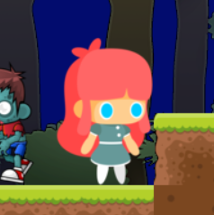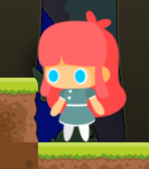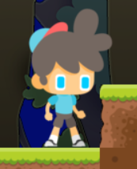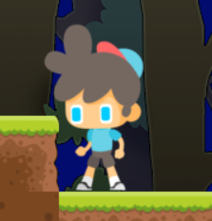

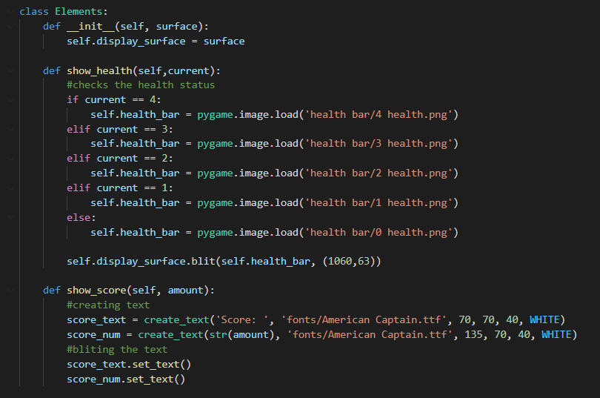

I created a class called element which would display the health and the score on the screen. The show score method uses the create_text class from settings.py to create the text.

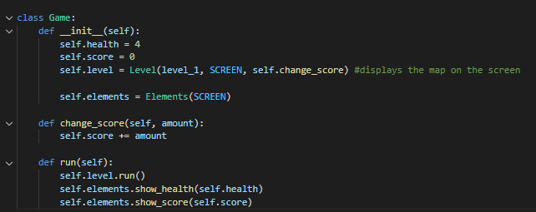

Then I made a class for the game which will keep track of the health and score, and call the methods from the element class.

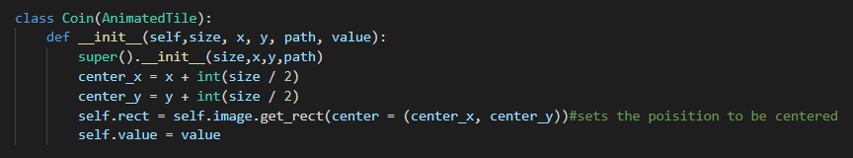

Since my game has 2 different types of coins, (gold and silver) each must have their own value. Therefore in the coin class I added another attribute to assign each their own value.

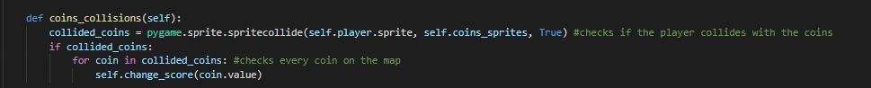

In the level class, I created a method that would check if the player collides with the coins, if the case is true, it would unblit the image from the surface. Then it would call the change score function and pass in the required value.

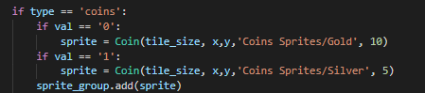

In the level class, in the create_tile_group, when it checks for which coin it is, it passes a value to the class which is how much each coin is worth. The gold coins are 10 and the silver coins are worth 5 points.

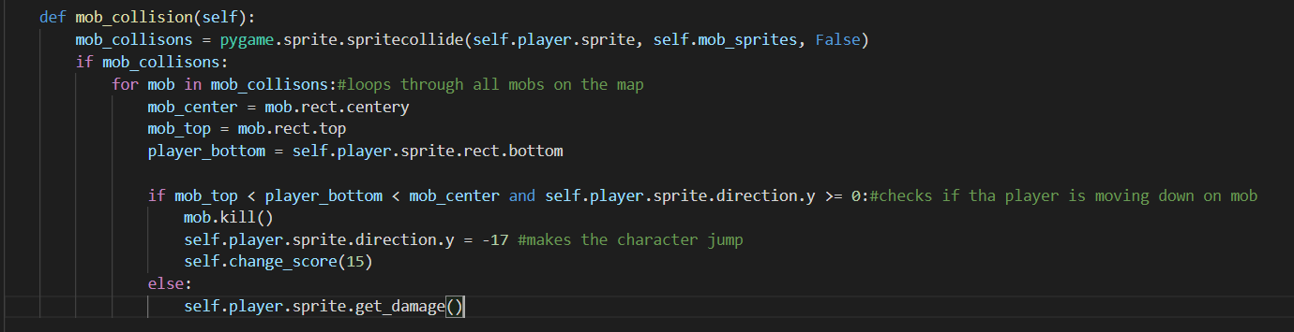

Now to make the player interact with the mobs, i need to check whether they collided or not, this method performs this action. It then loops through all the mobs to see which one the player has collided with.

For the player to kill the mob they must jump on them from the top, therefore a check is needed, once it has been checked the mob.kill() is called and 15 points is added to the score, furthermore, killing a mob would make the player jump to give it a nice effect.

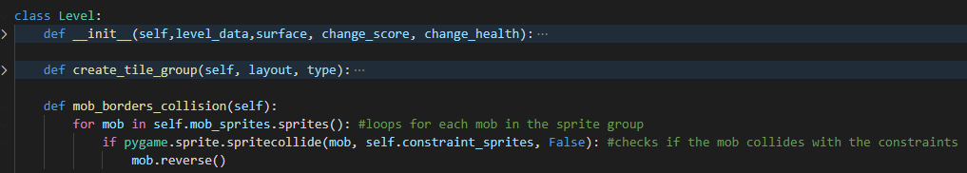

I also renamed the mob_collisions function to mob_border_collision, and gave this function the name “mob_collision” this is because I felt these are more appropriate names.

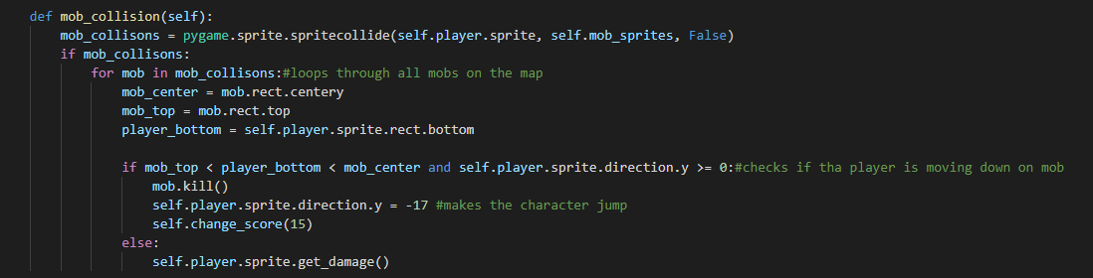

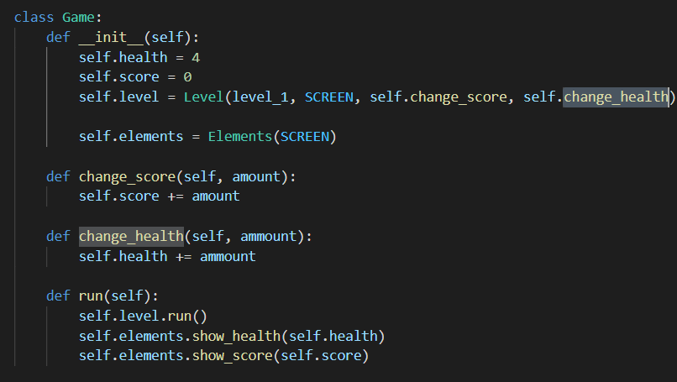

Back in the game class, I added a method called change health which will update the attribute health.

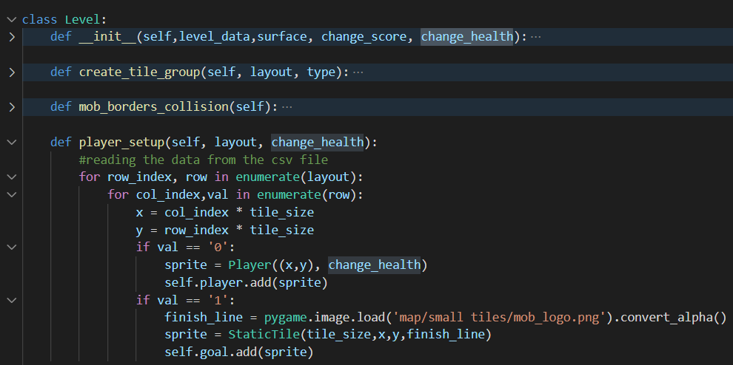

In the Level class, change health is added as an attribute so it can be passed to the player class when it's created.

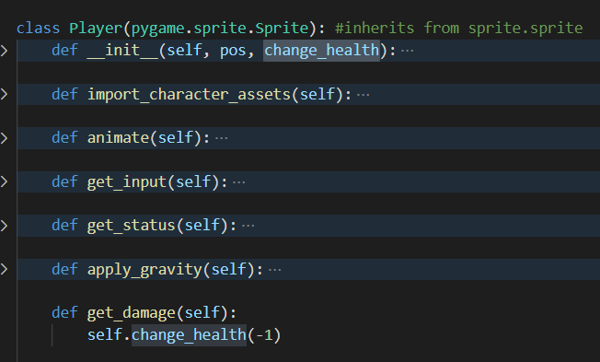

Lastly the get_damage method updates the health using the change_health attribute.

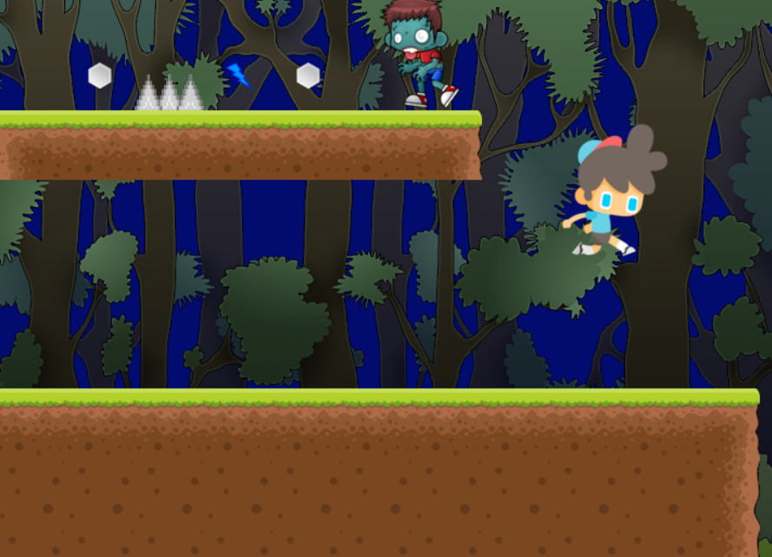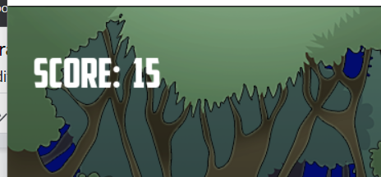

Now running the code, and the code works perfectly, the mobs are disappearing as soon as the player jumps on top of them, and the score is increased by 15

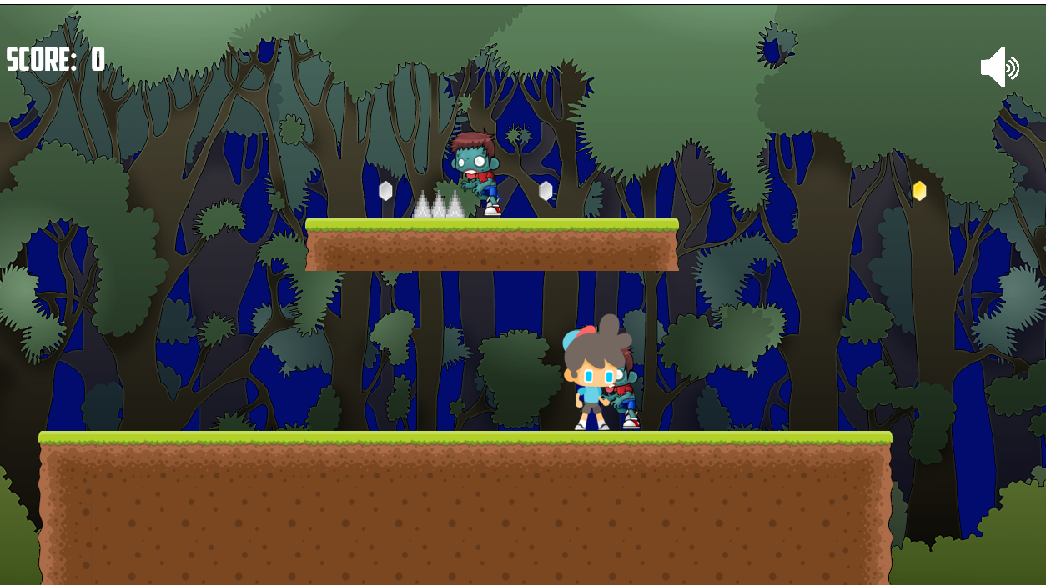

However if the player is colliding with the player, it decreases the health as it should, but it does it for each frame resulting the player to become at 0 health

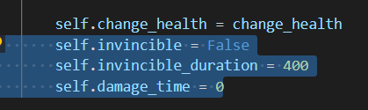

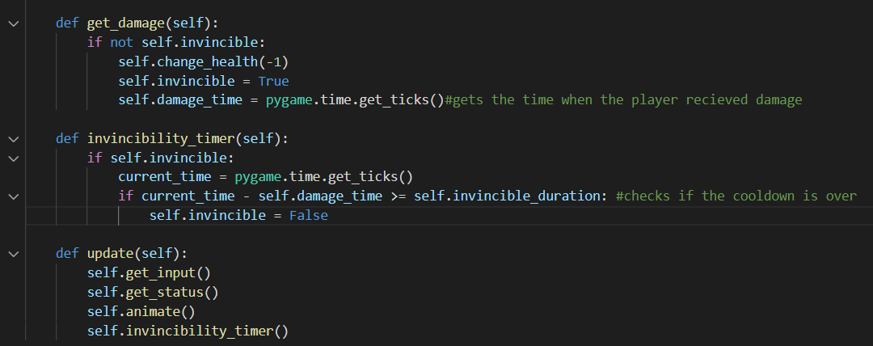

To fix this I added more attributes to the player class, these attributes are used by the get_damage function, where if would check if the player is invincible or not, if not then the damage will be applied and a cooldown will be set for the next time damage is dealt. Which is performed by the invincibility_timer function.

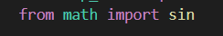

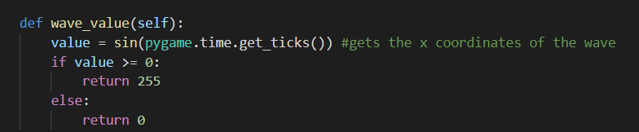

The only problem about having the character invincible is that the player can't tell when he is or isn't, to fix this issue, I used the sin graph which is an alternating graph between 1 and -1. Whenever the x values (x axis the the time) are positive that's when i want my character to be displayed otherwise I want him to go invisible. The wave value then returns the colour key (opacity) of which each x value is.

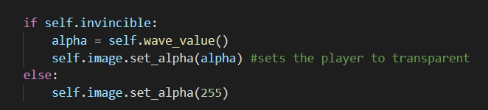

Then in the animate method from the player class, I added a few extra lines. The code checks if the player is ready to be invincible, if the case is True, it calls the wave_value method, and sets the image with the opacity of the returned value (alternating between 0 to 255) otherwise if the player isn't invincible the player’s opacity is 255.

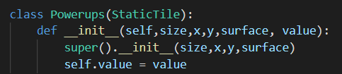

In order to make the powerups work, first I’ll need to be able to tell which is which, therefore in the powerups class, I added an attribute called value, which is a string that would be assigned to each powerup type.

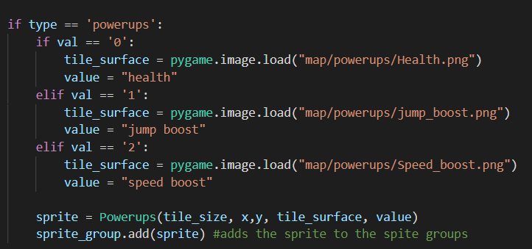

Back in the level class in the create_tile_group, I added a value for each type of the powerup. Then the value gets passed to the powerups class.

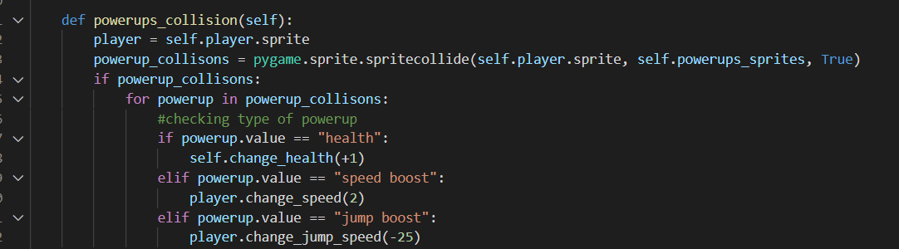

In the level class, I created a method that would check if the player collided with a powerup, if so it will delete it and check the type of powerup, depending on the type different methods are called.

E.g.

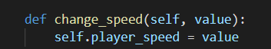

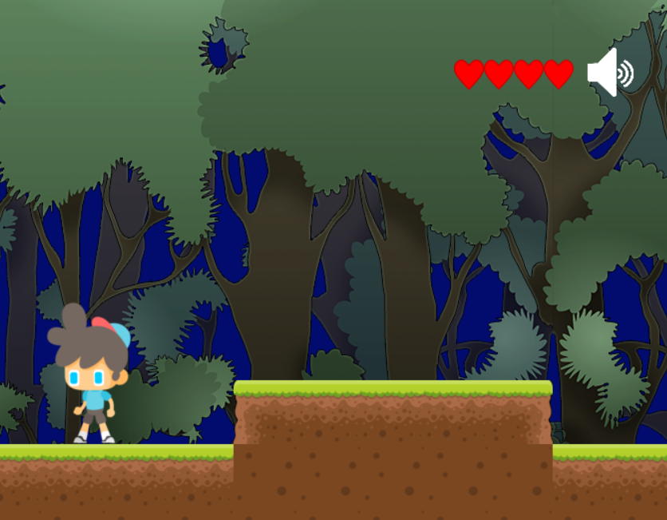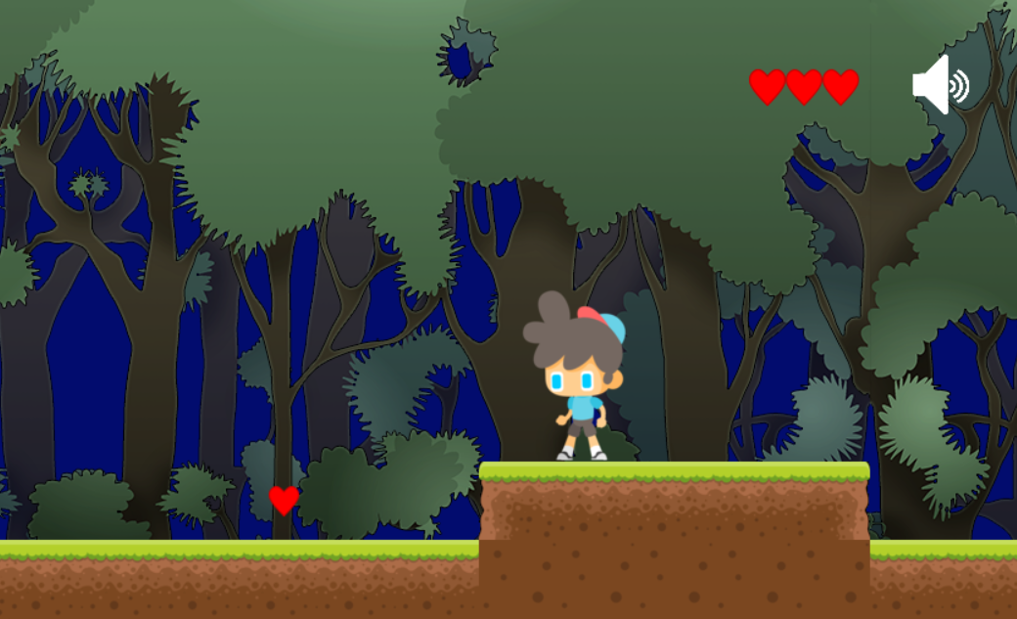

After testing it out, each powerup worked as it should, perfectly as intended.

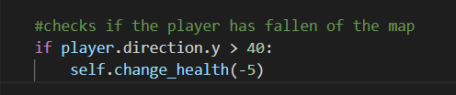

There was one last problem with the health management, which was that the player wouldn't die if he fell off the map, therefore in the collision class I added an extra 2 lines of code that would check the y direction of the player, and if it was above 40 it will kill the player dealing max damage.

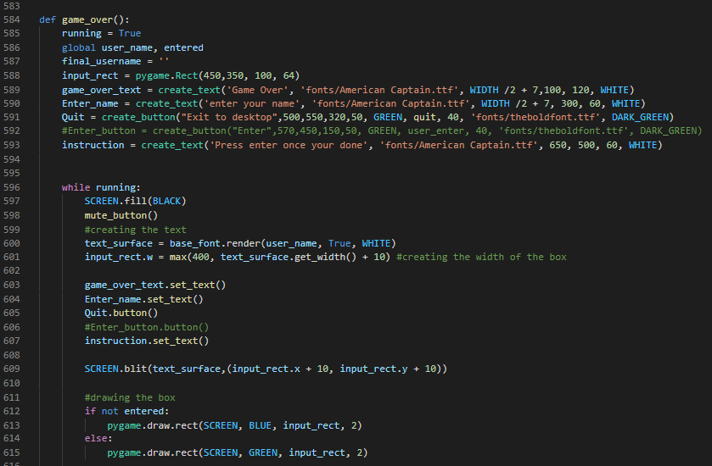

Once the player dies, a game over screen must show up, where it would ask for his name so that it can be added to the leaderboard.

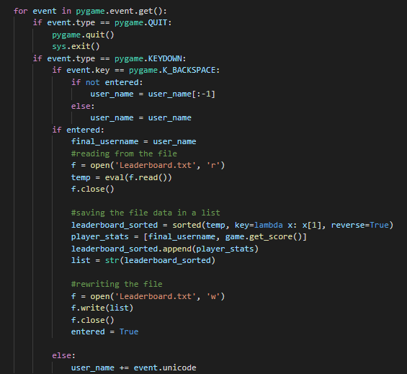

The function then waits for user input, once they press the enter key, the global variable “entered'' would be set to true stopping the user from making changes to name, allowing the program to open the leaderboard txt, read from it and save the list in a variable, once it's saved it gets sorted, then a list is made containing the name that the user wrote and their score. Then the two lists are merged and rewritten to the file.

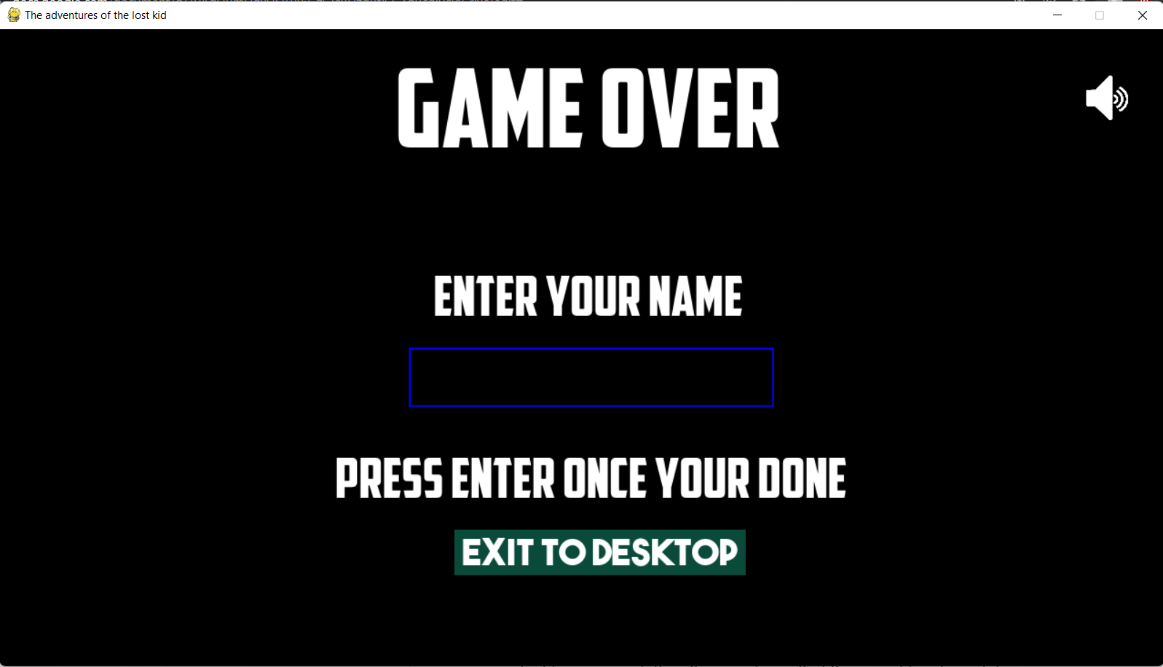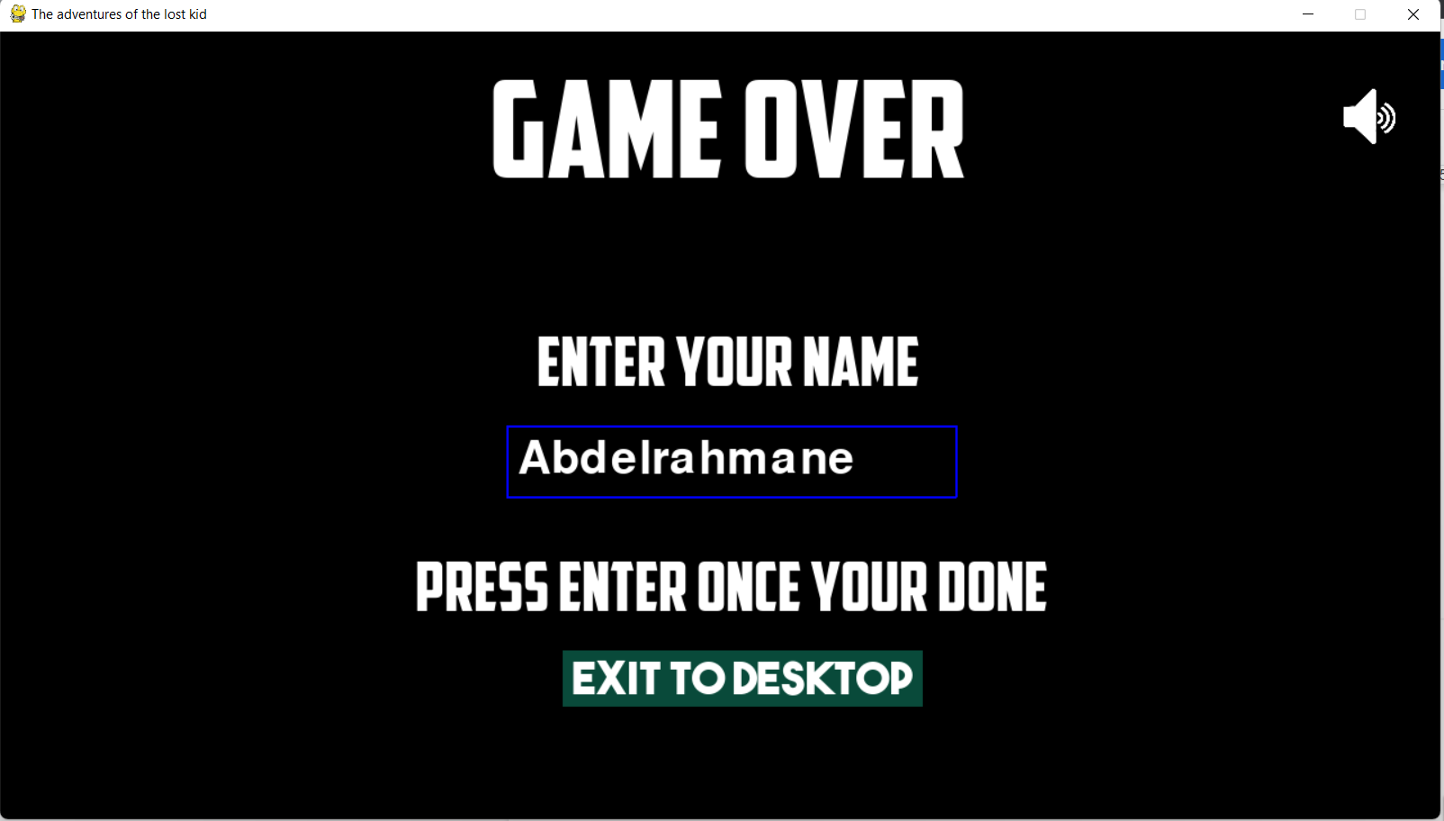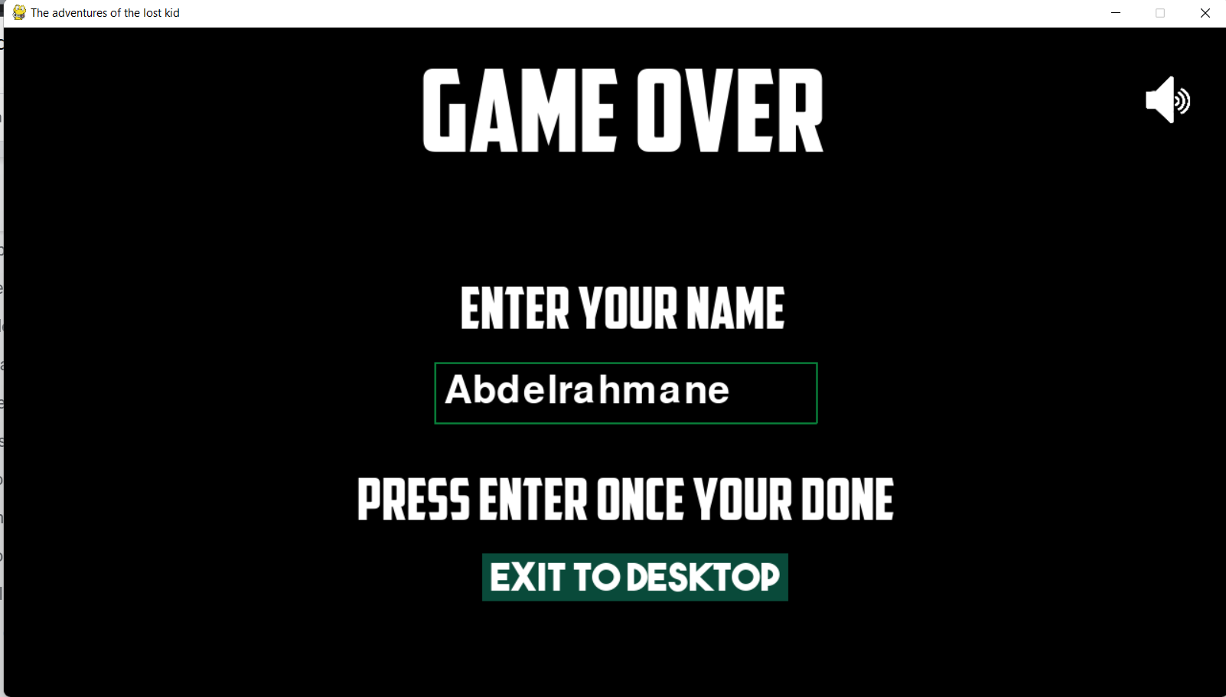Once the user presses the enter key, the border around the text turns green letting the user know that their input has been taken.



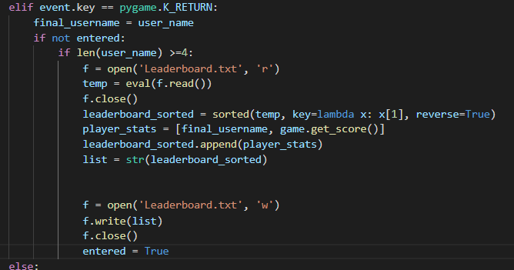

To make sure that the user enters a suitable name, I added code that checks if the username the player has imputed is at least 4 so that it can be added to the leaderboard.

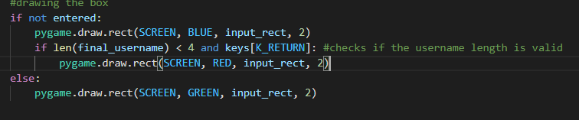

Otherwise it will draw a red box around the text, informing the user it was invalid

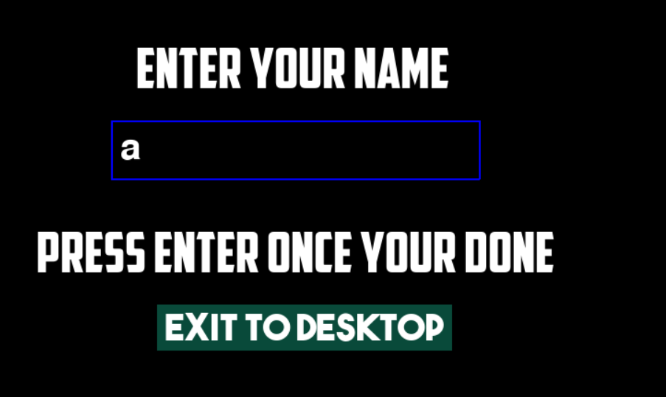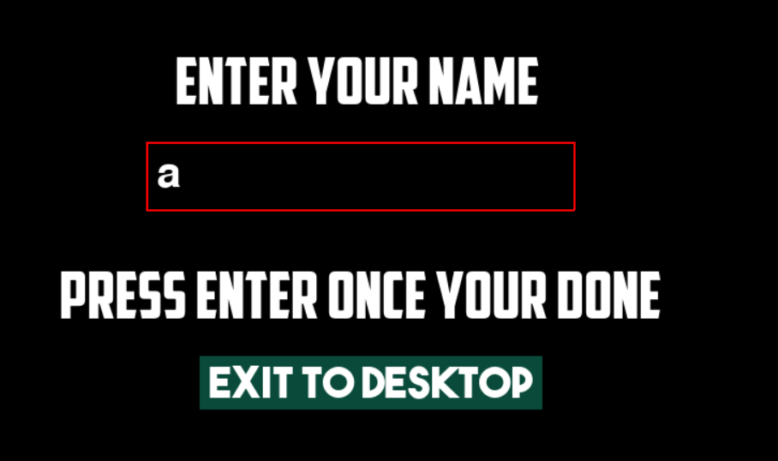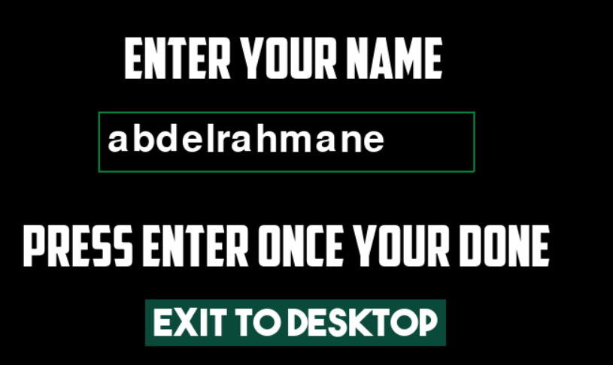

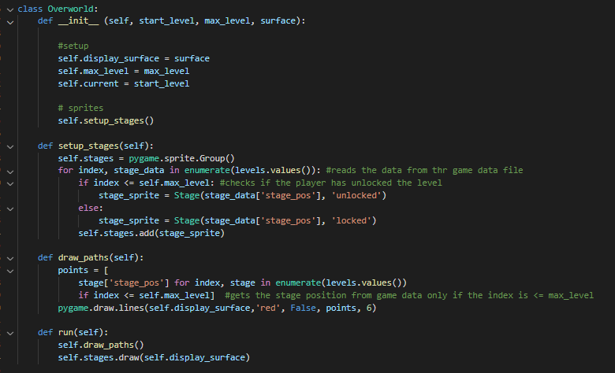

Since the game now has all the features required and ready to be played, I need to add more levels to it so that the playtime will be longer, and to achieve this, I will make an overworld where a player will be able to select the level he wants to play. However they can only choose between the levels they have unlocked by completing the previous level. I made an Overworld class which takes in the level the player is on, the highest level the player has unlocked and the surface where it would be displayed, then I made a method to get the data and find out which levels he has unlocked, since i set the max level to 3, i made a check where it would check the index if its higher than that number, if so then the level is not unlocked yet and the data gets passed to the Stage class then added to the Sprite group. In addition, I linked each with a line using pygame’s draw line function, and in the function that I made for this purpose (draw paths) it reads the data from game_data.py. And gets the coordinates of each stage and draws a line between them if the index is less than or equal to the max level.

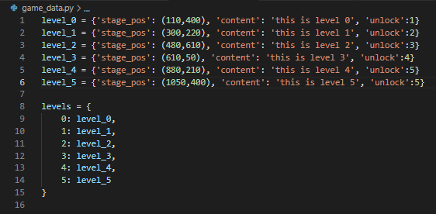

Game_data.py which stores dictionaries of the coordinates of each stage (on the overworld), the title of it and what each unlock. Then each dictionary is stored in one dictionary so it will be easier to be called later

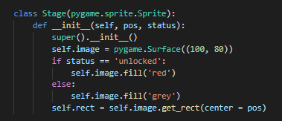

The stage class which inherits from pygame.sprite.Sprite and takes in the parameters position and status draws the the boxes for the stages on the overworld depending on the status.

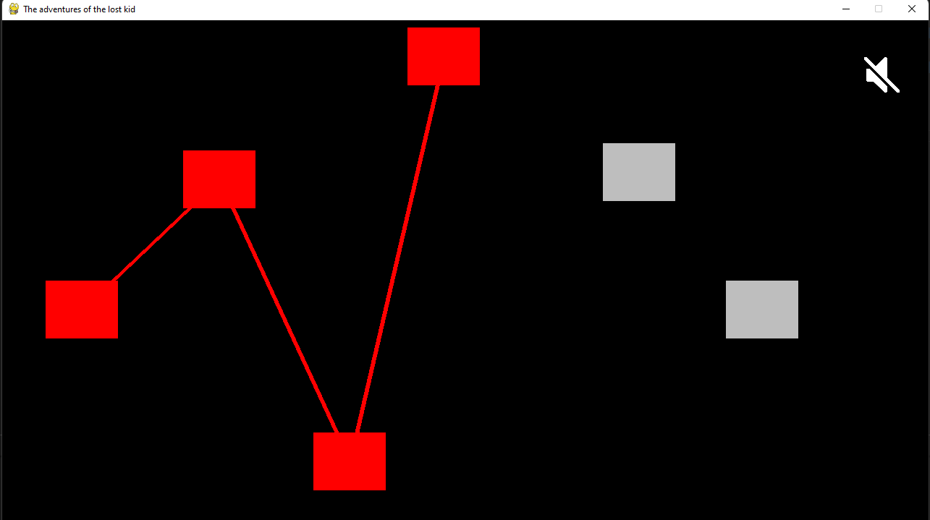

Running the overworld class and this is what it looks like so far.

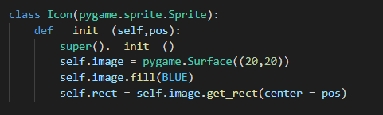

The user must know at which stage they are standing on, therefore I created a class that draws a small box at the position of the player.

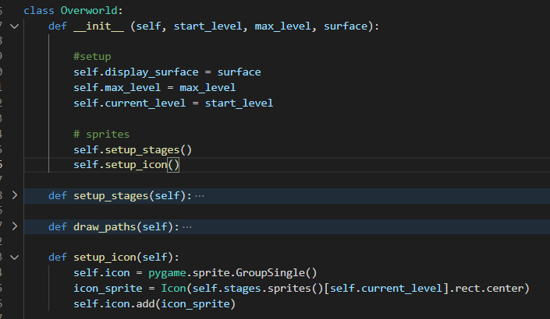

Then in the Overworld class, I created a method that makes a sprite for the icons, and passes in the values to the Icon class.

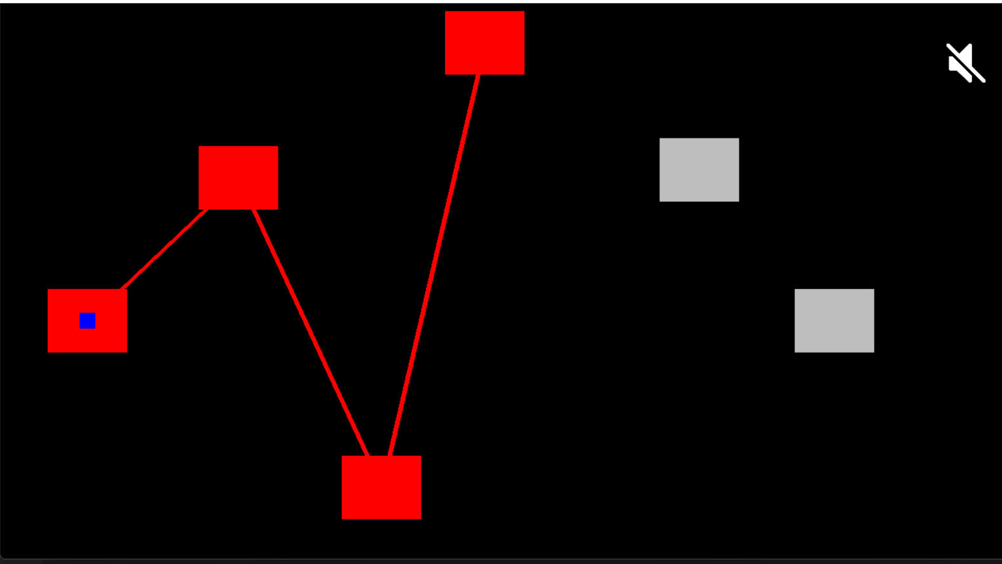

This is how the output looks like.

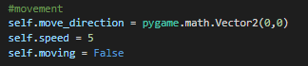

Setting up more variables to use in the class

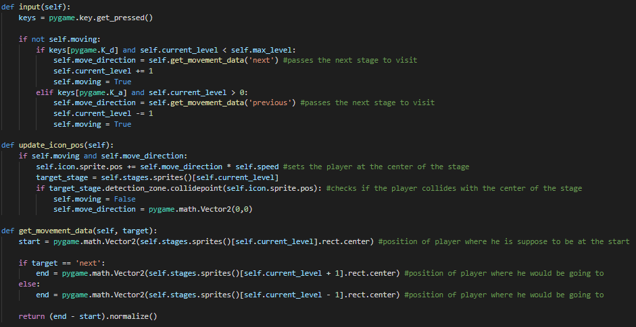

Then to get the character to move, I added a few more methods in the class. The input method gets the inputs the player has entered, then depending on the input it will add or subtract 1 stage and either pass “next” or “previous'' to the get_movement_data method.

The get movement data function gets the value by how much the player should move, it first gets the vector location of the player where he currently is (x,y) then depending on the next stage he is heading to, it will subtract the original location from it and return the value to move.

Finally the update_icon_pos method ensures that the direction the player is moving to is towards the centre of the stage rect, it also makes the player stop once he has reached the centre of the stage rect by using the collision detection, and setting the self.moving to false and the moving direction vector to 0

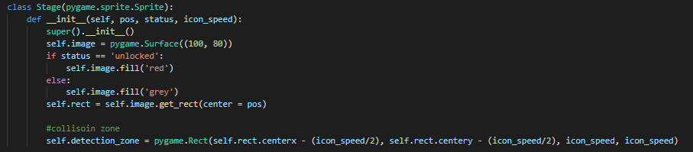

Back in the Stage class I added the self.detection_zone, which is a rectangle on the stage rect where the player should stop once it has hit it.

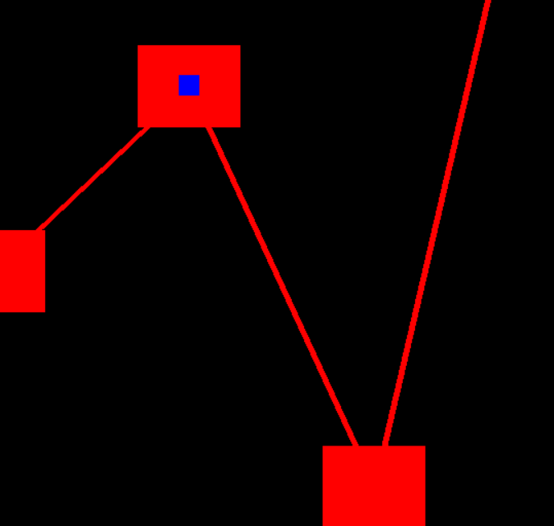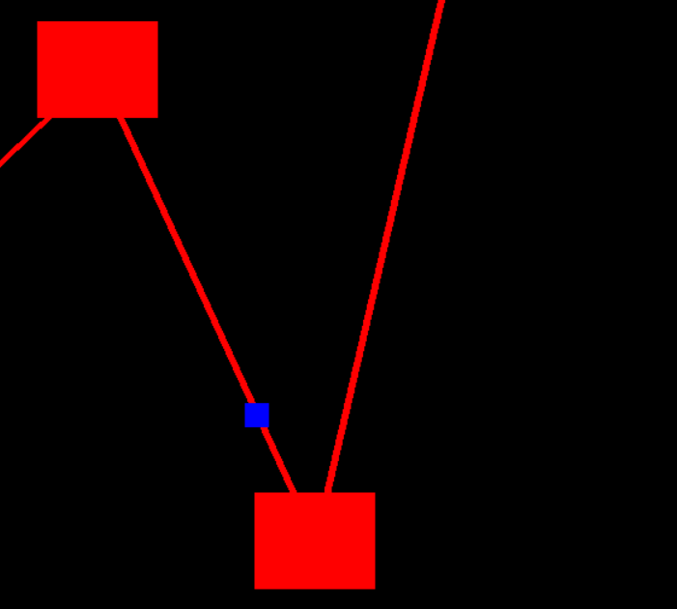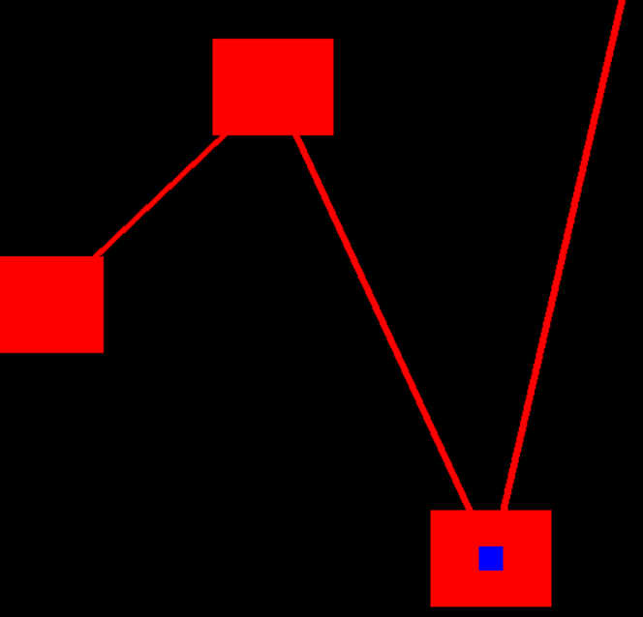

After running the program this is how it works and the blue rect moved successfully to its target when the key is pressed.

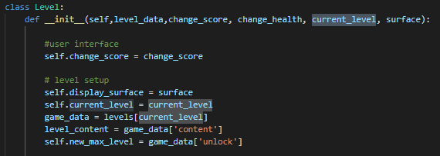

Now that the overworld functions, I need to make it work as it's intended to, such as loading the required level. Back in the level class, I added an extra attribute called current level, the class would load the data of that level, to be more specific its content(self.level_content) and what it unlocks (self.new_max_level).

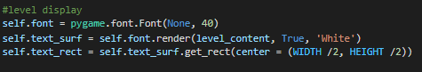

Then adding the content text to be displayed on the screen.

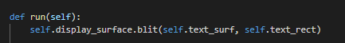

And its drawn from in run function in from the level class.

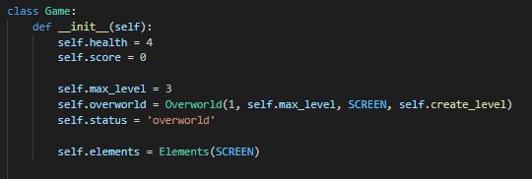

In the game class I added a new variable (self.status) which stores if the player is in the overworld or in the level, and since I want to load the overworld first, it will be set to “overworld” by default. Furthermore in the overworld class the function self.create_level is passed in.



The create level function loads the level that's needed, and that's determined by the “current_level” variable. Then it sets the status to “level” so that the game can start.

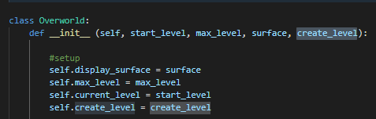

In the overworld class, an extra attribute is added which is create level, its passed in so that the function from the level class can be used.

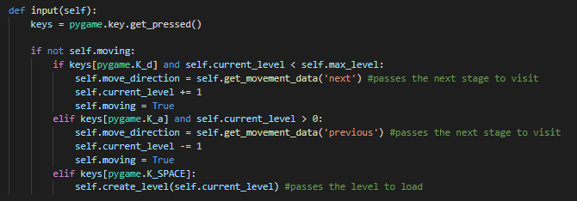

In the input method, once the user presses the spacebar key, it would load the function and pass in the current level the player is standing on

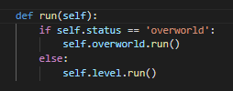

Lastly in the run method from the game class, the method checks the status and if the player is still in the overworld, it will load it otherwise it will load the level.

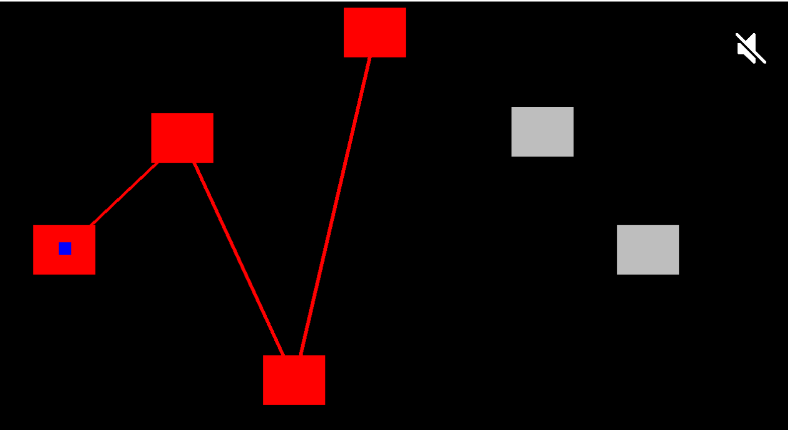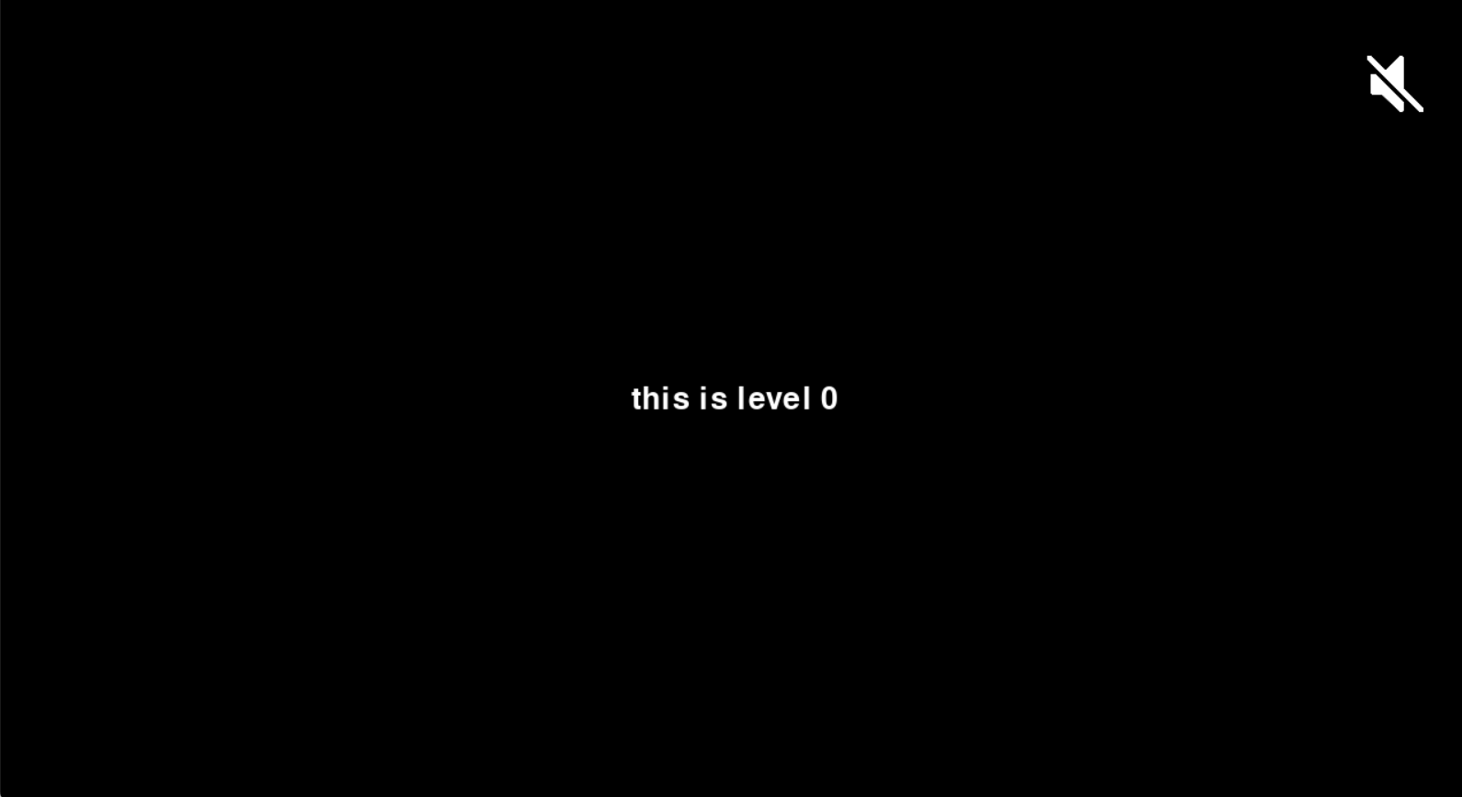

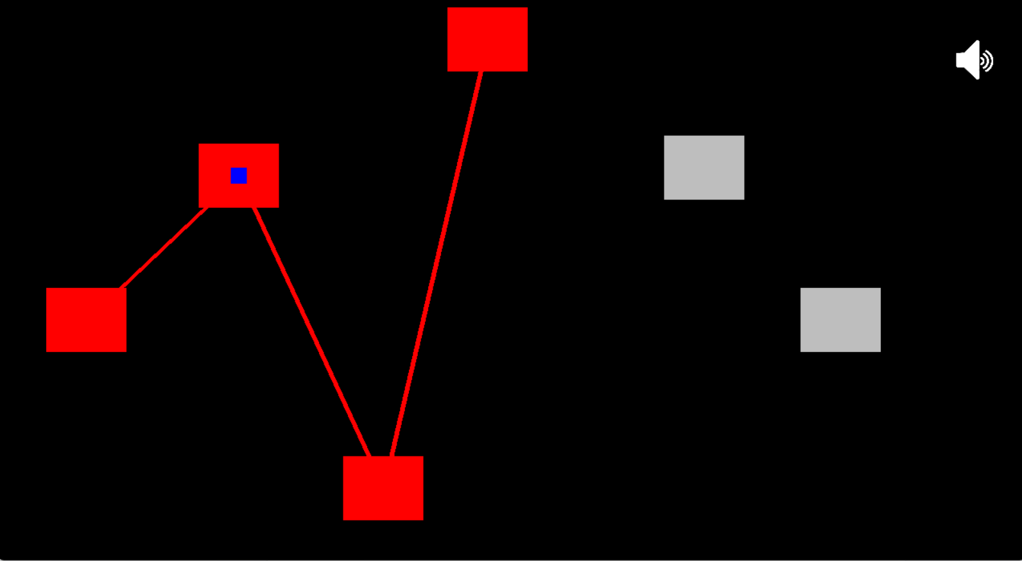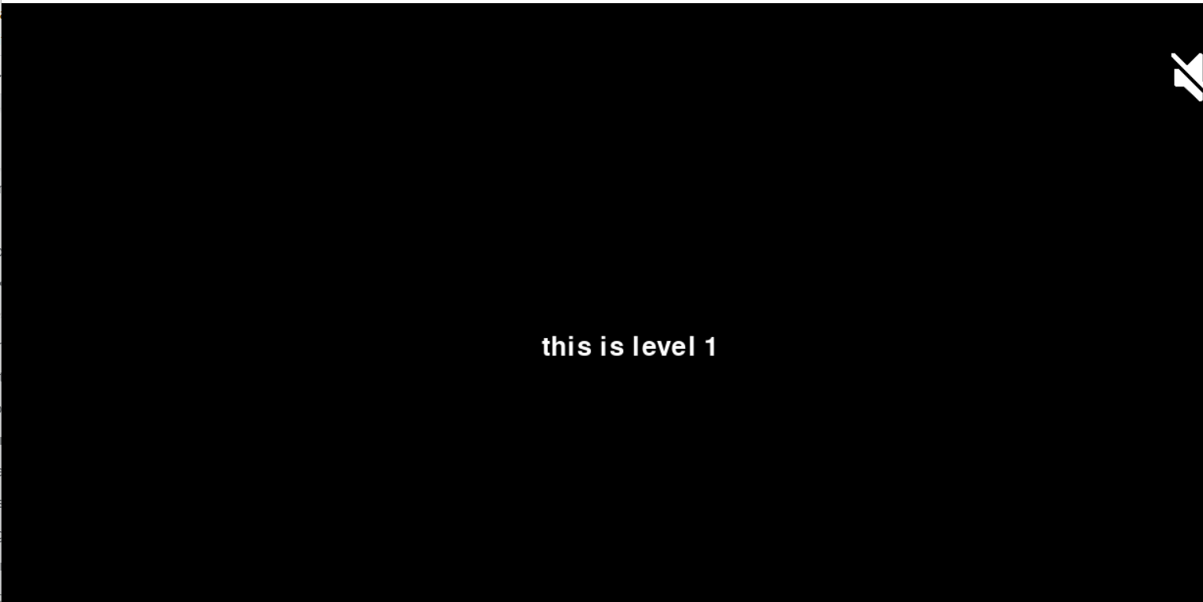

This is what the program looks like/loads once the player presses spacebar on different stages.

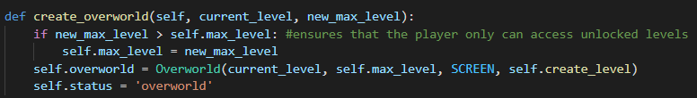

Since the overworld will keep changing every time a player completes a level, i had to make a code that performs such action, the create_world function from the game class has parameters which are (current level and new max level) the function first checks if the player has unlocked the level by comparing the max level the new max level, if the case is True the max level will be set to the new max level. Lastly the function calls the overworld class passing in the new updated values and setting the status to ‘overworld’.

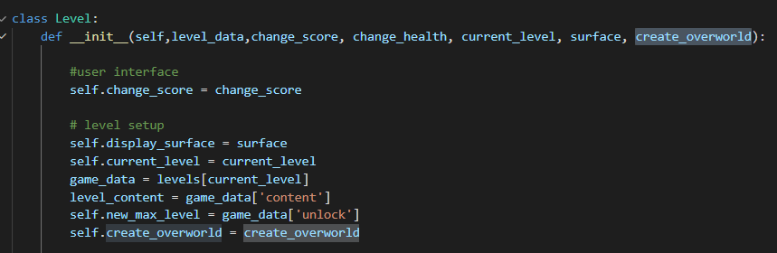

Back at the class level, I added an extra attribute called “create_overworld”, which will be used to access the function from the game class.

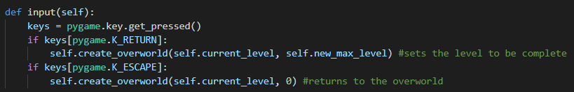

To test if this approach is working, I made a method in the level class which takes in inputs, if the user presses the enter key, the next level will be unlocked, otherwise if the player presses escape no further levels are unlocked.

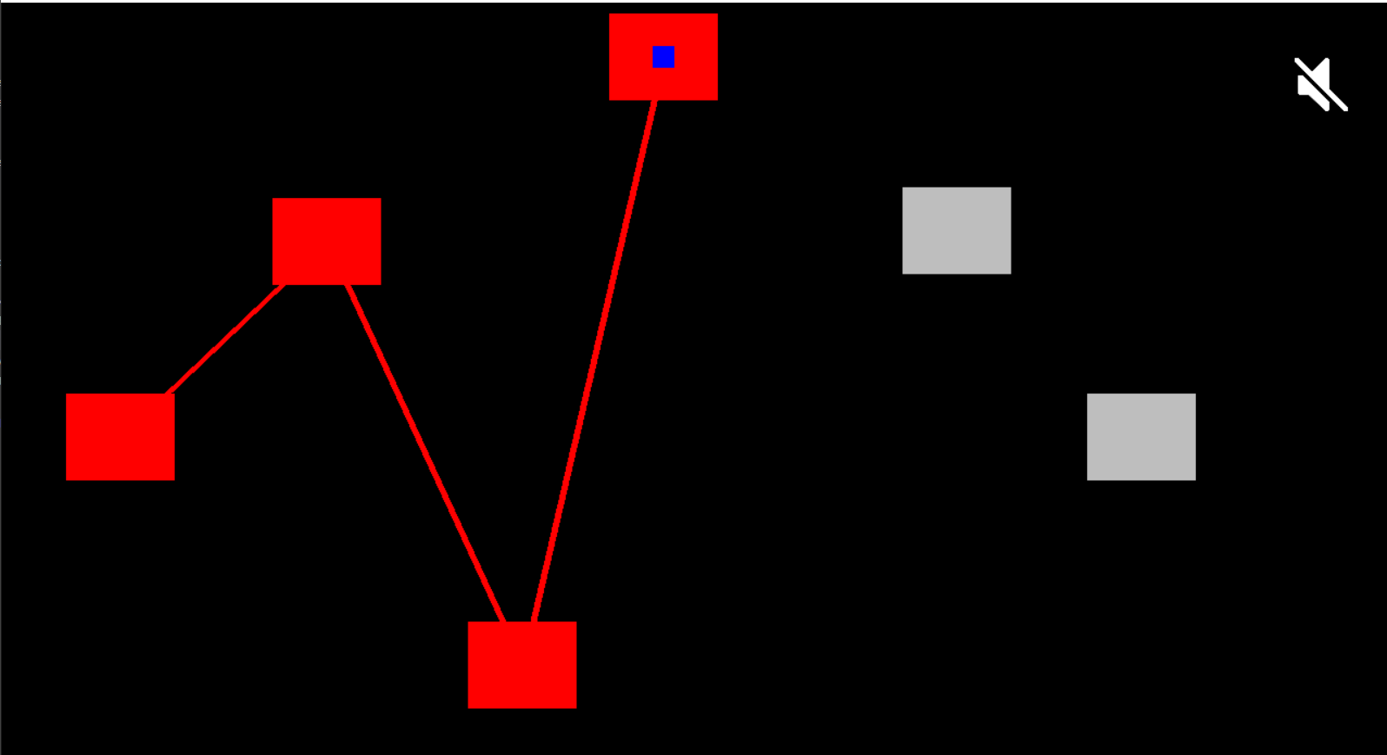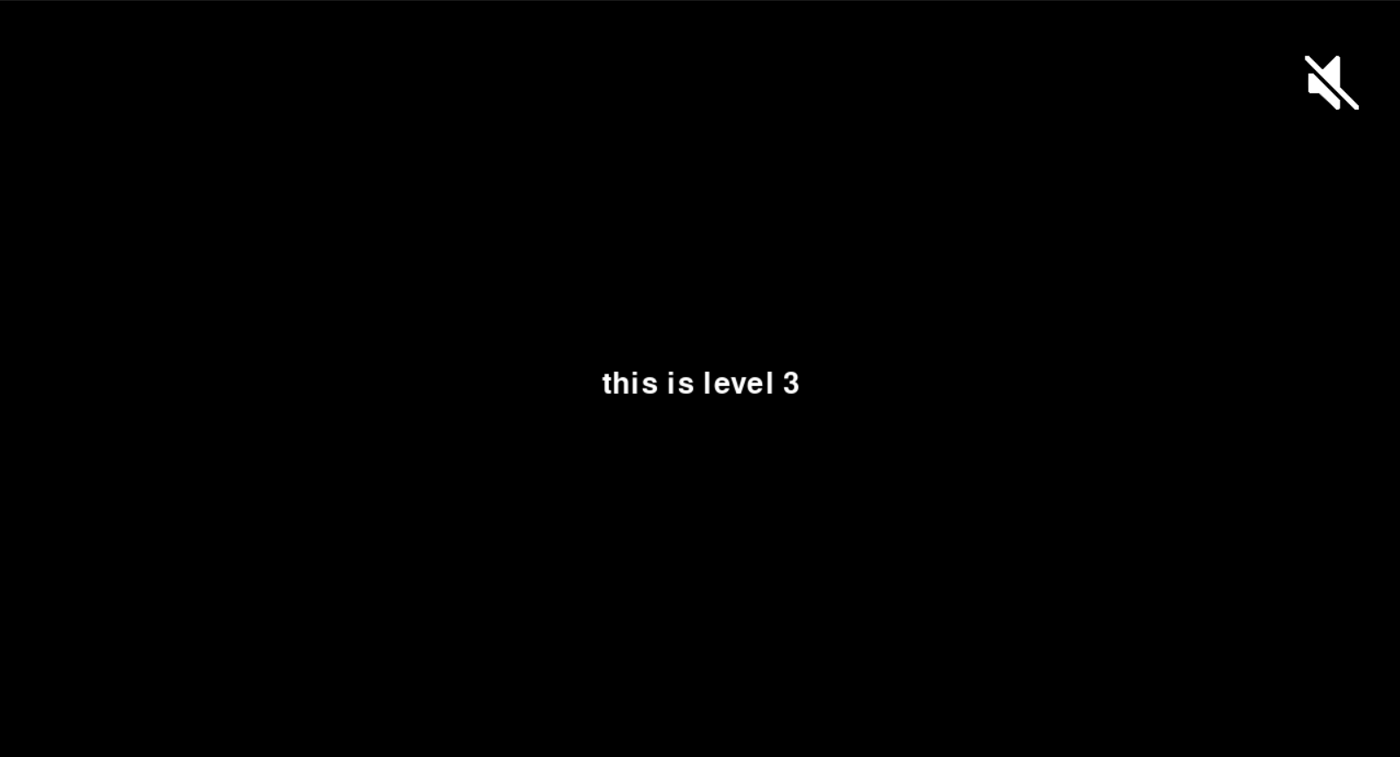

Now pressing the enter key:

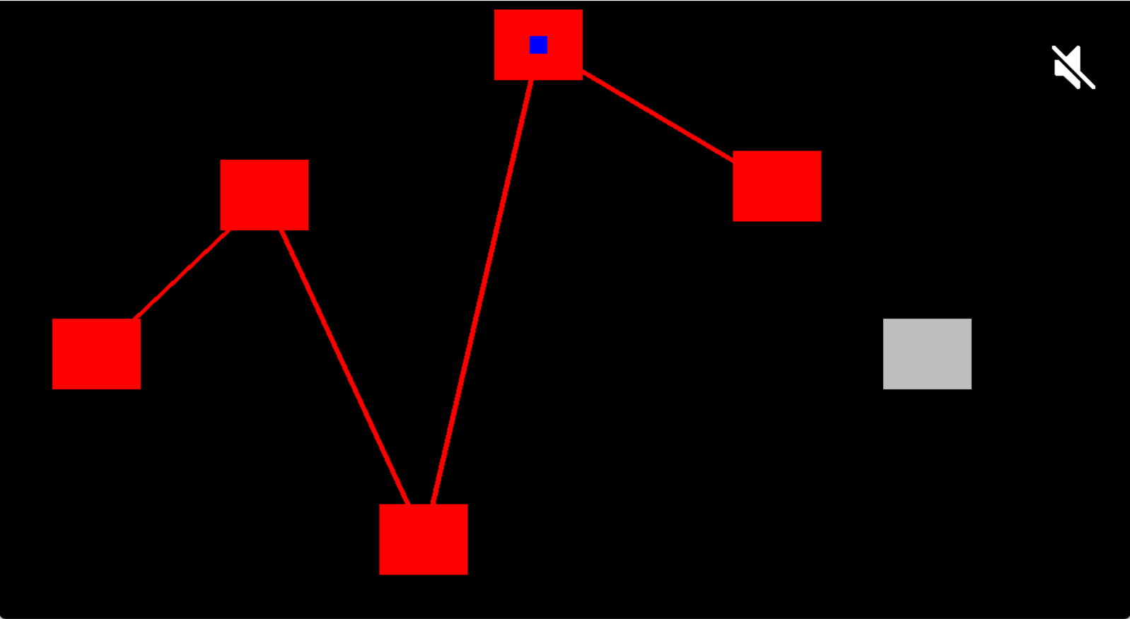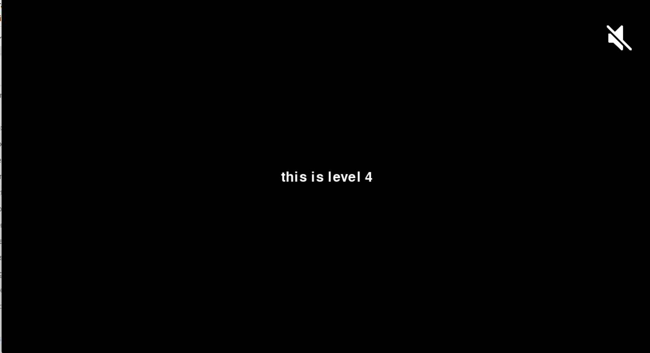

Now pressing the escape key:

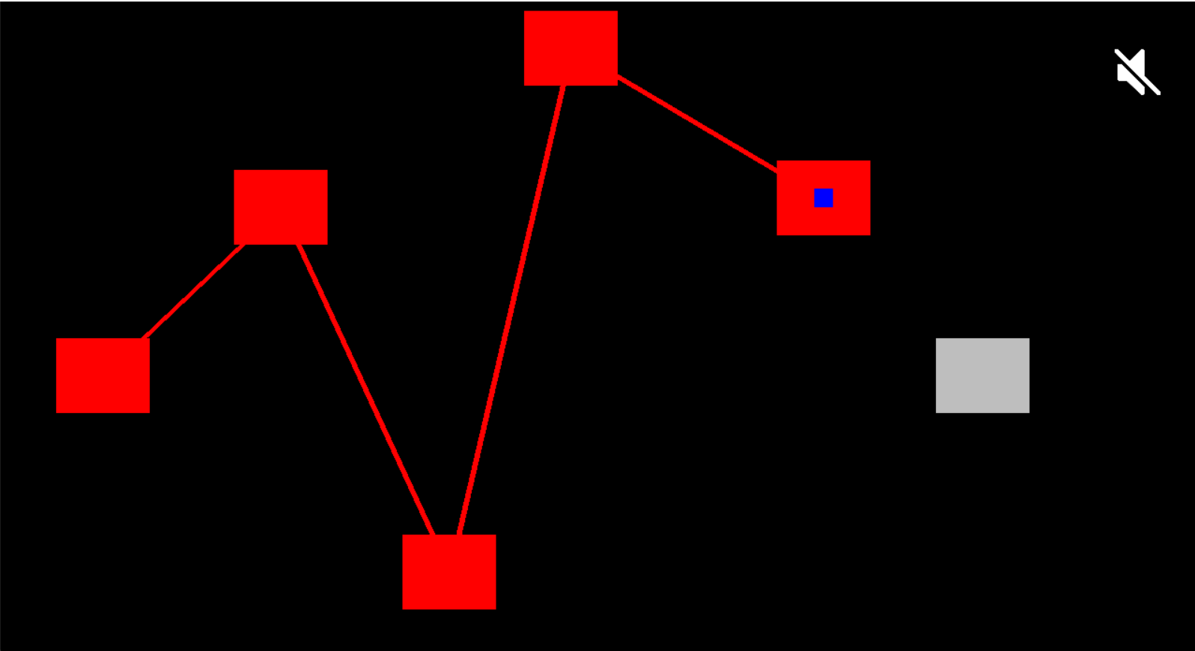

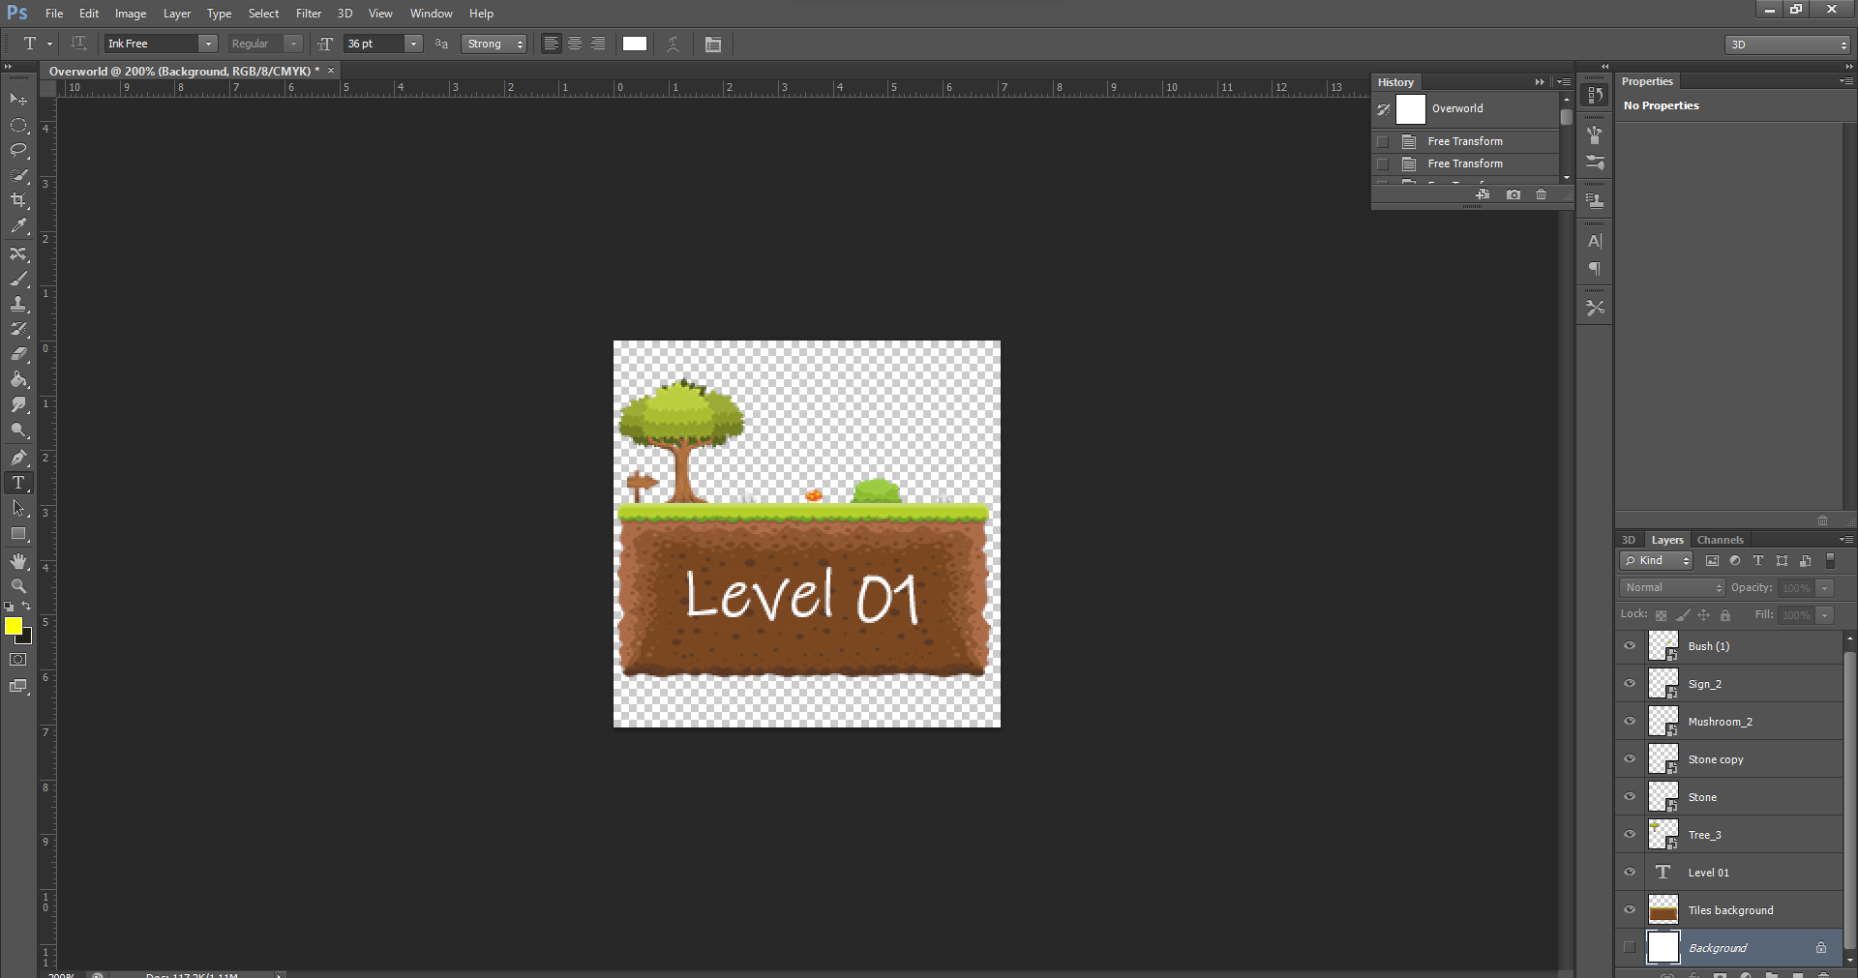

To start adding graphics to the overworld, I first need to make some images to blit on the screen. I created images for each stage telling the user which level he is standing on.

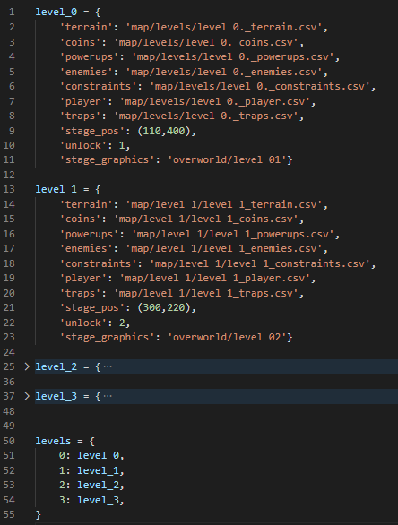

Now, to make the overworld work, back in the map_data I added 3 extra keys, the stage pos, what each level unlocks and their images.

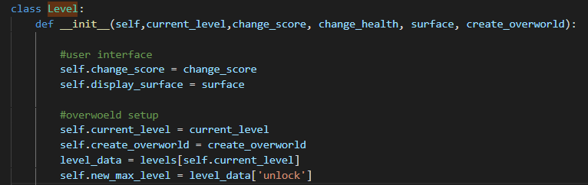

Now in the level class, passing in the current level and reading data from the dictionary.



In order to check whether the player has completed the level, i made a method in the level class, which checks if the player collides with the end point, if so then it sets the max level to whatever the level unlocks which is read form the map data.

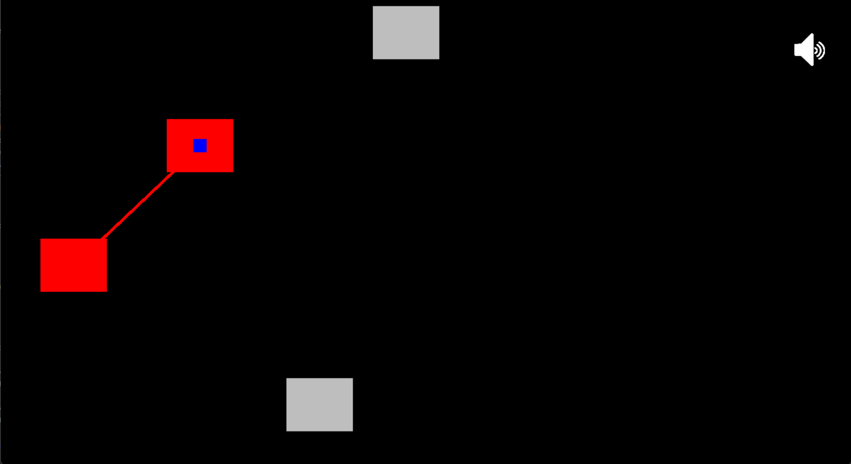

After completing the level:

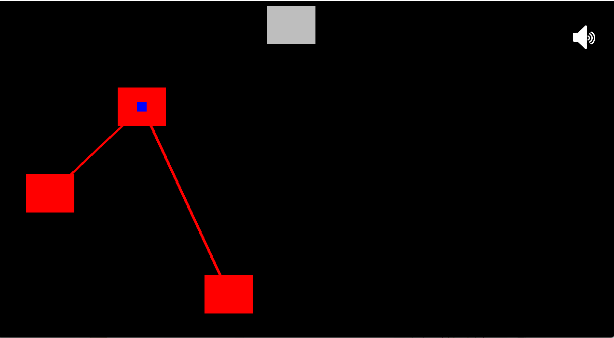

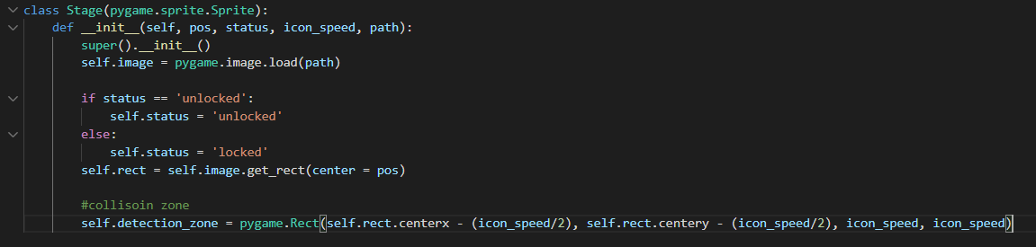

In the stage class, instead of filling the surface with a colour, I now loaded an image instead, and the image is located at “path” which is read from the map data.py



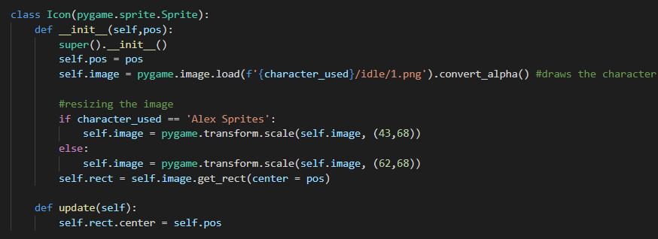

Lastly in the Icon class instead of filling in the surface with a colour, I loaded an image which is the idle state of the character chosen, then I resized it to make sure it fits well on the stage images.

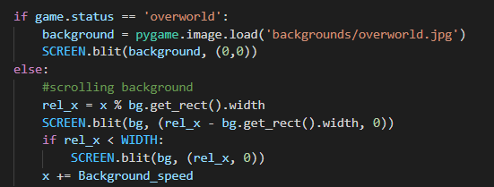

In the main_game loop, I added an if statement to check if the user is in the overworld or not, so that the correct background can change

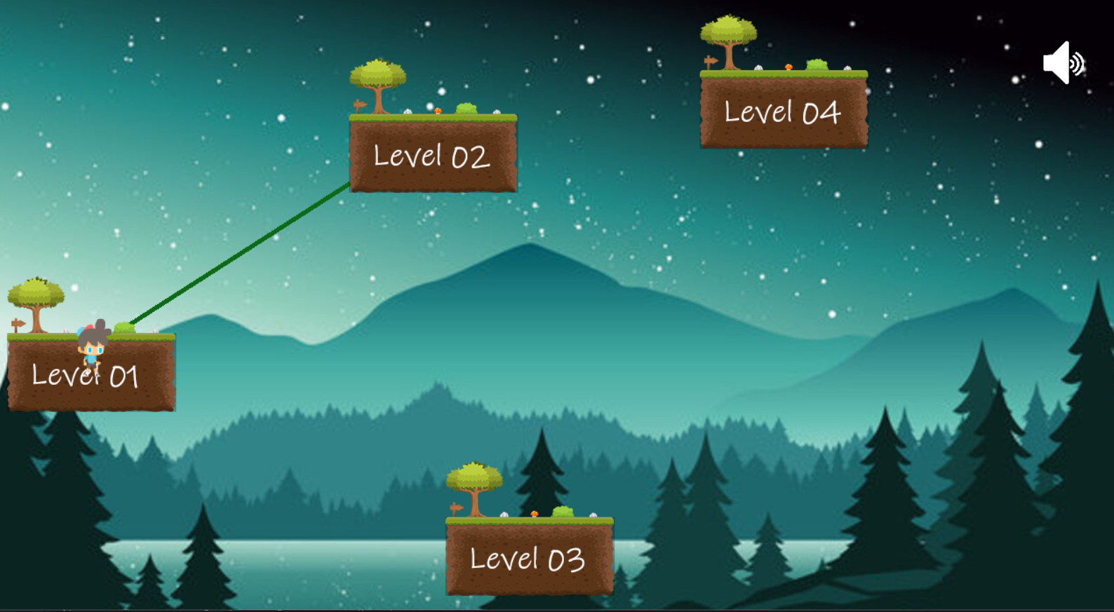

Once the code is run, this is what it looks like.

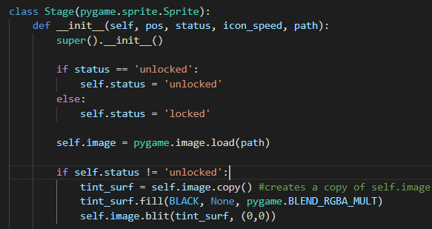

Having the images just like that might confuse the user, therefore I added a dark layer on top of the images for those stages that aren't yet locked.

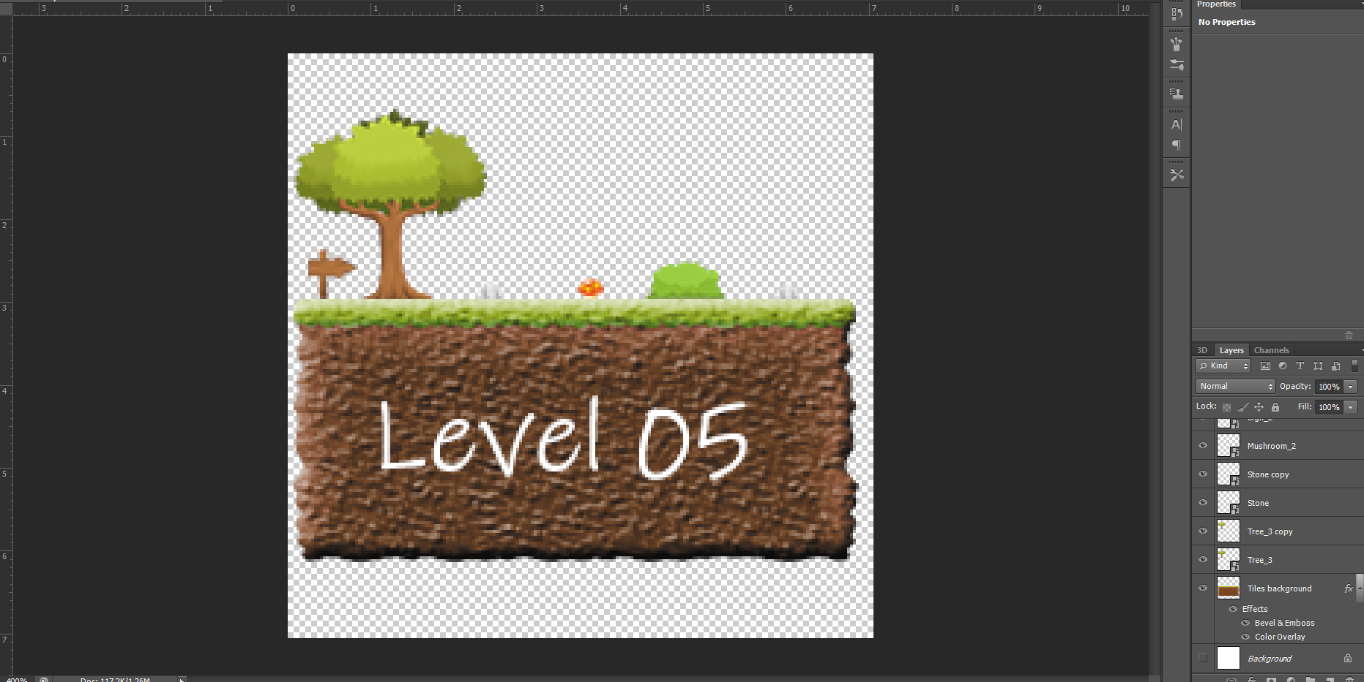

I also went back to photoshop and add effects to the stages images to give it a better look.

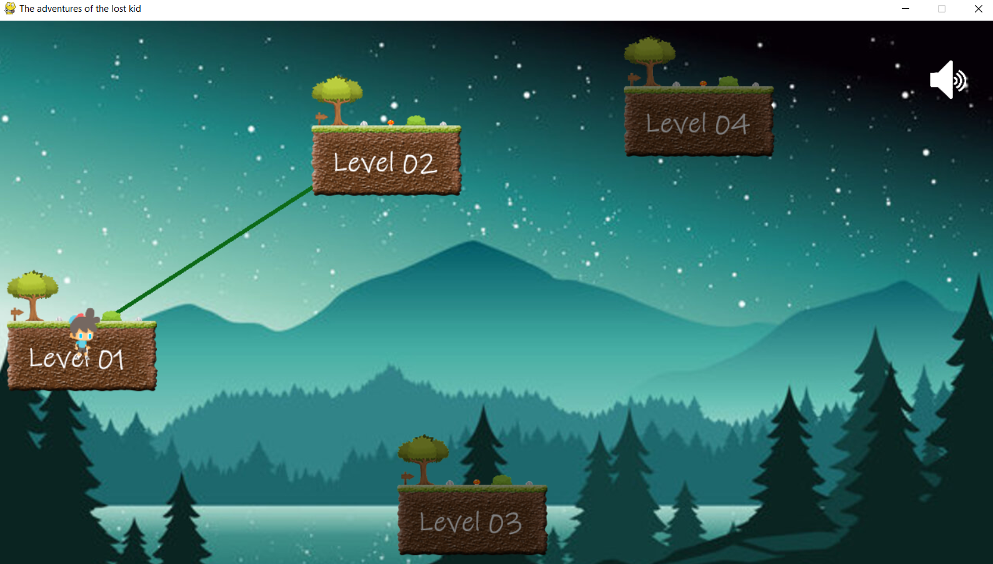

Now running the code, and this is what it looks like.

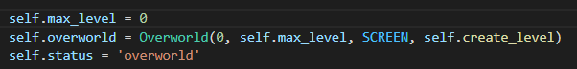

Since the overworld is now complete, I can set the it so that the only available level is the first level, and here, i’ve set the max level to be 0 as well as the start level.

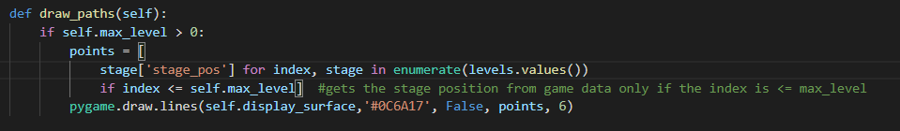

Back in the draw paths method, since the line requires 2 points to link together, it causes an error if the max level is set to 0, therefore the lines are only drawn if the max level is bigger than 0 which means at least 2 levels are available.

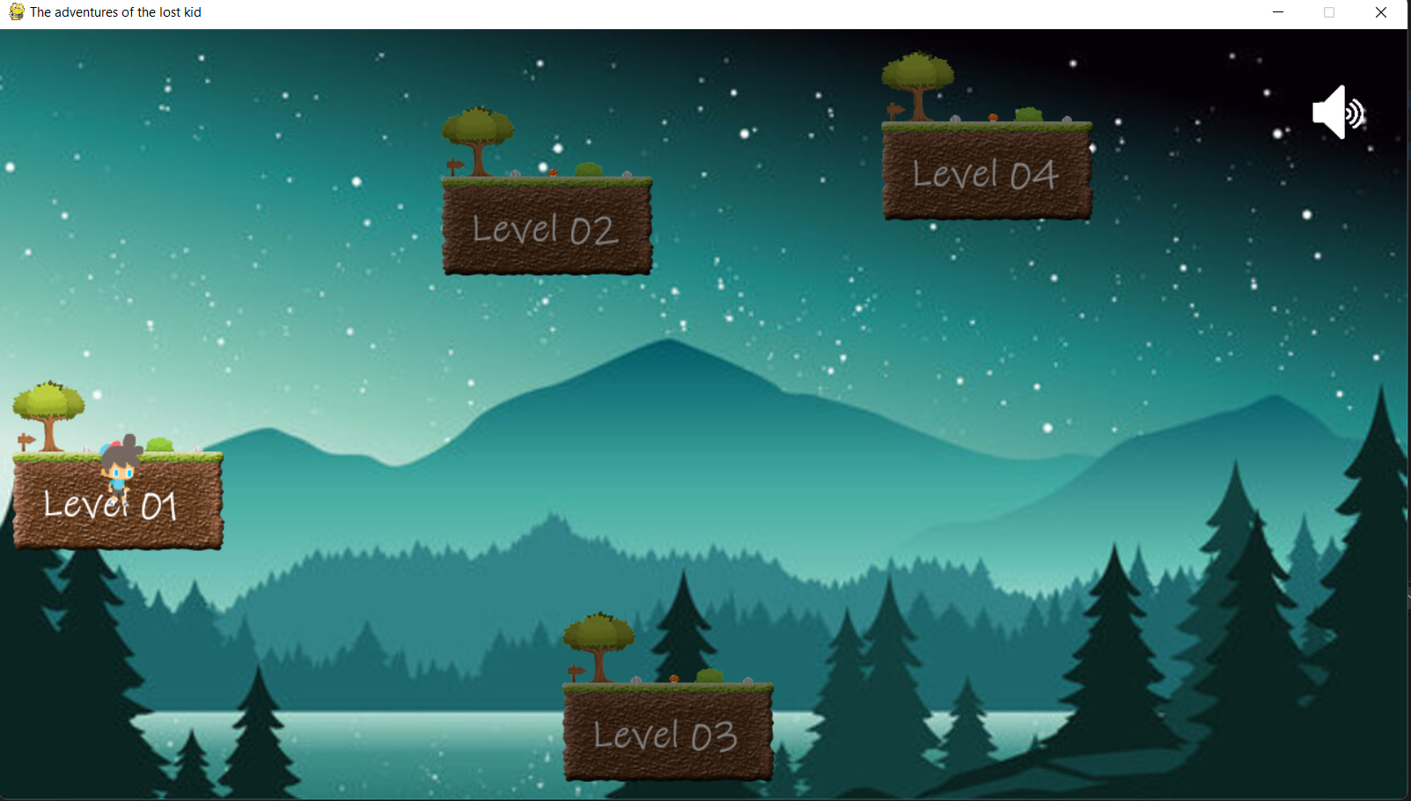

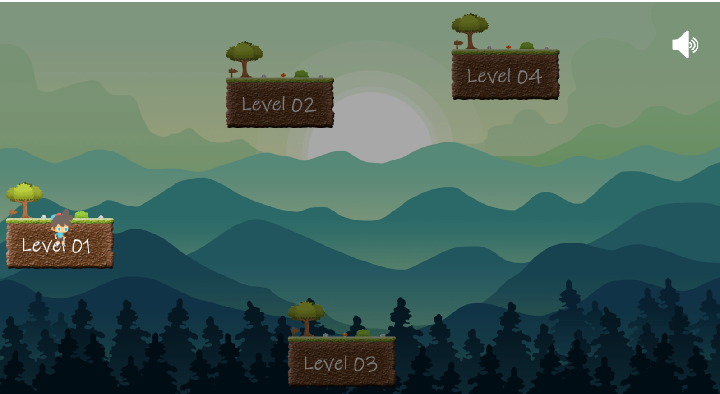

I noticed that the image background I was using required a licence and is not royalty free, therefore I changed it to a better images which would respect the copyright laws.

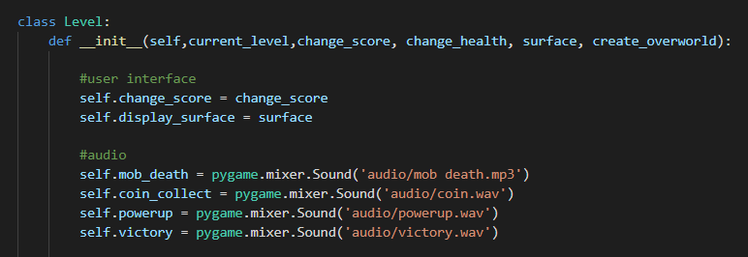

As per my client requirements they wanted to have sound effects in the game. Therefore i’ve add some, where I thought it would be appropriate to use.

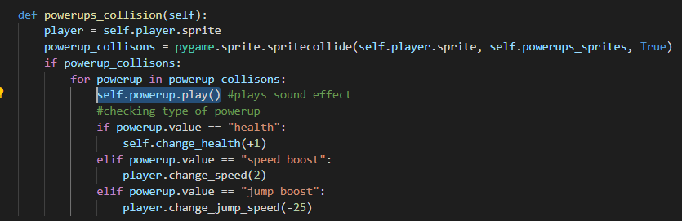

I then played the sound whenever there was a collision with the item.

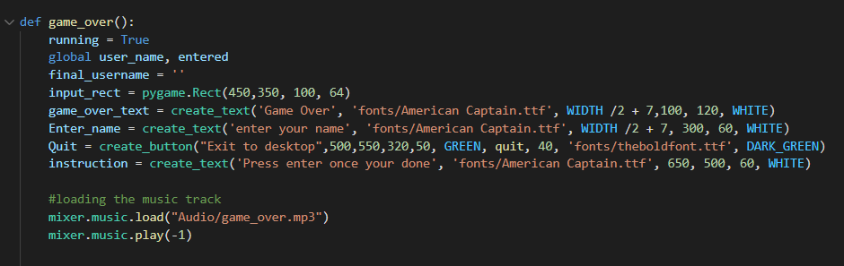Furthermore, for the game_over menu screen, i used a different music track to give the gamer a better sense of loss.

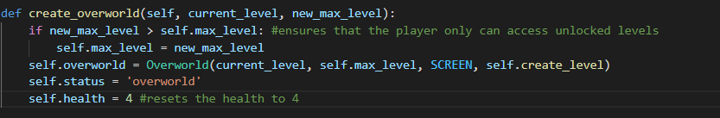

In the overworld method from the game class, I made the program reset the player’s health whenever they complete the level and return back to the overworld

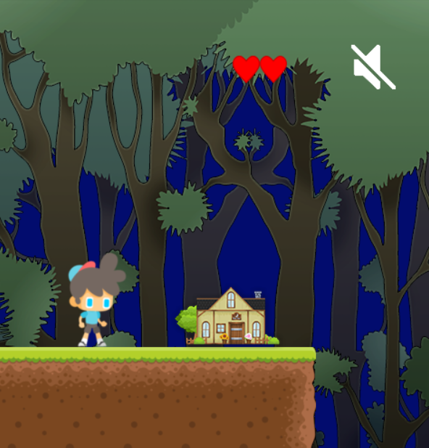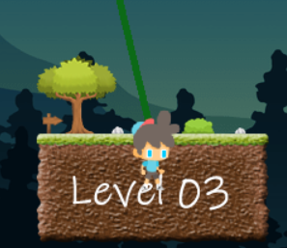

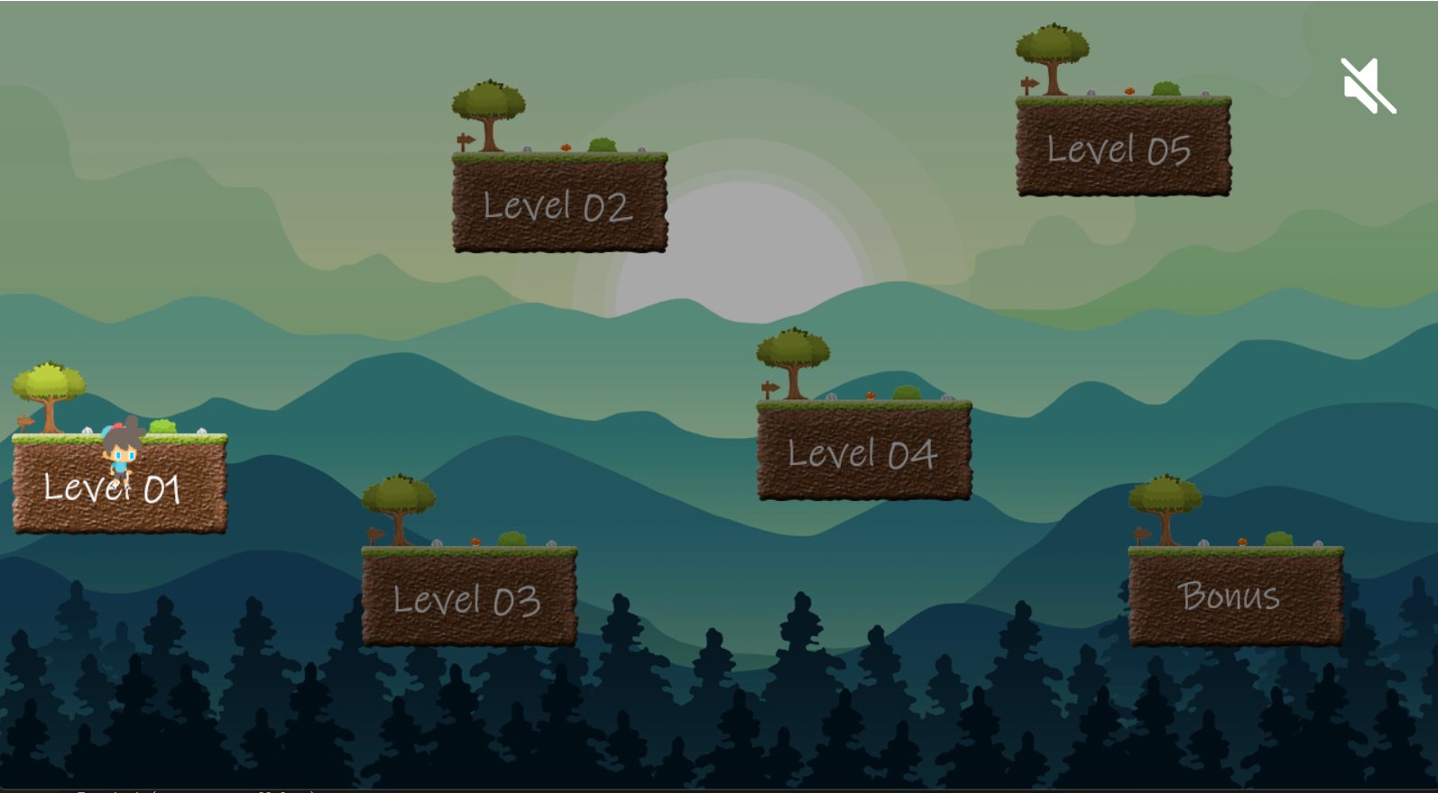

After making all the levels, this is what the overworld looks like.

## White Box testing

While making and coding the game, I was testing each component making sure it works.

|  |  |  |  |  |  |
| --- | --- | --- | --- | --- | --- |
| Test number | Test description | Test data | Expected result | Justification of test | Actual result |
| 1 | Buttons should work | Left click | The button should load the menu it is intended for | To make sure the game is running correctly and not misleading the users to different screens | works perfectly and each button performs the action it was intended to. |
| 2 | Usernames are stored | “James” | Username = “James” | Since my game will have a leaderboard, usernames will be needed to show what each player scored therefore I need to ensure this is working | Works, the program stores the username and saves it to pass it into the leaderboard list. |
| 3 | User can control the player | “WASD” keys | The character will move | The main objective of the game is to move the character across the map and reach the end of the map to complete the level | Works, the user is able to input keys to move the character around. |
| 4 | Powerup will be applied to the player | None | The player will be able to use the powerup | To make sure that the powerup actually loads when the player collects it. | works, I only added 3: extra health, speed and jump boost. |
| 5 | Buttons area | Left click | The user should click within the button area for it to work | The user shouldnt just click on a random spot and the game will load on the menu, however he should click on the button so it can work | Works, each button performs its action only if the user has the mouse on it. |
| 6 | Music control | Left click | The music should stop/play when the user clicks it | Some users might prefer to play with no music so I must ensure that this feature is working | Works, the mute button is on every screen and can be controlled at any time. |
| 7 | Score system | None | The score must start at 0 and keeps updating  Score = Score + new_score | In order for the player to keep track of his score this function must be working | Works, the player has a score which is 0 at the start and increases by collecting coins and killing mobs. |
| 8 | Game lives | None | Should start at 4 when the game is launched. Should decrease when a player gets damaged, ends when it's equal to 0 While health > 0:  Run game | The game lives is an essential part of the game, it keeps a track of the player health before it ends the game | Works, the user starts with 4 lives and the game ends once the user reaches 0 health. |
| 9 | Displays | None | Every relevant object/element is displayed to the user | So that the user can see and recognise what he is doing in the game | Works, each button is labelled so that the user knows the function of it. |
| 10 | Quit function | Left click | The game should close  quit() | If the user decides to close the game, this function would be necessary in order to achieve this requirement. | Works, there is a quit function which is called when the quit button is pressed. |
| 11 | Player can kill mobs | None | The user must be able to kill the mobs and in return he will get a certain amount of points | To match the score system the user must have ways to gain the points, and the ways must fully function so it can keep getting added | Works, the player is able to kill the mobs by jumping on them, and the player gets 15 points for each kill. |
| 12 | Traps display | None | The traps should be invisible until a player collides with them | I will need to make sure that the player wont see the traps so he can just easily avoid them and complete the level easily | **Partially,** The traps are visible throughout the whole level, this is because i didn't have enough knowledge to know how to blit it only if a player collides with it. |
| 13 | Mobs display | Images | The mobs should be displayed to the user  Mobs.blit() | This will ensure that the mobs and traps won't be the same thing and it will allow the user to see them, kill them and gain the points | Works, the mobs are displayed all the time and the user is able to see them. |
| 14 | Map display | Image | The map should be displayed and moves with the player  Map.blit  Map. update | For the player to see where he is heading and see the upcoming obstacles this needs to be tested and make sure it fully works to achieve this | Works, the map is displayed and has a camera that moves along with the player. |
| 15 | Username minimum characters | String | username.length() >= 4 | Since my game will have a leaderboard I will make sure that the usernames are not just a letter and can be recognised by other players | Works, the game_over function checks if the username is at least 4 characters so it can add it to the leaderboard. |

# Validation:

In order to make my game function as it is intended to, I must check many components in the code. The input keys are validated such as only expected keys are the only ones that give an output such as W or space key makes the character jump, and this is validated by checking each input and performing the action required. Furthermore the animation sprites are checked so that each animation is played whenever needed, this is done by using a dictionary that stores the sprites of the character and calling the appropriate key when a valid input is detected.

In addition the player’s name is also validated so that the length of the name is at least 4 characters and then can be saved to the leaderboard file. This is achieved by using an if statement that checks the length as well as a boolean that is set to True when the user presses enter.

# 

# 

# Evaluation:

After I completed the game, I made some of my clients test the game while I was assessing how they were interacting with the game. I noticed that almost all the users were getting confused by the “x” button in the: leaderboard, credits and character selection screens, as they thought it would take them back to the main menu. To fix this I changed its function to load the main menu screen and deleted the old button.

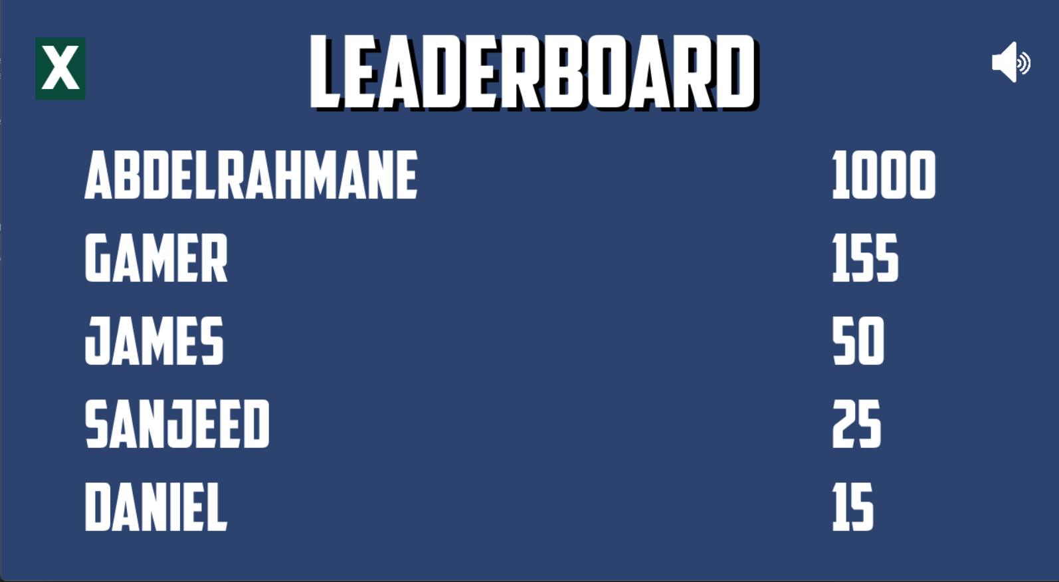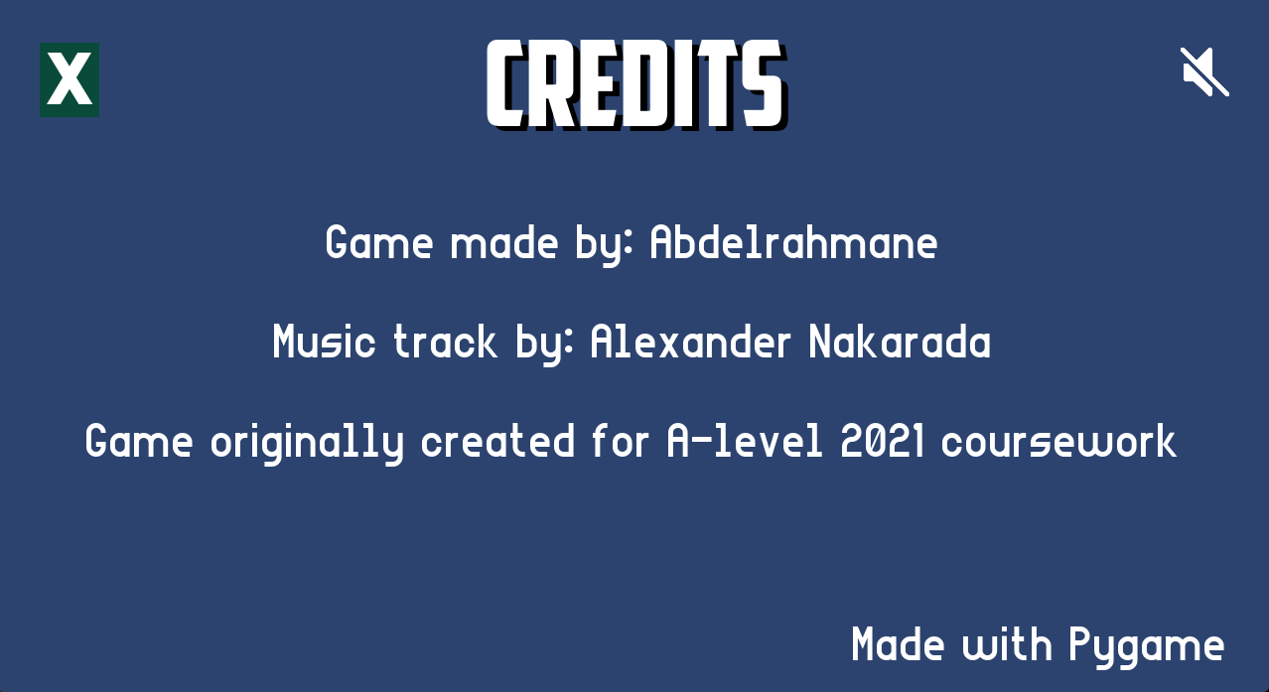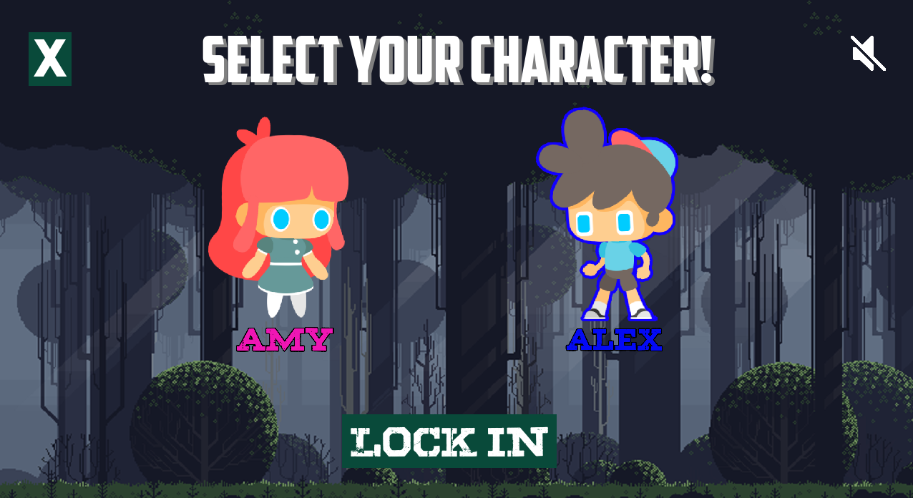



I then also noticed that the user was able to tell the controls and how to play it, especially in the overworld, and to fix this issue, I created a new screen that would show all the game controls.

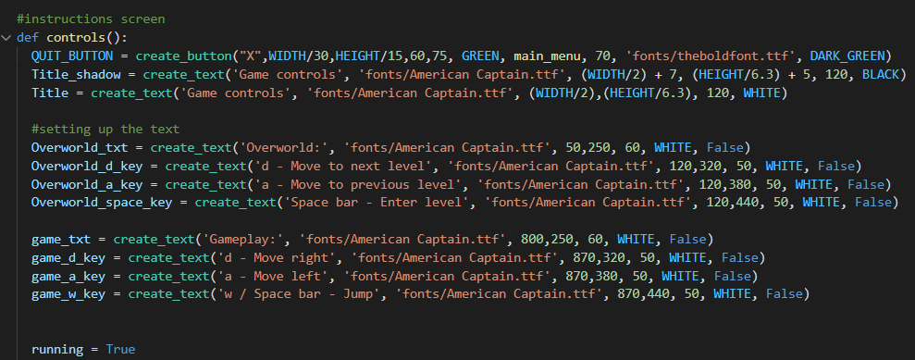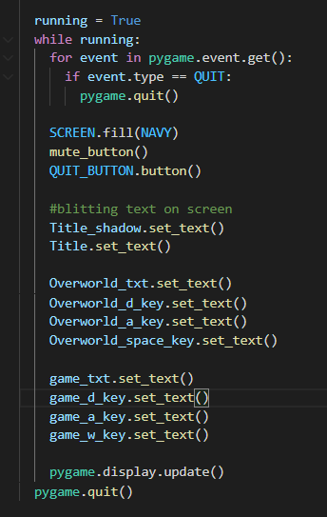

In the main menu function:

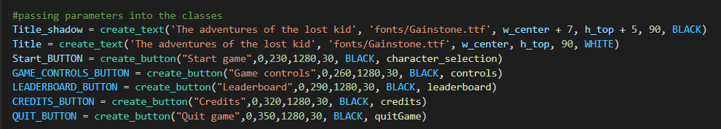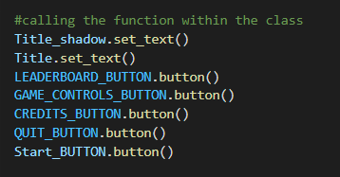

What the screen looks like:

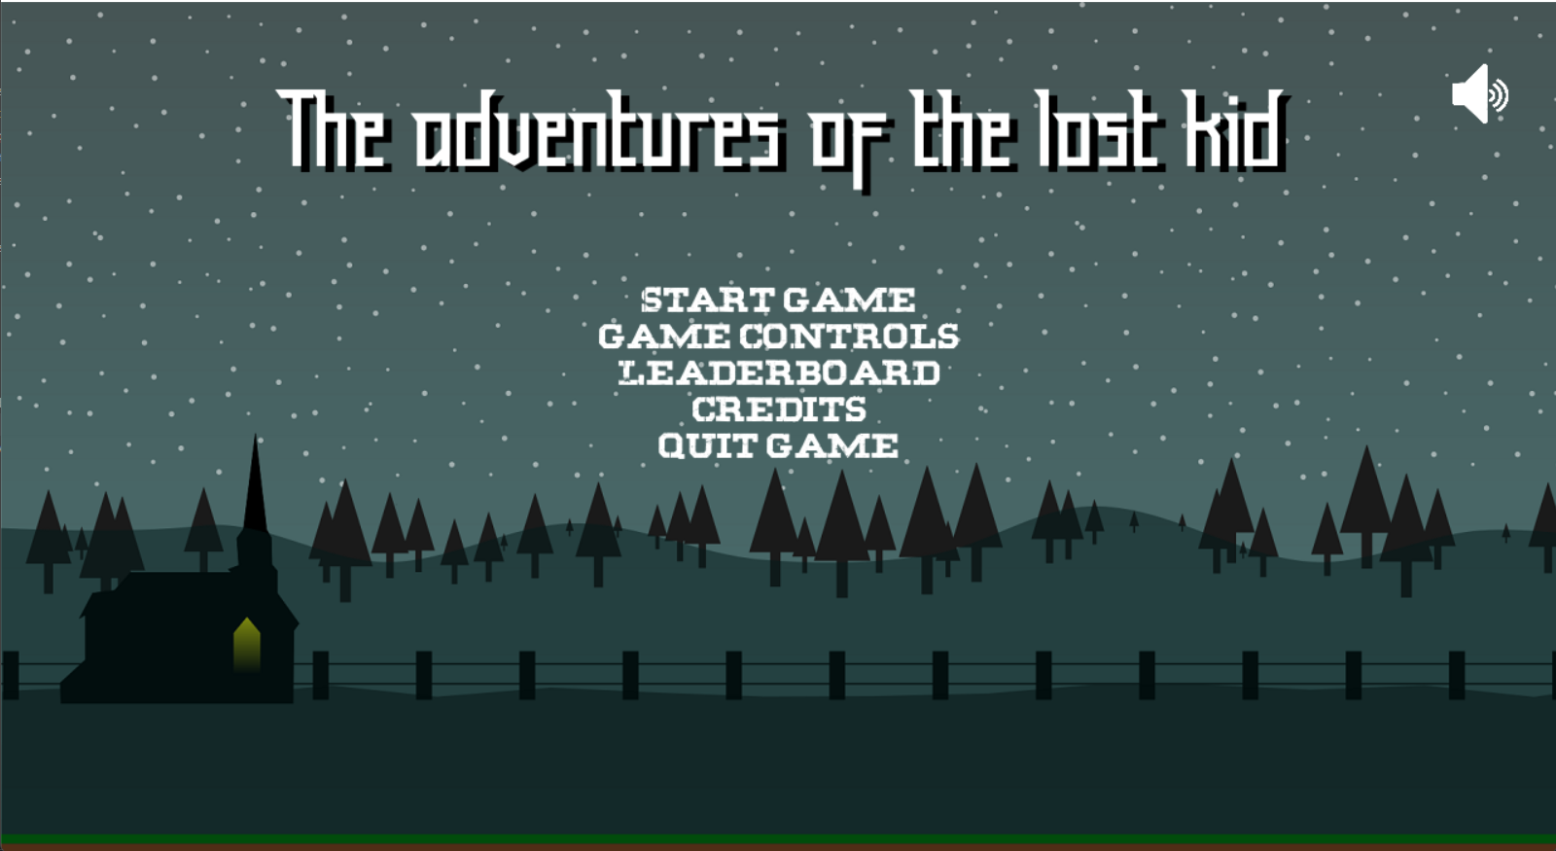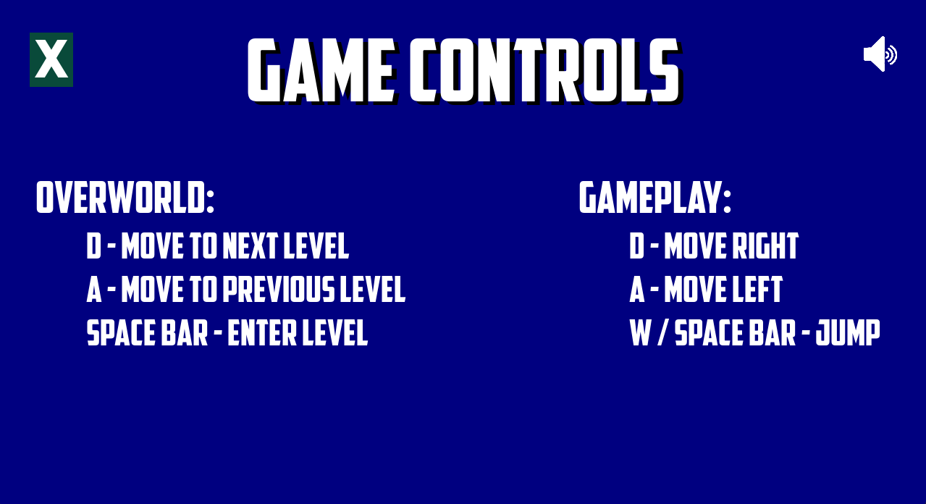

## Usability

To make sure my game met my client requirements and satisfies them, I made a small questionnaire.

|  |  |
| --- | --- |
| Did the game run smoothly on your computer? | This question will be able to tell me of my code was efficient enough to run on multiple different computers such as those with low specs. |
| How hard did you find the game? | One of the client requirements was to make a game with medium difficulty, so this question will tell me whether I achieved it or not. |
| Did you have any trouble navigating around the program?, if answered yes specify the reason | One of my success criterias is to have a clear user interface. Asking this question will give me an idea where I could improve the interface in the future. |
| Rate the game | Rating the game will give me a clear understanding of how much the users enjoyed the game. |
| Is there anything that could have made the game better? | This question will give me ideas for further improvements in future updates. |

**Question 1: Did the game run smoothly on your computer?**

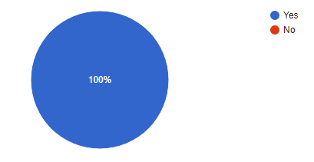

**Analysis**

According to this pie chart, all my clients didn't have any issues running the game on their computers, therefore this shows that my code is efficient and doesn't use much memory and power.

**Question 2: How hard did you find the game?**

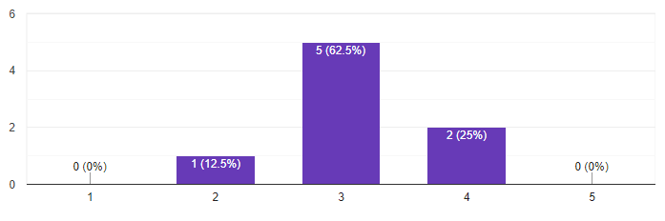

**Analysis**

This bar graph shows me how difficult my clients found the game, the majority voted 3 out of 5 which is around the medium difficulty, while a few found it a bit easier while others a bit harder. But on average the game was found to be with a medium difficulty which meets my client requirements.

**Question 3: Did you have any trouble navigating around the program?, if answered yes specify the reason**

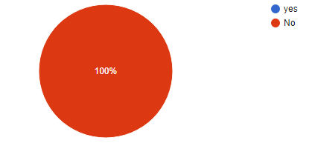

**Analysis**

This pie chart shows that none of my clients found an issue with navigating around the program which shows that everything was clear and thus my client requirement has been achieved.

**Question 4: Rate the game**

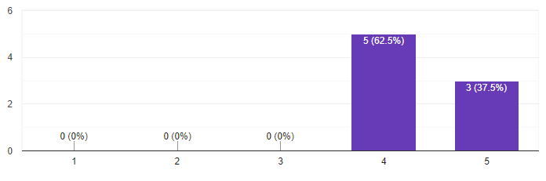

**Analysis**

On average my game was rated a minimum of 4/5 where some rated it a 5/5 which is a really good rating for the game. This shows that my clients really enjoyed the game.

**Question 5: Is there anything that could have made the game better?**

1. More levels and improve the graphics
2. Added more levels
3. The colour palette choice of the characters go along a more bubbly world - light colours and all, the zombies and the grass on the other hand are the complete antithesis to this, other than nothing else bugged me.
4. Everything looks great
5. Make the game harder
6. More Levels
7. This user had many suggestions:
   1. Make it that if you fall off the map the game doesn't end but instead you just lose 1 life
   2. Make an in-game store in which you can spend the coins you gain during levels, on items, e.g. extra lives, different skins, etc.
   3. Add a soundtrack list so users could choose what music they'd like to listen to
   4. Make the game 2 players
   5. Add movable objects in the game to help you along the way, like in fire boy and water girl
   6. Add different types of enemies to make the experience on each level different
   7. Add a pause button in your game
   8. Allow other factors to affect the score eg, how many lives they end the level with, how long they took to complete the level
8. I found the game to be very good and didn't come across any issues or problems. Everything went smoothly, I like how it is and there is nothing I could recommend to make the game better.

**Analysis**

The responses form this question have a big range of different answers, about the majority said that they want more levels to be added to the game, so they can play more of it and enjoy it more, despite the game having only 6 levels they wanted more which suggests that they were enjoying it. Response 1 and 3 both talk about the game graphics, as they both preferred the game to look slightly better to have a more matching character sprites with the environment. One of the users found the game easy (response 5) and therefore suggested making it harder, from this I can add a menu where the user will be able to select the difficulty easy, medium and hard. Response 7 had many suggestions however I found a few of them more of a personal thought and game changing ideas such as c, d, these suggestions would completely change the game aspect and might make the game not meet the client requirements. 7a) would make the game way more easier to complete, making the character die when he falls out the map makes the game more intense and challenging to beat. 7g, I was going to add a pause button, but due to the time limitation i didn't have enough time to add this future. However the rest such as 7b, 7e, 7f, 7h are actually good ideas that can be added to future updates.

## Criteria met:

Success criteria

|  |  |
| --- | --- |
| Success criteria | Has it met? |
| The game must have a music track | yes |
| The game must have sound effect | yes |
| The user should be able to turn on/off the music | yes |
| The game should display a full health once as soon as it starts | yes |
| The game should have mobs | yes |
| The game should have traps | yes |
| The player should lose lives if they collide with a trap or a mob | yes |
| The level should end when the player runs out of lives | yes |
| User interface must be clear | yes |
| Some screens require a mouse input | yes |
| The game needs a keyboard to control the player | yes |
| The game must have the option to pick characters | yes |
| The game must have animations | yes |
| The map must update depending on the player location | yes |
| The game must have power ups | yes |
| There must be a score system | yes |

## Black box testing

|  |  |  |  |  |
| --- | --- | --- | --- | --- |
| Requirement | Success criteria | Test/test data | Actual output (via video timescale) | Justification for the test |
| 1. The game must have audio | 1.The game must have a music track | The music should start playing as soon as the game launches | Seen throughout the whole video e.g. 00:31 | So that the the game can provide entertainment for the player and create a tone for it, as well as meeting the success criteria |
| 2.The game must have sound effect | Audio should be outputted according to the user interaction in the game | Seen throughout the game play e.g 05:15 | In order to make the game more enjoyable and make it look more reactive this feature needs to be included in the game |
| 3. The user should be able to turn on/off the music | The mute button should function correctly | 00:20 - 00:25 | Some user would rather have the music off while gaming so this is needed for them |
| 2. The Character must have in game lives | 1. The game should display a full health once as soon as it starts | When the game starts 4 hearts should be shown on the top of the screen | 00:55 | So that the user gets informed of how many lives he has before he dies and the game ends |
| 2. The game should have mobs | When the player gets in the reasonable range for a mob, it should be displayed | seen throughout the gameplay e.g. 01:45 | To add ways the player can lose lives and not just complete the level with no in-game difficulty |
| 3. The game should have traps | The traps shouldnt be visible until a player collides with them | **Not met** due to the lack of knowledge, however traps are still displayed all the time. Seen throughout the whole gameplay e.g. 03:56 | To increase the difficulty of the game and make players have more fun trying to remember where the traps are and avoid them |
| 4. The player should lose lives if they collide with a trap or a mob | The number of hearts displayed on top of the screen should decrease | Seen throughout the whole gameplay e.g. 06:46 and 1:36 | The user must know how many lives he has left before the game ends and he loses |
| 5. The level should end when the player runs out of lives | Make sure the “game over” screen and the game will request for username input | 09:15 | So the game can end when the player dies, and have his score saved in leaderboard under his name |
| 3. There must be a user interface | 1. User interface must be clear | Make sure that all the buttons are in the right place and easy to access | 00:02 - 00:52 | Since my target audience are aged between 15-19 years old, the user interface must be clear for them so they don't struggle using the program |
| 2. Some screens require a mouse input | In order to press the buttons a mouse input will be used, so i will test if the mouse input will be working when the buttons are clicked | 00:02 - 00:52 | Some menus and the mute button require this type of input so it is essential to have this working |
| 3. The game needs a keyboard to control the player | The sensible character will be assigned a task for the game and each should do its task where as the others shouldn't affect the game | Seen throughout the whole gameplay e.g. 01:25 | I will need to make sure that the user can control the player easily and use the powerups and other functions, also i need to make sure that the other keys don't affect the game make it crash |
| 4. The game must have the option to pick characters | The mouse input should make the selection and it should be saved under a variable and loaded to the game | 00:44 | My game will have multiple characters for the user to choose from and use to play with in the game |
| 4. The game must be responsive | 1. The game must have animations | Each movement key for the character will load a different images of the character creating an animation of the player moving | Seen throughout the whole gameplay e.g. 06:40 | To make the game look less boring and give a more advanced tone animations will be used and to make it look smoother |
| 2. The map must update depending on the player location | There will be a camera tracking the player | Seen throughout the whole gameplay e.g. 07:30 | The player needs to know where he is on the map, whats facing him and what he needs to do to get to the next part of the map, therefore I will need to use a camera tracker to follow the player |
| 5. The game should be at a medium level of difficulty | 1. The game must have power ups | When the player collects them they should be applied to him, and the powerup should be displayed on the map so the user can see them and collect them | seen throughout the gameplay, e.g. 01:02, 01:06 and 1:15 | One of making the game more fun is through using power ups, having these working will make the users want to complete the level in different ways and test multiple power ups |
| 2. There must be a score system | The score system needs to start at 0 and keeps updating whenever the player gains points | seen throughout the gameplay, e.g. 07:37 | So that the user’s score can be stored in a leaderboard creating a self competition to try and beat it each time they play the game. |

## Maintenance and limitations

Since my game works and supports python 3.9.7, in the future there might be a python update where it would no longer support this version, therefore maintenance is really important to keep the game working and available to use.

In my code I ensured to make comments and keep variable names logical and reasonable so that if I or another developer had to go and change the code to maintain it they would not struggle to read it. I also made sure to keep all my files organised with appropriate names so that any developer can understand what each file is used for.

Future versions of this program can include more levels such as having multiple overworlds that unlock by completing all the levels from the previous one. Each overworld can have different themes, such as the first can be about being in the forest, then in a cave, or mountains until the storyline ends when the character finds his home.

Furthermore, future versions can include more abilities for the player to have, and abilities to be randomised to either a good ability or a bad one which can make the level easier or harder to complete. Moreover, there could be more mobs type with different ways of dealing damage and different ways of movement, such as shooting or flying/bouncing.

The game can be further improved so that the traps will only become visible when the player collides with them. I wasn't able to add this feature in my game due to not having enough knowledge to code this action. In addition, I only added a few powerups (extra health, speed and jump boost) due to the time limitation I had, otherwise I could have added more such as making the character shoot.

Moreover, the game can have more collectable items which play a significant role in the player’s point. The game can have floating objects such as 1 per level (bonus points), and the more the character collects, his score will be multiplied by the number he has gained or follow another algorithm to change his score.

In addition, the game can be further improved by adding more modes such as an online mode where 2 players can compete to finish all the levels as quickly as possible and gain the most points on their way.

Another improvement that can be made is to have better graphics such as using paid sprites for the characters and the powerups, as well as adding more characters to choose each with their advantages and disadvantages such as a fat character could have more health however his movement speed would be less whereas a skinnier character can have less health but more movement speed.

**Sources**:

<https://pngio.com/images/png-a1037008.html>

Main menu background

<https://www.gameart2d.com/the-boy---free-sprites.html>

[Cute Girl Free Sprites](https://www.gameart2d.com/cute-girl-free-sprites.html)

Character Sprites

<https://opengameart.org/content/tower-defense-dirt-background>

Credits background

<https://www.pinterest.co.uk/pin/788692953476885743/?d=t&mt=login>

Character selection screen background

<https://opensource.com/article/17/12/game-python-moving-player>

Player movement

<https://www.iloveimg.com/crop-image>

PNG cropper

<https://picresize.com/>

Image resizer

<https://www.shazam.com/gb/track/553847930/forest-walk>

Menu song

<https://www.chosic.com/download-audio/29768/>

Gameplay song

<https://www.gameart2d.com/free-platformer-game-tileset.html>

Tiles

<https://opengameart.org/content/large-forest-background>

Gameplay background

<https://opengameart.org/content/coins>

Coins

<https://opengameart.org/content/power-ups>

Powerups

<https://www.gameart2d.com/the-zombies-free-sprites.html>

mobs

<https://www.pngaaa.com/detail/2430689>

Spikes

[https://favpng.com/png_view/building-2d-computer-graphics-tile-based-video-game-building-side-scrolling-png/fe2L49SG#](https://favpng.com/png_view/building-2d-computer-graphics-tile-based-video-game-building-side-scrolling-png/fe2L49SG)

House

<https://pngtree.com/freebackground/forest-mountains-sun-beautiful-natural-green-background_1465277.html>

Overworld background

<https://www.fesliyanstudios.com/royalty-free-sound-effects-download/zombie-174>

Zombie sound effect

<https://opengameart.org/content/ui-and-item-sound-effect-jingles-sample-2>

Powerup sound effect

<https://www.findsounds.com/ISAPI/search.dll?keywords=game+coin>

<http://www.utc.fr/si28/ProjetsUpload/P2006_si28p004/flash_puzzle/sons/rush/coin.wav>

Coin sound effect

<https://opengameart.org/content/win-music-3>

Victory sound effect

<https://opengameart.org/content/death-is-just-another-path>

Game over background music

**credits**:

[www.youtube.com/playlist?list=PL8ui5HK3oSiGXM2Pc2DahNu1xXBf7WQh-](http://www.youtube.com/playlist?list=PL8ui5HK3oSiGXM2Pc2DahNu1xXBf7WQh-)

Tutorials